YEAR 10 HOME ECONOMICS LESSON NOTES

WEEK 6
LESSON 41
STRAND: HEC 10.2 FOOD AND NUTRITION
Sub Strands: HEC 10. 2.2 What is Food
CLO: HEC 10.2.2.1 Demonstrate an understanding of Commonly used foods

FRUITS
Classification | Examples
Citrus fruit, | Mandarine, lime, Star apple,oranges
Hard fruit | Guava
Stone fruit | Mango, Avacado, Dawa, Tarawau
Berries | Rasberries, Strawberries
Others | Banana, Pineapple, Pawpaw, Vutu, Soursap

NUTRITIVE VALUE
Fruits provide our body with vitamins, minerals, fibre and water
- Vitamins A and C
- Some minerals(small amounts e.g. iron, calcium )
- Some sugar
- A large amount of water
- Good amount of fibre if skin is edible

CHOOSING FRUITS
- Buy fruits when in season; it is cheaper when plentiful in supply.
- Firm and of a good colour, free from bruises, skin punctures and decay.
- Not to be over ripe, wrinkled, withered or too soft

STORING FRUITS
- Best to keep in the crisper compartment of the refrigerator.
- Few fruits (e.g. bananas) do not keep well in the refrigerator; they become softer and skin darkens.

COOKING FRUITS
Most fruits are delicious when eaten raw and very few nutrients are lost. Cooking softens fruits as some elderly find it difficult to eat crisp fruits. Fruits can be baked, fried, grilled or stewed in water or syrup. During cooking vitamin C is lost so the following should be done:
- Fruits which are already cut should not be soaked in water.
- Cook in a sauce pan with tight fitting lid.
- Water/ syrup must be boiling before cooking and place fruits in as soon as it is peeled.
- Stewed fruits should not be boiled but only simmered.
- Serve syrup with fruits containing dissolved nutrients

SERVING FRUITS
Fruits may be served in a variety of ways:
- Fresh fruits can be served at breakfast.
- As a desert
- Good snack
- Stewed fruits can be used as a filling for pies, flans and tarts.
- In salads as it adds colour and texture

ACTIVITY
- Which compartment in the refrigerator listed below is best for storing fresh fruits?
A. Freezer
B. Chiller
C. Ice bin
D. Dairy tray

- Identify two ways of storing fruits.

- State two ways of serving fruits.

LESSON 42
STRAND: HEC 10.2 FOOD AND NUTRITION
Sub Strands: HEC 10. 2.2 What is Food
CLO: HEC 10.2.2.1 Demonstrate an understanding of Commonly used foods

VEGETABLES
Vegetables are valuable in our daily diet because of the vitamins they contain. They also provide water, minerals and fiber.

TYPES OF VEGETABLES

Parts of the plant | Examples
Green leafy | Bele, chauraiya, cabbage, saijan, ota, tubua, rourou
Flowers & sprouts | Cauliflower, broccoli, bean and moong sprouts
Legumes and pulses | Beans, dhal, chick peas, etc.
Underground vegetables | Onion,garlic,ginger,carrot,potatoes
Fruit vegetables | Tomatoes, cucumber, chillies, pumpkin etc

FOOD VALUE OF VEGETABLES
Greater food value is obtained from vegetables when they are eaten raw.
Nutrient | Vegetables rich in this
Protein | Peas,beans,Lentils
Fats | None present
Carbohydrate(starch, fibre) | Roots, tubers and seeds especially
Water | Most vegetables contain 90-95%water
Vitamin A(carotene) | Carrots ,tomatoes, silver beet, pumpkin
Vitamin B | Small amounts in most vegetables
Vitamin C(ascorbic acid) | Capsicums, parsley ,bean sprouts, cabbage ,potatoes, zucchini, peas

BUYING VEGETABLES
Buy vegetables in season as they are cheaper.
- Choose fresh, firm or crisp vegetables; they are nutritious
- Choose those with bright colors. Avoid those that are wilted or bruised

STORING VEGETABLES
- Store salad vegetables in the crisper compartment or in plastic bags in the refrigerator. Use leafy vegetables first.
- Store potatoes and onions in cool and dark place that allow circulation of air.

COOKING VEGETABLES
RULES | REASONS
1. Prepare veggies just before serving. | Vitamin C is destroyed or exposure to oxygen
2. Do not soak in water | Vitamin C is soluble in water and will be lost
3. Peel thinly or wash and cook in skin. | Prevents loss of vitamins and minerals just under skin.
4. Cut into even sized pieces. | All will be cooked at the same time.
5. Use a small amount of water. | Vitamin C is soluble in water and could be lost
6. Bring water to boil before adding veggies. | Reduces cooking time hence reduces loss of Vitamin C.
7. Reduce heat when veggies start boiling. | More economical.
8. Once veggies are boiled cook without lid. | Allows volatile acids to escape.
9. Do not overcook. Prepare just before serving and serve as it is cooked. | Prevents further loss of nutrients.
10. Do not add sodium bicarbonate to green vegetables. | Sodium bicarbonate is an alkali which destroys  Vitamin C.
11. Save cooking water for soups and gravy. | Contains minerals and vitamins lost from  vegetables while cooking and is flavorsome.
12. Cook frozen vegetables in boiling water  without thawing. | Reduces loss of nutrients.

SERVING VEGETABLES:
Serve cooked vegetables as soon as they are ready.
Vegetables may be served in a variety of ways:
- Raw as in salads snacks etc.
- Cooked as in soups, savory dishes or simply stir fried.

Activity
- Soaking vegetables in water leads to
  - a longer shelf life.
  - the destruction of Vitamin C.
  - the loss of fat-soluble vitamins.
  - the retention of water-soluble vitamins.

- State a reason for the following statements.
- Prepare vegetables just before serving.
- Once vegetables are boiling, remove the lid and cook with the lid off.

LESSON 43

Strand : HEC 10.2 FOOD AND NUTRITION
Sub Strands: HEC 10. 2.2 What is Food
CLO: HEC 10.2.2.1 Demonstrate an understanding of Commonly used foods

CEREALS
- Cereals are one of the oldest forms of food used by human beings.
- Cereals are edible seeds or grains of cultivated grasses.
- the term is often used to include breads and other cereal products, such as breakfast cereals, pasta and flour.

TYPES OF CEREALS
Wheat, Oats, Corn, Rice, Barley, Rye
Structure and Nutritive Value of a Cereal Grain
A cereal grain consists of three parts-the bran, the endosperm and the germ.
- The bran, which is the outer covering of the seed .
- The endosperm, which forms the body of the grain, is the largest part of the seed.
- The germ is the embryo from which the young plant will grow.
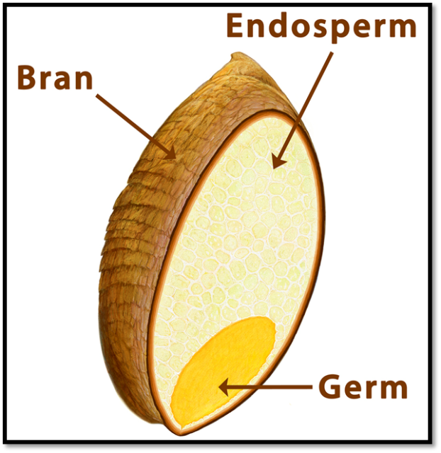
Bran: a good amount of dietary fibre
Small amount of Vitamin B and minerals
Germ: small amount of vegetable proteins and fats, small of Vitamin B and minerals (calcium, iron and phosphorus)
Endosperm: rich in carbohydrates, small amount of vegetable protein.

Cereal Products
Wholegrain or enriched breads | Whole meal, Wholegrain, High Fibre, Multigrain
Wholegrain | Rolled oats, Oatmeal, Wheat meal, Unpolished (brown) rice
Refined products | Refined products (Bran and germ removed during milling)-  Cornmeal (polenta), Semolina, Flour, Corn flour, Polished rice, Many breakfast cereals .
Enriched products | Nutrients added after refining or during production e.g.Vitamin B and iron.Pasta, Some flours, Enriched cereals.

STORAGE OF CEREALS:
- Cereals should be stored in cool, dry place.
- Whole grain cereals cannot be kept long compared to refine cereals due to its fat content from the germ.
- Cereals are likely to be attacked by insects and rodents therefore, it should be kept in containers with tight fitting lids.
Good to Know…
About Whole Grains…..
Whole grains are packed with goodness. Heart disease prevention, cancer risk reduction and blood glucose level stabilization are just a few benefits of whole grains as evidenced by many studies. Choose from wheat,rice, rye, spelt, oats or quinoa. For those trying to lose weight, whole grains are filling and help to fight hunger.
ehealthforum.com

ACTIVITY
- Which of the following terms refers to edible seeds of cultivated grass?
A. Herbs
B. Cereals
C. Vegetables
D. Root Crops

- Why is it important to serve breakfast cereals with milk and fruits?

- The diagram given below shows the structure of a wheat grain.
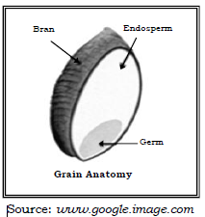
Name one nutrient present in the bran.

