**YEAR 10 HOME ECONOMICS LESSON NOTES**

**WEEK 5**

**LESSON 38**

**STRAND: HEC 10.2** FOOD AND NUTRITION

**Sub Strands: HEC 10. 2.2** What is Food

**CLO: HEC 10.2.2.1** Demonstrate an understanding of Commonly used foods

**FISH**

* Fish is one of the most important foods for Pacific Island people.
* Fish consist of short, fine muscle fibers, bound together by a small amount of fine connective tissue. This makes it tenderer than meat.
* Care must be taken not to overcook fish, as the flesh will fall apart. It is easy to digest and is therefore ideal for children, the elderly and invalids.

**Nutritive Value Of Fish**

|  |  |
| --- | --- |
| **Nutrients** | **Sources** |
| **Protein** | Great source of protein |
| **Water** | High content |
| **Fat** | Fresh fish, oysters and scallops are low in cholesterol.However,Prawns,crabs and squid are high in cholesterol. |
| **Minerals** | **Iodine** and **fluorine** in salt water fish |
| **Phosphorus** |
| **Calcium** if bones are eaten |
| **Vitamins** | Fat Soluble vitamins A and D in Fish |
| Some B group Vitamins |
| No Vitamin C |
| **Carbohydrates** | Very little[small amounts of muscle glycogen] |

**TYPES OF FISH**

|  |  |  |
| --- | --- | --- |
| **1.White fish:**   * flesh is whiteand has very little fat | **2.Oily or fatty fish:**   * flesh is darker in color   and has higher fat content than white fish | **3.Shellfish –** rich in protein   * B group vitamins and iodine * Small amount of CHO & fats * Moderate to high amount of cholesterol. |
| * Haddock * Cod * Whiting * Very little fat i.e. ,less than 5% * Kabatia * Sabutu * Nuqa * Walu * Rawarawa | * Herri * Salmon * Sardines * Mackerel * High fat content (10-25%) * Flesh is therefore slightly darker and has a high nutritional value than white fish. * Tuna * Saqa | * Crustaceans(crabs, prawns, ma-na) * Mollusks-mussels, oysters, scallops * Or oily fish * Flesh is less digestible than white or oily fish. Usually cooked before being sold (except oysters and scallops, which require very little or no cooking). |

**CHOOSING FISH**

1.firm and springy flesh.

2.scales are moist ,bright,shiny and close to the skin.

3.No unpleasnat smell.

4.Bright red gills.

5.Bright and prominent eyes.

**COOKING FISH**

Common methods of cooking fish

1. Boiling
2. Grilling
3. Baking
4. Frying
5. Poaching

Fish is usually battered to:

* Reduce nutrient loss
* Prevent it from breaking apart (fine muscle fibre soften easily when cooking)
* Improve aesthetic quality (colour, taste, texture)

**STORING FISH**

* Remove scales, gills and entrails and wash the fish carefully. Place the fish in polythene bag and freeze it immediately
* Do not thaw fish in water as this will allow for the loss of B vitamins and encourage the growth of microorganisms. Do not refreeze fish once it has been thawed.

**HOW TO FILLET FISH**

1. Make sure that all scales are removed and the gut removed from the belly. Wash well.
2. Using a sharp knife, cut into the flesh beside the backbone, working the knife between the flesh and the bones from the tail towards the head. Flick the fillet (flesh) away from the bone.
3. Turn the fish over and do the same on the other side.

**ACTIVITY:**

1. Fish takes a short time to cook because it has
   1. more elastin.
   2. low cholesterol.
   3. fine muscle fibres.
   4. tough connective tissues.
2. Fish takes less time to cook when compared to meat because it
   1. is high in fat.
   2. has more elastin.
   3. is low in cholesterol.
   4. has fine connective tissues.
3. Identify two nutritive values of fish.
4. Explain two ways of storing fish.
5. Discuss the difference between white and oily fish.
6. Careful selection of fish for consumption is important to prevent food poisoning.

State **two** points to look for when buying fresh fish.

**LESSON 39**

**STRAND:**  **HEC 10.2 FOOD AND NUTRITION**

**Sub Strands: HEC 10. 2.2 What is Food**

**CLO: HEC 10.2.2.1 Demonstrate an understanding of Commonly used foods**

**MILK**

* Milk is often called” perfect food”. It is a good source of protein and calcium, both of which are very important for growth of bones and teeth.
* Milk is not a perfect food, because: **It is low in iron.**
* Babies must be given extra iron after they are 6 months old, to prevent anaemia..
* It must be taken in large quantities to obtain the maximum nutrients
* It has little or no Vitamin C (a water-soluble vitamin). For this reason, it is a good practice to combine milk dishes with fruits (which are rich in Vitamin C
* It has no cellulose (fibre**).** It is important to include fibrous foods in the diet, to make up for this deficiency.
* Any Vitamin B that is present (mainly riboflavin) can be easily destroyed by sunlight. This is why you should not leave milk in bottles standing in the sun.

**NUTRITIVE VALUE OF MILK**

**PROTEIN:** 3.5% - is of high biological value, builds muscle and flesh

**FAT**: 4% - concentrated source of energy, easily digested due to fine emulsion

CARBOHYDRATE: 5% sugar in milk **Lactose** provides energy

**MINERALS**: 0.5% (calcium, phosphorus) builds strong bones and teeth.

**VITAMINS:** A, B, D protect and regulate the body processes.

**WATER 87%** to regulate the body processes.

**MILK PRODUCTS**

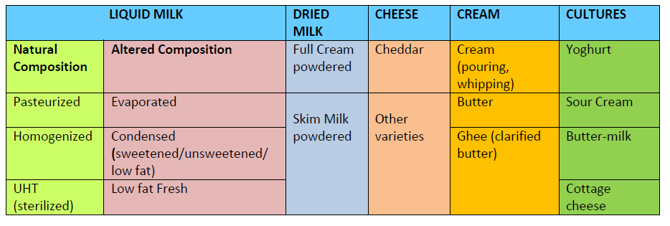

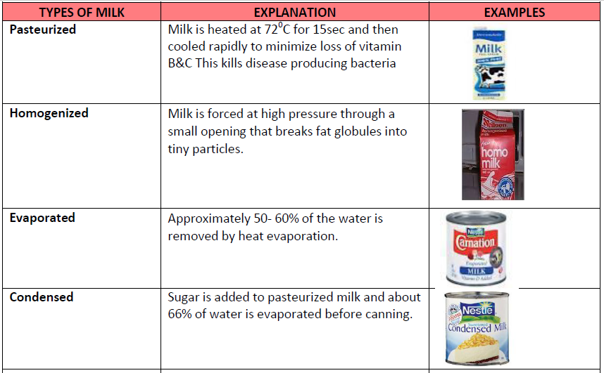**MILK PROCESSING**

\

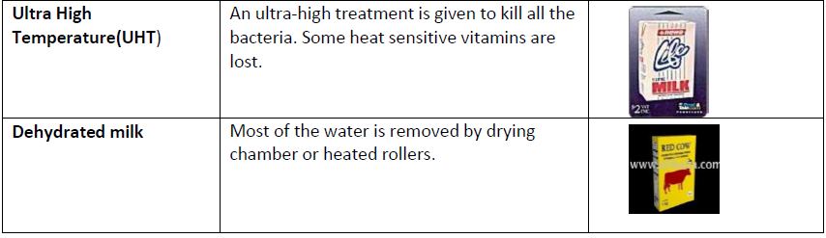

**STORAGE OF MILK**

* Damp air can cause the dried milk to harden and go bad. Dried or powdered milk will last for a long time if it is kept in air tight container
* Liquid milk must be stored in a clean, covered container in a cool place (refrigerator).
* Sweetened condensed milk keeps better than evaporated milk because of the higher amount of sugar in it

**USES OF MILK**

* As a beverage on its own or with other beverages such as tea, coffee and milk shakes.
* Used in cereals and fruit salads.
* As the liquid component in baking which not only helps moisten the mixture but it also contributes to then aesthetic value of the product.
* As a main ingredient in other products such as frozen desserts such as ice cream and other dairy products example cheese and yogurt.
* For cosmetic production such as, facial and body cleansers example face musk and milk baths, body soaps etc.

**ACTIVITY:**

1. Explain why milk is referred to as a **complete food**.
2. Identify two nutritive value of milk
3. State two uses of milk
4. Explain a reason milk is not a perfect food.

**LESSON 40**

**STRAND: HEC 10.2** FOOD AND NUTRITION

**Sub Strands: HEC 10. 2.2** What is Food

**CLO: HEC 10.2.2.1** Demonstrate an understanding of Commonly used foods

**EGG**

**STRUCTURE OF AN EGG**

* **Air space**- exchange of gases. As eggs get older the air space gets bigger
* **Membrane**- prevents moulds and bacteria.
* **Albumen** – acts as a cushion for the developing chick
* **Yolk**- where the chick develops
* **Chalazae**- hold the yolk in the centre of the egg.
* **Shell**- porous allows the chick to breath and protects inside the egg.

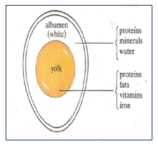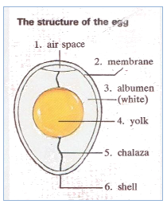

**FOOD VALUE OF AN EGG**

Eggs provide important nutrients; proteins, fats, iron and vitamin A. There is a small amount of calcium, phosphorus, sulphur, Vitamins A and D. Although eggs are nutritious, they should be eaten in moderation.

**CHOOSING EGGS**

* Buy eggs in small quantities as eggs do not stay fresh for long
* Buy eggs from a reliable grocer.
* The shells of fresh eggs feel slightly rough.
* Fresh eggs feel heavy.

**COMMON METHODS OF COOKING EGGS**

* Boiling
* Frying
* Poaching
* Baking

**TEST FOR FRESHNESS**

* Place an egg in a glass of salt water. (½ tsp of salt to 1 glass of water).

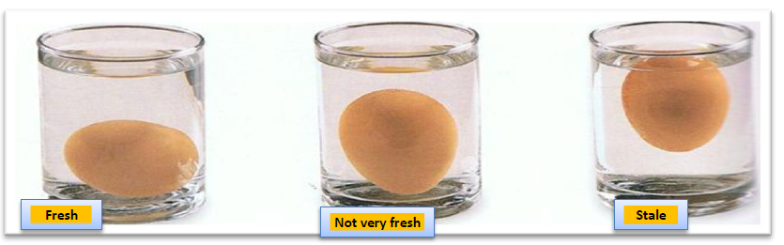

**USES OF EGGS**

|  |  |  |
| --- | --- | --- |
| **CULINARY USED** | **METHOD** | **EXAMPLES 0F DISHES** |
| As a main dish | Eggs can be used in place of meat and fish in a main dish. They are easily digested and, when cooked in dishes such as steamed eggs and meat or omelette. Are especially suitable for invalids, children and elderly people | Egg curry |
| Binding | Eggs can be used to bind ingredients together as they are coagulated when cooked | Hamburgers, Patties, Omelettes |
| As a raising agent | Whisked eggs hold air and this helps to make soufflés and sponge cakes light. | Cakes |
| Coating | Coating batters use whole eggs and breadcrumbs to provide a coating or protection for the food item prior to cooking. | Fried or deep fried foods ,such as fish, meats and vegetables. |
| Enriching | Whole eggs add flavour and nutritional value. | Cakes &Puddings  Pasta |
| Emulsion | Whipped egg yolks can hold other ingredients together that do not normally mix, such as oil and vinegar. | Mayonnaise |
| Garnishing | Sliced, sieved or chopped hard boiled eggs can be used as a garnish. | Fried rice, potato salad |
| Glazing | Beaten whole egg or yolk brushed onto food items before baking will give it a gloss or glazed finish | Bread rolls Duchesse potatoes |
| Thickener | Beaten egg yolks will coagulate and hold a liquid in suspension when heated. | Soups, Custards |

**STORING EGGS**

* Store eggs in a cool place, like the refrigerator, as soon as you buy them.
* Place the eggs with the round side up so that the yolk will remain in the centre and will not dry up.
* Store eggs away from strong smelling foods like garlic and onion. The porous shell of an egg will absorb the smell.
* Do not wash eggs. Washing removes the protective film on the shell and allows bacteria to enter the eggs. If they are dirty, wipe them with a damp cloth.
* Store cracked eggs in a covered container in the refrigerator. Use them as soon as possible.

**NOTE**

The formation of a black ring around the yolk after boiling makes it unappetizing in colour though the nutritional value is not affected.

**Cause**: Boiled egg(s) overcooked /not cooled properly in water.

**Prevention**: Cool boiled eggs immediately under running water

**ACTIVITY:**

1. The picture of the egg shown on the right indicates that the egg is
   1. fresh. **Water**
   2. stale.
   3. not very stale.
   4. not very fresh.
2. Black rings around the yolk of hard boiled eggs is caused by
3. placing the eggs in hot oven.
4. leaving the eggs in warm water.
5. over cooking and not being cooled properly.
6. placing the eggs in cold water immediately after boiling.