**HOME ECONOMICS YEAR 10 LESSON NOTES**

**WEEK 4**

**LESSON 35**

**Strand**: HEC 10.3 CLOTHING AND TEXTILES

**Sub strand**: **HEC 10. 3.5** Patterns /Designs

**CLO: HEC 10.3.5.2** Understand and competently use commercial patterns in construction of an article.

The Pattern Catalogue

The Pattern catalogue is a fashion directory where one can choose the latest pattern styles and find information on suitable fabrics and accessories. It is grouped into categories such as:

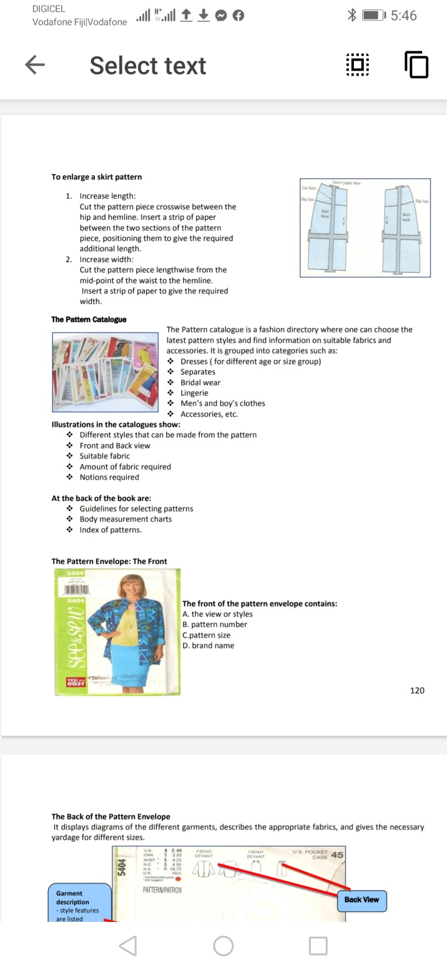 Dresses ( for different age or size group)

 Separates

 Bridal wear

 Lingerie

 Men’s and boy’s clothes

 Accessories, etc.

**Illustrations in the catalogues show:**

 Different styles that can be made from the pattern

 Front and Back view

 Suitable fabric

 Amount of fabric required

 Notions required

**At the back of the book are:**

 Guidelines for selecting patterns

 Body measurement charts

 Index of patterns.

**The Pattern Envelope: The Front**

**The front of the pattern envelope contains:**

A. the view or styles

B. pattern number

C. pattern size

D. brand name

**The Back of the Pattern Envelope**

It displays diagrams of the different garments, describes the appropriate fabrics, and gives the necessary yardage for different sizes.

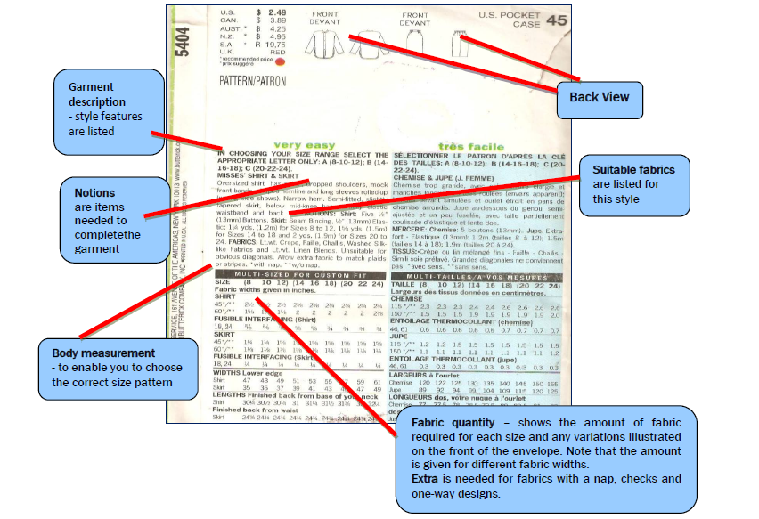

**ACTIVITY**

1. What is pattern catalogue?
2. List any **two** pieces of information that are found at the back of a commercial-pattern envelope.
3. Define notions.

**LESSON 36**

**Strand**: **HEC 10.3** CLOTHING AND TEXTILES

**Sub strand**: **HEC 10. 3.5** Patterns /Designs

**CLO: HEC 10.3.5.2** Understand and competently use commercial patterns in construction of an article.

**Pattern Markings**

Commercial patterns are made from tissue paper and are printed with different marks or symbols to help you cut out the garment correctly. Patterns are usually for one side of the garment. It is important for the beginners to spend some time reading the instructions given on the pattern pieces before cutting them out, as this will avoid any mistakes being made.

Pattern markings on commercial patterns include those that:

**1. Help to identify pattern piece required:-**

(a) Pattern number

(b) Pattern size

(c) Letter – to identify pattern piece required

(d) Name of pattern piece

**2. Give directions for cutting out:-**

(a) ______ cutting line = heavy solid line around the pattern

(b)  Scissors = cutting position

(c) Straight grain arrow = place this line on the straight grain of the fabric or parallel to the selvedge.

(d) Place this line on the fold of the fabric, along the straight grain.

(e) Seam allowance (usually 1.5 cm) - the space between the cutting line and the sewing line.

(f) Printed instructions

(g) Number of pieces to cut, e.g. cut 1

(h) Centre front and centre back positions

(i) Double lines = alteration lines, i.e. shorten or lengthen here.

**3. Gives directions to aid sewing:-**

(a) ----- ---- Broken line = stitching line or seam line. Also shown by a *presser foot* on the line.

(b) _ _ _ _ _ ‘Gathering line’ printed along the stitching line. The fabric is to be gathered to fit the pattern piece to which it is to be joined. Dots or notches indicate length to be gathered.

(c) Dots ----- large and small dots indicate correct positions.

(d) Notches or diamond shapes act as guidelines when pinning pieces. They are often numbered.

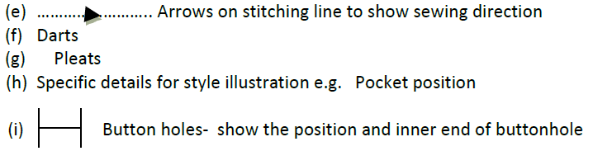

**ACTIVITY**

1.Explain the term commercial patterns.

2.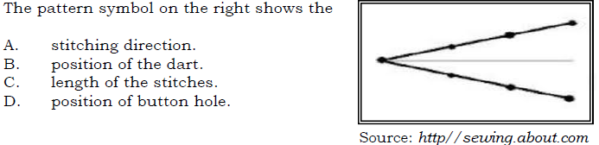

3.

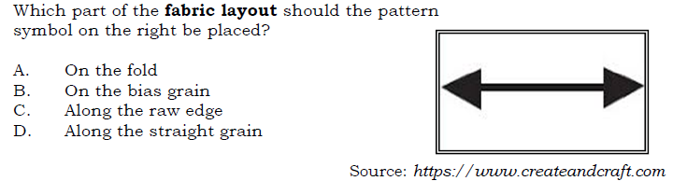

* LAYOUT AND CUTTING OF PATTERN PIECES.

**LESSON 37**

**STRAND: HEC 10.2 FOOD AND NUTRITION**

**SUB STRAND: HEC 10. 2.2 WHAT IS FOOD**

**CLO: HEC 10.2.2.1** Demonstrate an understanding of Commonly used foods

**WHAT IS FOOD?**

Food is essential to the human body just as fuel is to a vehicle. Therefore, it is important to have basic knowledge of food, the type of nutrients they contain and their importance to our bodies.

**MEAT**

* Meat is animal flesh that is eaten as food.
* In the Pacific our major sources meat are pork, beef, chicken, duck, goat and mutton.
* In addition to the fresh meat, we also have processed or canned meats, such as canned beef and canned mutton.
* White meats include chicken, duck and fish.
* Red meats include pork, beef and lamb. It is important to know if meat is red or white because eating too much red, fatty meat can lead to heart disease.

**NUTRITIVE VALUE OF MEAT**

|  |  |
| --- | --- |
| **Nutrient** | **Composition** |
| Protein | Very high biological value of main protein- myosin. |
| Fat | All meat, even the leanest meat contains fat. The amount of fat depends on the age, type of animal and the type of meat. |
| carbohydrates | Very little found in the liver in the form of glycogen. |
| Vitamins | Good source of B group vitamins (thiamine, riboflavin and niacin) found in liver and kidney. Vitamin A in liver. Vitamin C is lacking in all meat |
| Minerals | Contains iron in liver and kidney. Small amounts of Sulphur in most meats. Offal is rich in phosphorous. |
| Water | Most meat contains about 70% water. |

**TYPES OF MEAT**

|  |  |  |
| --- | --- | --- |
| **RED MEAT** | **WHITE MEAT** | **ORGANS** |
| *Beef  *Veal (beef up to 1 year old) *Lamb  *Hogget (sheep from 1-2 years old)  *Mutton(sheep from 2 years old) *Pork/ ham *Goat | *Chicken  *Turkey  *Goose  *Duck  *Wild game  *Fish  *Crab  *Lobster  *Mussels | *Liver  *Heart  *Kidney  *Brains  *Sweetbread  *Tripe |

**MEAT STORAGE**

Meat is a perishable food. The major surface of meat encourages bacteria to grow. Therefore meat must be stored carefully.

|  |  |
| --- | --- |
| **Storage of Raw Meat** | **Storage of Cooked Meat** |
| * It is essential that raw meat and poultry are refrigerated promptly after purchase and remain refrigerated until ready to be cooked. * It is important to keep raw meat in a sealed container or wrapped container to avoid contamination with other foods such as vegetables or butter. * Store meat in the coldest part of the fridge. * Meat can also be dried or salted to keep for later use. * Do portion pack as per family need. | * Cooked meat, poultry and seafood must never be left at room temperature for longer than two hours. * Keep hot food in an oven or on a stove, above 60◦C until it is ready to be served. If not eaten within two hours, cooked meals should be refrigerated. * Do not cover hot pieces of meat before refrigerating. * Place meat uncovered in the fridge until it cools. Then cover cooled meat with a lid or firmly wrap it with cling wrap. |

**METHODS OF COOKING MEAT**

* Meat can be cooked in many different ways.
* Tough cuts of meat can be cooked using long, slow, moist method of cooking such as boiling and stewing, whereas lean, tender cuts are suitable for roasting, grilling and frying.

**MAKING TOUGH MEAT TENDER**

* Some types of meat are tough and must be made tender so we can chew it.
* If you live in town where meat is very expensive, you can buy cheaper pieces of meat, which are usually tough.
* Although these may be cheaper, their nutrient values are the same as the more expensive pieces.
* Here are some ways of making this meat tender so they will taste good and not take too long to cook.
* Meat can be cooked with pieces of green pawpaw flesh.
* Wrap meat in pawpaw leaves a few minutes (the longer the better) before cooking.
* Soak or marinate meat in soya sauce for at least half an hour before cooking.
* Meat can be pounded using a heavy knife, a chopper or a special pounder. This softens or tenderizes the meat.

**ACTIVITY:**

1. Identify three different ways in which to tenderise meat.
2. State two methods of cooking meat.
3. Explain a reason why is it important to keep raw meat sealed in a container.