**YEAR 10 LESSON NOTES**

**WEEK 2:HOME ECONOMICS**

**LESSON 29**

**STRAND**: HEC 10.3 CLOTHING AND TEXTILES

**Sub Strands:** **HEC 10. 3.3** Clothing Needs & Selection /Clothing consumer

**CLO**: **HEC 10.3.3.1** Discuss wardrobe planning for teenagers

* Wardrobe planning involves determining what types of clothing you need, necessary number of clothing articles, amount to spend and time to make the purchase.
* Before shopping, consider what you already own. Make a list of what you have and what you need but do not have.
* Keep the inventory up to date by adding the new clothes you buy and removing those that are no longer suitable.

**Factors influencing clothing needs**

1. **Occasion**

* To be part of a group we use clothing as a means of being accepted.Whether recognized or not, every occasion has a written or unwritten dress code.
* The most important thing to remember is that the clothes you buy must suit the purpose for which they are bought.
* Clothes for school, work or weekend wear may not be suitable to wear to a special function.

2**. Personal preference**

* Clothing is used as a means of self-expression and to convey moods and feelings to others.
* Teenagers begin to need clothes which make them confident about themselves.
* Yourself image is the total picture of the feeling and attitude you have about yourself. It is what makes you an individual set apart from everyone else.
* Your personal preference may not be in agreement with how other people see you.
* Since standards of dress differ, you may consider yourself well-dressed while others may feel your clothing is average or poor. Choose styles which you feel comfortable in.

3. **Colour of fabric**

* Colour comes from light and has great potential to affect the way things look.
* Understanding the effects of warm and cool colours can make wardrobe planning easier.
* Colours also have the ability to make objects look larger or smaller.
* If you what to look larger, choose clothes in bright, warm colours.
* If you like to look smaller, look for cool colours and darker shades. You can use colour to give the illusion you want.

4. **Climate**

* Clothing can also protect us from the environment.
* When choosing clothes, consider where you live and what the climate is like.
* You may not need to have many woolen garments if you live in the western part of Viti Levu.
* Choose fabrics and clothes which are easy to care for. This will save you time on laundering.

5. **Budget**

* Think about the cost on how much money you have to spend on new clothes.
* Plan your purchases over a period of time.
* Be sure that what you buy is right for you, will fit into your wardrobe and lifestyle, is really a good buy.
* Compare prices and quality on a specific item for this is a good way to get the most for your money.

6. **Accessories**

* A**ccessories are additional items that are worn with your clothes to complement your outfit. e.g** Hats, scarves, purses, ties, jewelry, belts.
* Fashions change rapidly in this items, but as a rule they are less expensive than clothing.
* Inexpensive accessories give you a chance to have fun with fad items.

**ACTIVITY**

1.Define wardrobe planning.

2.Explain how **personal preferences** influence clothing needs for teenagers.

3.Accessories are worn to compliment an outfit.

List **three** accessories that can complement a black blouse or shirt worn over a denim skirt or pants.

**LESSON 30**

**STRAND**: HEC 10.3 CLOTHING AND TEXTILES

**Sub Strands:** **HEC 10. 3.3** Clothing Needs & Selection /Clothing consumer

**CLO**: **HEC 10.3.3.1** Discuss wardrobe planning for teenagers

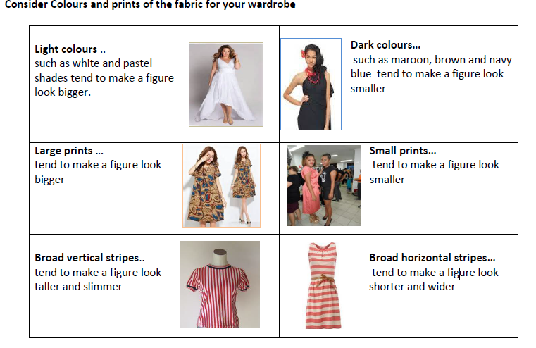

**Other factors to be considered by teenagers are**

1. mix and match ; using separates to match and contrast what is to be worn e.g. A matching skirt and blouse.

2. have clothes for more than one occasion.

3. clothes are bought according to ones *need* for the occasion and not according only to *wants.*

4. make an effort to save money on clothes or learn to sew own clothes.

5. recycling and renovating greatly helps in increasing ones collection of clothes.

6. cultural consideration; have special cultural clothing items readily available for that special occasion eg. Sulu and jaba, salwar khameez etc.

**Ways of improving teenager’s wardrobe**

1. Look through your closet: separate clothes you love and the ones you hate

2. Reason out why you love those clothes: study the pieces that you love for similarities in style and shape

3. Dispose clothing that you hate: throw out clothing with holes or stains. - If cannot be parting with a piece for sentimental reasons, store it in a box kept separate from your wardrobe.

4. Evaluate clothing you feel neutral about: determine what pieces look good on you and which do not. - Hang on to clothing that fits you well or has potential. These pieces can be spiced up.

The value of having a well-planned wardrobe and accessories may be as follows:

* Money will not be wasted on unsuitable purchases
* Hasty buying of garments which are not really necessary will be avoided
* The garments of your wardrobe will look as though they belong to each other and variety may be achieved by interchanging
* You will have suitable clothes for all occasion
* Clothes which have been carefully chosen will give you more pleasure
* Fewer basic accessories such as shoes, gloves and handbags will be needed
* Variety may be obtained by the addition of smaller articles of accessories such as hats, blouses and scarves.
* You will be better dressed.

**ACTIVITY**

1.A black skirt which can be worn with two different coloured blouses on different occasions is an example of

A. recycling.

B. renovating.

C. accessories.

D. mix and match.

2. Name **one** factor that influences a teenager’s choice of clothing.

3. Explain **one** value of having a well-planned wardrobe.

**LESSON 31**

**Strand:** HEC 10.3 Clothing and Textiles

**Sub strand: HEC 10. 3.5** Patterns /Designs

**CLO: HEC10.3.5.1** Recognize the different figure types and relate appropriate designs for the different figure types

**FIGURE TYPES PRINCIPLES AND ELEMENTS OF DESIGN**

|  |  |  |
| --- | --- | --- |
| **FIGURE TYPE** |  | **DESCRIPTION** |
| **1. Rectangle or Banana** | Shoulders ,waistline and hips are of the same size. | * The banana figure, also known as "straight" or "ruler," is generally rectangular without a defined waist. * Those with an athletic body, smaller bust size, and toned arms often fit into this category. * If your waist measures less than 9 inches (23 cm) smaller than your bust or hips, you are banana shaped. |
| **2. Inverted Triangle or Apple shape** |  | Apple shaped figures are rounded, with larger busts and smaller hips.  The apple figure is the opposite of the pear -wider at the top, smaller at the bottom.  Women who are apple shaped have broader shoulders, larger busts, and narrower hips.  They also tend to carry most of their weight in their midsection. |
| **3. Triangle or Pear shape** |  | Pear shaped figures have small busts and larger hips.  The pear figure looks like a triangle -- smaller at the top, wider at the bottom. Pear  shaped women often have a smaller bust and carry most of their weight in their hips,  and thighs. Generally, the hips are more than 5cm (2 inches) larger than the bust and the  waist about 24cm(9 1/2 inches) smaller. |
| **4. Hourglass** |  | Hourglass figures are larger at the bust and hips and smaller at the waist.  The hourglass figure is true to its namesake; the bust and hips are about the same size,  with a small waist. A woman's figure is considered a "perfect hourglass" if the  difference between her bust and waist measurements and waist and hip  measurements is at least 23cm (9 inches). |

**SUITABLE CLOTHING FOR DIFFERENT FIGURE TYPES**

|  |  |  |  |  |
| --- | --- | --- | --- | --- |
| **FIGURE TYPE** | **LINE** | **COLOUR** | **DESIGN** | **FABRIC** |
| **1.Rectangle or**  **banana shape:**  **straight or ruler** | Horizontal line,  Yokes &belts,  pockets | Contrasting,  Separates Light  bright. | Waist/hipline  interest.  Flared & cuffed  trousers.  Gathered  skirts/pleats. | Bulky textures,  Plaids, checks,  florals. |
| **2.Inverted or apple**  **shape** | Vertical.  Horizontal on hip. | Contrast with darker  colours on top. | Simple bodice.  U or V Neckline.  Plain sleeve. | Lightweight.  Plain textures for  tops |
| **3.Triangle or pear**  **shape** | Horizontal in upper  area  Yokes, gathers, tuck. | Contrasting.  Bright prints &  patterns on top. | Neckline interest.  Shoulder pads.  Simple skirt pattern. | Texture fabric for  tops.  Simple texture for  skirts or trousers. |
| **4.Hour-glass** | Vertical | One colour | Slimming dresses | Simple and lightweight |

**ACTIVITY**

1. List the four figures types

i. _____________________________________

ii. _____________________________________

iii. _____________________________________

iv. _____________________________________

2. Study the illustrations of the two figure types given below and answer the questions that follow.

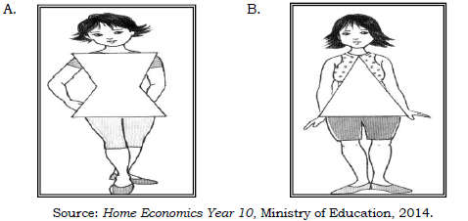

(i)Name the **two** figure types shown above.

(ii) Identify **one** suitable colour for A.