RATU NAVULA COLLEGE
WEEK 1 NOTES/ ACTIVITIES/ WORKSHEET FOR YEAR 10 ENGLISH
COMPILED BY: MRS ALI
6-29-2021

LESSON NO: 47 | TOPIC: LANGUAGE  Types of Sentences- Simple, compound, Complex
STRAND | Reading and Viewing/Listening and speaking
SUB STRAND | Language features and rules
LEARNING OUTCOME | Differentiate between the various sentence types.

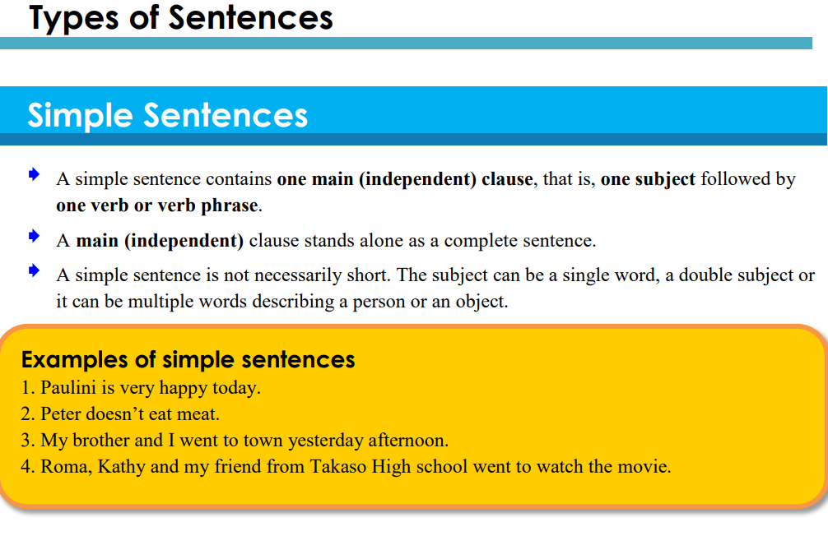
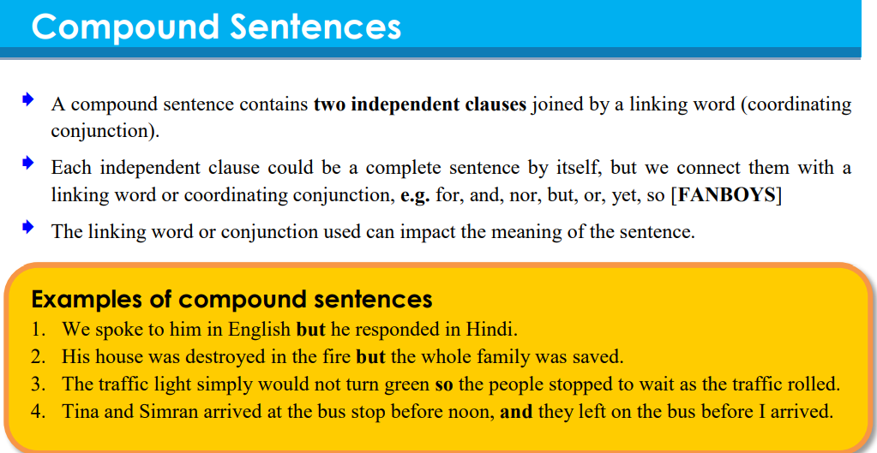
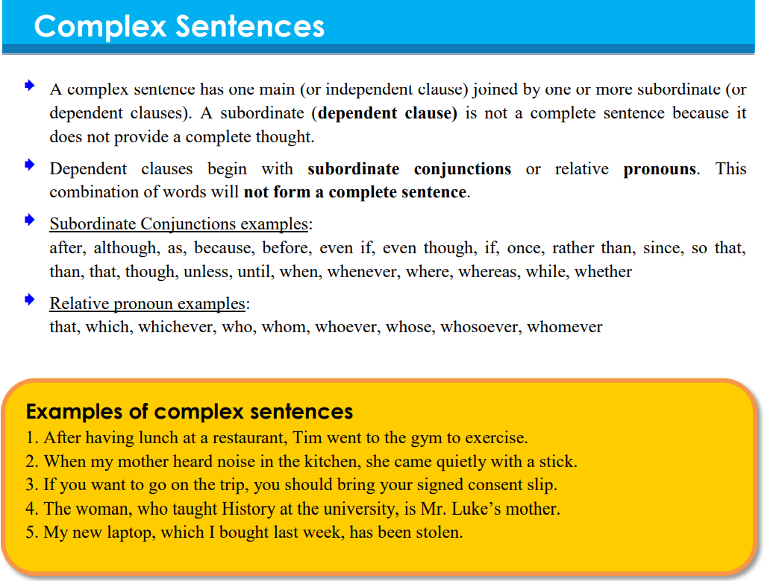

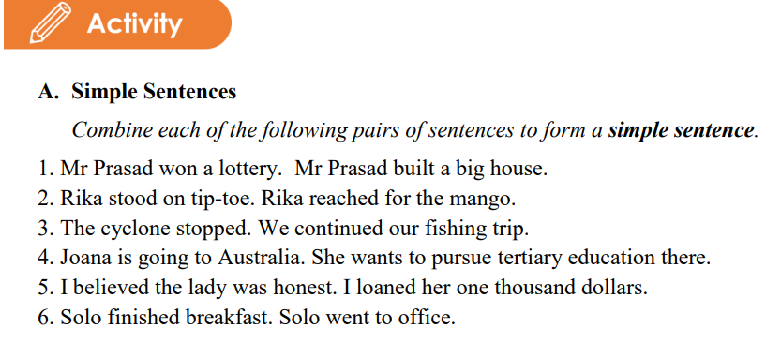
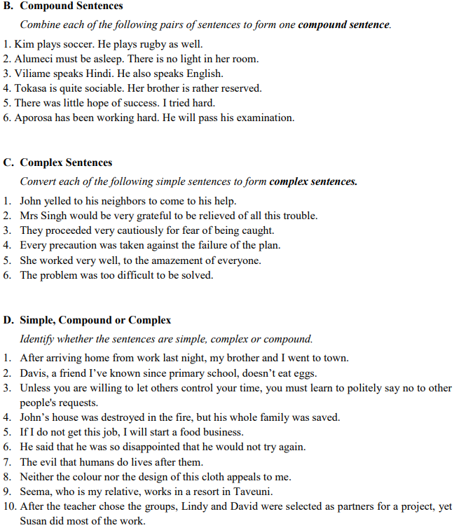

LESSON NO: 48 | TOPIC: Comprehension 4/5
STRAND | Reading and Viewing
SUB STRAND | TEXT TYPES: MEDIA TEXT, EVERYDAY COMMUNICATION & LITERARY TEXT
LEARNING OUTCOME | -Read with understanding and analyse the passage by answering given questions.  -recall important details.
Read the story below and answer the questions that follow. Passage 1

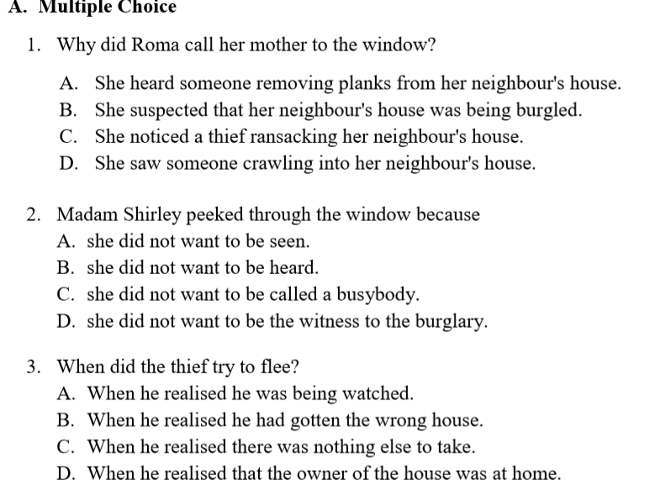 | 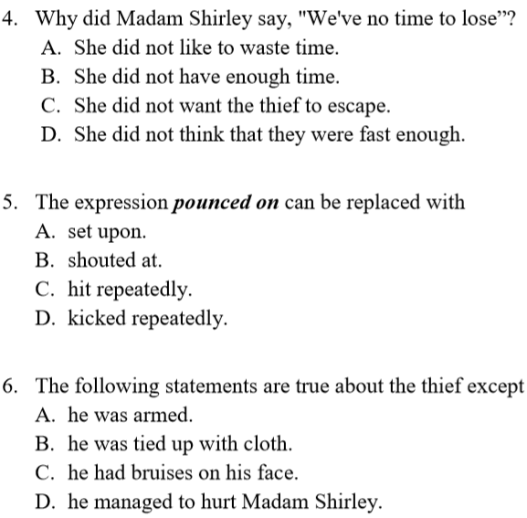

PASSAGE 2

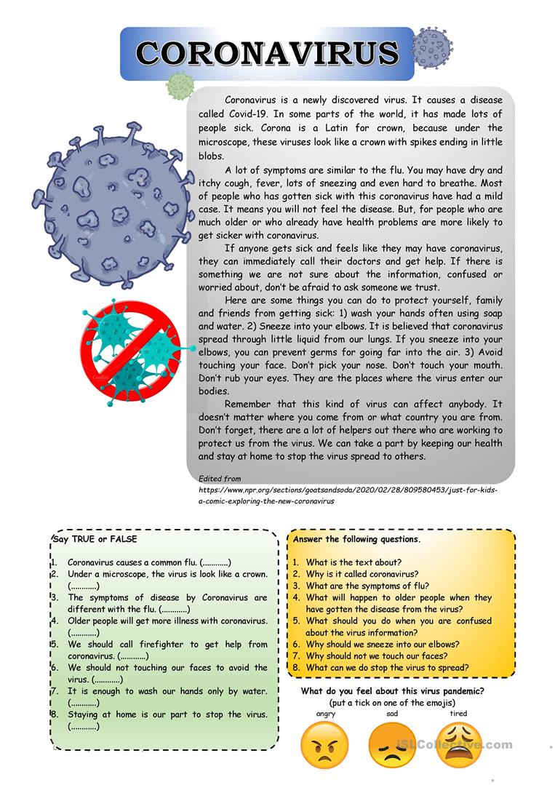

LESSON NO: 49 | TOPIC: LANGUAGE Subject verb Agreement
STRAND | Reading and Viewing /Writing and Shaping
SUB STRAND | Language features and rules
LEARNING OUTCOME | -Know the subject and verb in a sentence  -learn the agreement rules.  -apply agreement rules correctly in sentences.

A subject is a noun or pronoun. A verb is the action performed by the subject.
Matching Subjects with Verbs
Verbs must agree with subjects in number and in person (1st/2nd/3rd).
EXAMPLE: The dog drinks his water every day.
Singular subject Singular present tense verb.
- Singular subject takes singular verb.
- Plural subject takes plural verb.

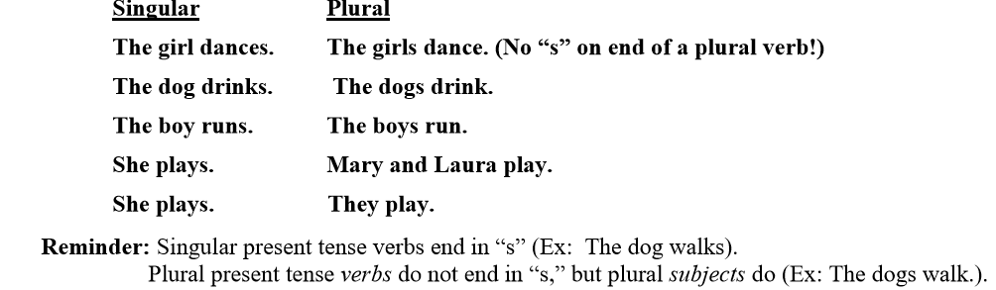

- A verb must agree with its subject, not with the object of a prepositional phrase, which often comes between the subject and the verb.
EXAMPLE: The boxes of cake mix are on the shelf.
Plural subject Plural verb
Prepositional phrase

4.
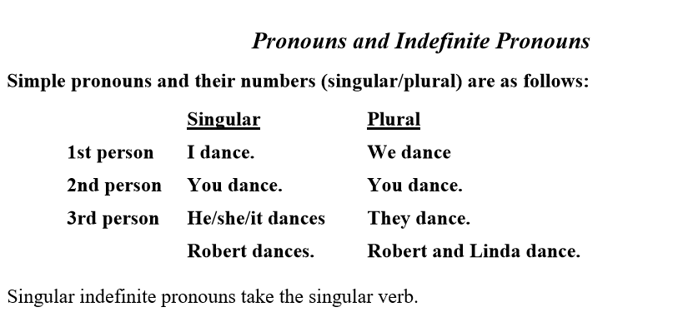
EXAMPLE: Everyone in the class supports the teacher

SINGULAR SUBJECT SINGULAR VERB
5. Other singular indefinite pronouns are anybody, anyone, anything, each, either, every, everybody, everyone, everything, neither, nobody, no one, somebody, someone, something.
EXAMPLE: Every man, woman, and child was/were given a book. (“was”)
Each student is/are required to pass the final exam. (“is”)
Since “Every” and “Each” are both indefinite pronouns, they take singular verbs.

6. Indefinite pronouns such as few, many, and several are plural and take plural verbs.
EXAMPLE: Both of my dogs has/have collars. (“have”)
Several of my friends is/are sick. (“are”)
Since “Both” and “Several” are plural indefinite pronouns, they take the plural verbs “have” and “are.”

7. Special Cases
If a sentence has two subjects connected by or/nor, either/or, or neither/nor, the verb must agree with the second subject (the subject closer to the verb.)
EXAMPLE: Neither the dogs nor the cat is going outside.
SUBJECT 1 (PLURAL) SUBJECT 2 (SINGULAR) SINGULAR VERB
However, if a sentence begins with “neither” or “either” without the “or/nor” combination, the verb is singular.
EXAMPLE: Neither of the two stores is open.
Either store is fine with me.
Underline the correct answer.

LESSON NO: 50 | TOPIC: PERSONAL WRITING  Conversation/ dialogue writing
STRAND | Writing and Shaping
SUB STRAND | TEXT TYPES: MEDIA TEXT, EVERYDAY COMMUNICATION & LITERARY TEXT
LEARNING OUTCOME | -know the features and style of dialogue writing.  Plan and write a dialogue.

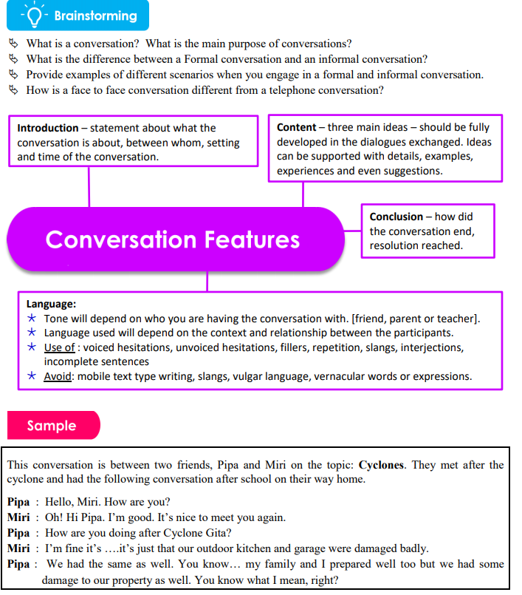
Class Activity
Theme : Obedience
Plan and write a conversation between you and your friend regarding the breech of curfew hours during school holidays.

