RATU NAVULA COLLEGE
YEAR 10 ENGLISH
HOME STUDY PACKAGE
WEEK 10

Compiled by Mrs Ali ( 31/8/2021)

Contents: Lesson 83- 86

Lesson No. 83 | Mass Media, Library and Dictionary
Strand | Reading and Viewing/ Writing and Shaping
Sub Strand | Text types and Communication/ Language features and rules
Learning outcome | -Attempt activity on mass media, library and dictionary through recall.  - Analyse dictionary entry correctly.

PART I MASS MEDIA (3 marks)
Use your knowledge of Mass media to answer the following questions in the spaces provided in your Answer Booklet.
1. Write the name of your favourite radio or television programme. (1 mark)

2. How does this programme benefit you? (1 mark)
3. State one advantage of newspaper over radio. (1 mark)
PART II LIBRARY (3 marks)
Match the terms in Column A with their correct definitions from Column B. Write down the letter of your answers beside each number in the Answer Booklet.
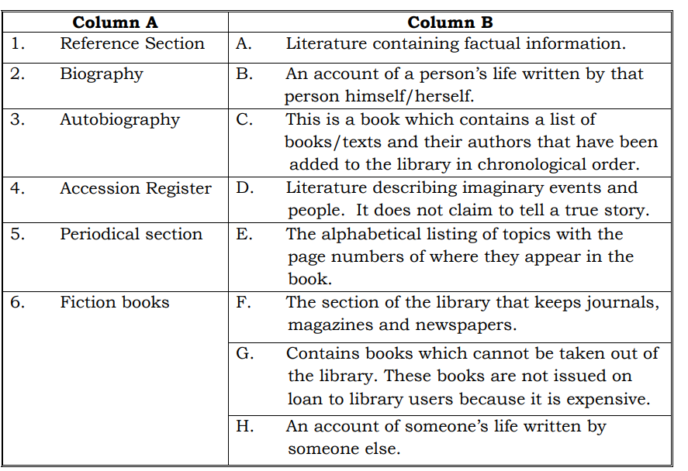
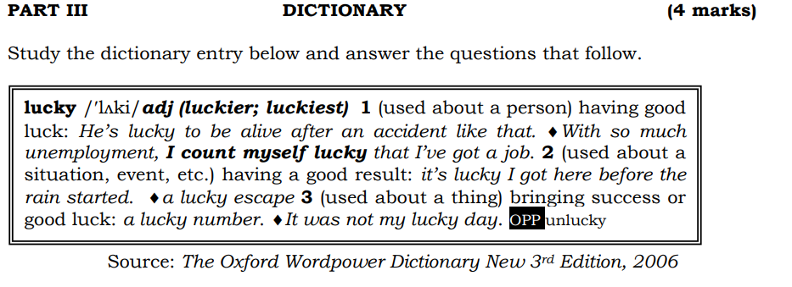
1. Write the long form of the following abbreviations:
(i) adj
(ii) OPP (2 marks)
2. What information comes immediately after the headword? (1 mark)
3. Which definition of the headword does the following sentence illustrate? (1 mark)
He is the luckiest boy in his class.

Lesson No. 84 | Reading comprehension
Strand | Reading and Viewing/ Writing and Shaping
Sub Strand | Text types and Communication
Learning outcome | -Read and analyse the main ideas given in the text.  -Enjoy and appreciate reading.
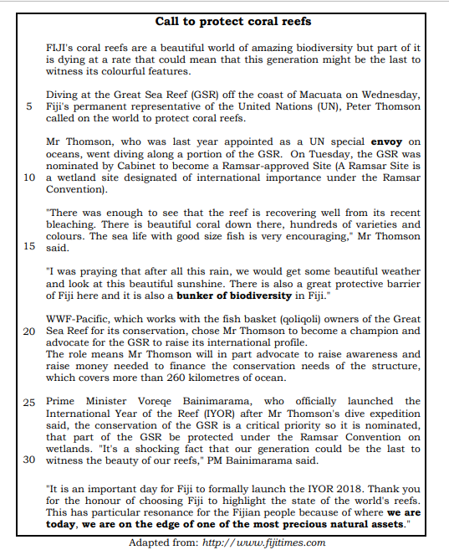

MULTIPLE-CHOICE QUESTIONS
Circle the letter of the best answer in the Answer Booklet.
1. According to paragraph 1, why is there a call to protect coral reefs?
A. Coral reefs are disappearing.
B. There is not enough being done to protect coral reefs.
C. The diving expedition identified serious issues affecting reefs.
D. The United Nations has declared all nations to protect reefs.

2. Which word is similar in meaning to the word envoy used in line 7?
A. enemy
B. salesperson
C. representative
D. person in charge

3. A Ramsar-approved Site is
A. the Great Sea Reef of international importance.
B. the ocean which is used for diving under the Ramsar Convention.
C. the international area of sea which protects the marine ecosystem.
D. a wetland site of international importance under the Ramsar Convention.

4. The expression bunker of biodiversity in line 18 means
A. place with scarce marine resources.
B. the reefs which need to be protected.
C. area which shelters large number of different plants and animals
D. area of the Exclusive economic zone prescribed by the UN convention, which belongs to Fiji.

5. As mentioned in paragraph 5, two main significance of coral reefs are that it
A. supports growth of biodiversity and protects fish.
B. is a protective barrier and habitat for marine organisms.
C. provides beautiful weather and beautiful sunshine.
D. protects the coast from high waves and provides beautiful weather.

6. The WWF Pacific works with the (qoliqoli) owners of the Great Sea Reef for its
A. biodiversity. C. fishing rights.
B. conservation. D. traditional rights.

7. The two roles that Mr Thomson has to play as WWF-Pacific’s champion and advocate for the GSR are to
A. conserve sea resources and raise money.
B. raise GSR’s international profile and conserve resources.
C. raise awareness and raise money needed to finance the conservation needs of the structure.
D. promote financial stability of conservation programmes for the GSR and protect coral reefs.

8. According to paragraph 6, GSR covers __________ kilometers of ocean.
A. 26 B. 260 C. more than 26 D. less than 260

9. The International Year of the Reef was officially launched by
A. Peter Thomson C. the Minister for Environment
B. the United Nations D. the Prime Minister Voreqe Bainimarama

10. The sentence “…we are on the edge of one of the most precious natural
assets” in the last paragraph, indicates that
A. coral reefs are a precious asset.
B. coral reefs are at an immediate danger of extinction.
C. coral reefs will be there for many generations to come.
D. Fiji has developed good programmes to safeguard coral reefs.
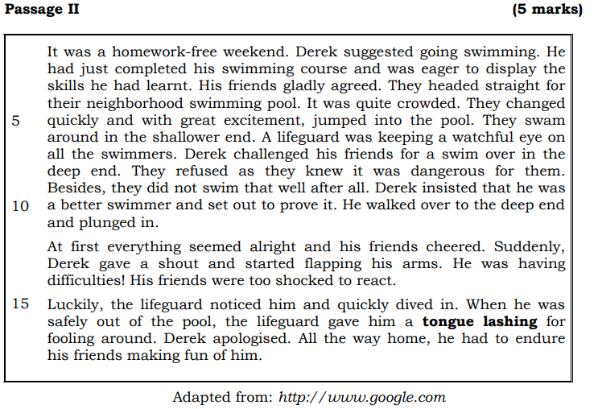QUESTIONS
Circle the letter of the best answer in the Answer Booklet.
1. Derek and his friends went swimming during the
A. break. C. weekday.
B. weekend. D. holidays.

2. Derek suggested swimming as he wanted to
A. test the lifeguard.
B. complete his swimming course.
C. show his swimming skills to his friends.
D. teach his friends the skills he had learnt.

3. The lifeguard was keeping a watchful eye on all the swimmers to ensure that
A. all people entering the pool are checked.
B. people are not noisy and maintain the pool.
C. all swimmers are safe and to provide support.
D. people do not throw rubbish around the pool.
4. Derek’s friends did not want to swim in the deep end because they
A. wanted Derek to swim alone.
B. knew how to swim well already.
C. knew the lifeguard would be upset.
D. knew they could not swim well enough.

5. Tongue lashing as used in line 16 means that Derek received____________ from the
lifeguard.
A. advice C. warning
B. scolding D. encouragement

Lesson No. 85 | Language and Grammar exercise
Strand | Reading and Viewing/ Writing and Shaping
Sub Strand | Language features and rules
Learning outcome | -Apply correct grammar rules and British English rules to attempt the activity
MULTIPLE-CHOICE QUESTIONS
Circle the letter of the best answer in your Answer Booklet.
1. I took _______ apple from _______ refrigerator and ate it.
A. a…….a C. a…….the
B. an…….a D. an…….the

2. My father ______________ meat from the butcher once a week.
A. buys C. has bought
B. is buying D. will have bought

3. Although he was convicted, everyone believes he is not guilty. Which of the following is a synonym of the underlined words?
A. right C. innocent
B. good D. righteous

4. He is very sensitive ____________criticism.
A. at B. to C. in D. for

5. If I had studied medicine, I _____________ have become a doctor.
A. can
B. may
C. will
D. would

6. We all trust people ____________ speak the truth.
A. who B. whose C. whom D. which

7. ____________Teresia ____________Shima were elected as prefects in their school.
They are extremely happy.
A. Either……..or C. Neither……..nor
B. Both……..and D. Not only……..but also

8. Identify the adverb in the sentence given below.
Don’t speak loudly because we are in the library.
A. we B. speak C. loudly D. library

9. Which of the following words is correctly spelt?
A. ocassion C. pronounciation
B. neccesary D. accommodation
10. Mother said, “___________________________ before watching TV.”
A. finish your homework C. to finish my homework
B. Finish your homework D. To finish my homework

Lesson No. 86 | Reading a poem exercise
Strand | Reading and Viewing/ Writing and Shaping
Sub Strand | Literary text types
Learning outcome | -Read and analyse the poem by answering the questions.  -Enjoy and appreciate reading poems.

Read the poem and answer the given questions.
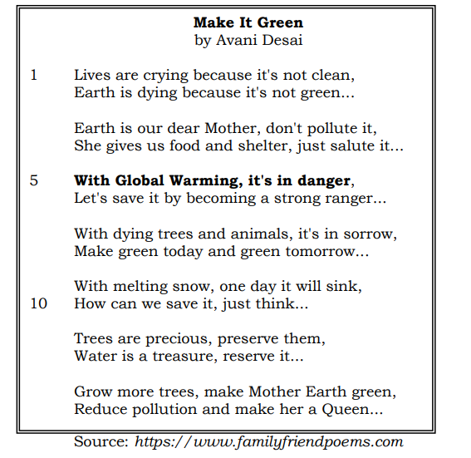
(a) Identify two rhyming words from the poem. (1 mark)
(b) Describe the tone of the poem. (2 marks)
(c) In your own words, explain, With Global Warming, it's in danger (line 5). (2 marks)
(d) According to the poem, what two things can people do to save Mother Earth? (2 marks)
(e) The poet has used words such as Mother Earth and Queen. Explain the effect of using such words. (2 marks)
(f) Identify one stylistic device used by the poet and provide an example. (2 marks)
(g) Explain the main message the poet is trying to put across to the readers. (2 marks)
(h) Explain how the poem is relevant to present day society. (2 marks)
Week 10 Worksheet
