RATU NAVULA COLLEGE
YEAR 10 ENGLISH
HOME STUDY PACKAGE
WEEK 7

Compiled by Mrs Ali ( 10/8/2021)

Contents: Lesson 71 -74

LESSON NO: 71 | TOPIC: FORMAL WRITING Speech of Acceptance
STRAND | Writing and Shaping
SUB STRAND | Text types/Socio cultural contexts and situations
LEARNING OUTCOME | identify the format and style  -plan and draft an acceptance speech.

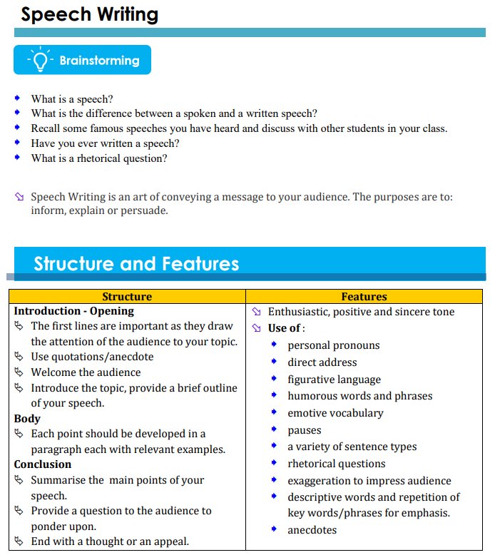
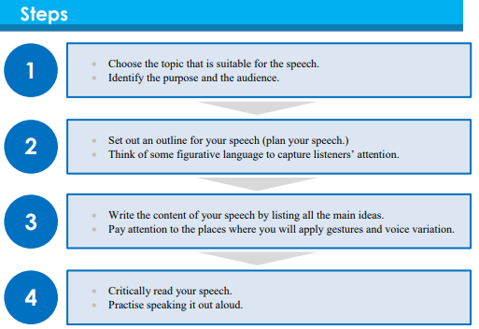

Sample 1
Sample 2
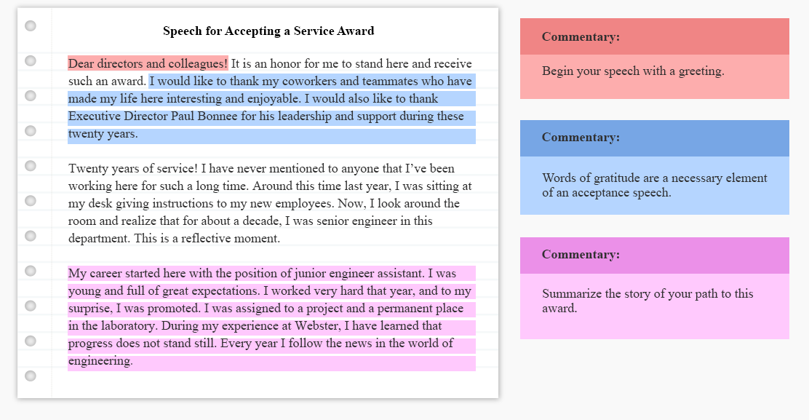
Activity
Plan and write an Acceptance speech
Question
Your school received a donation of gardening tools from Leon Hardware Supplies on World Environment Day. You have been asked by your principal to deliver a speech of acceptance on behalf of the school. Plan and write the text of your speech.

Guideline
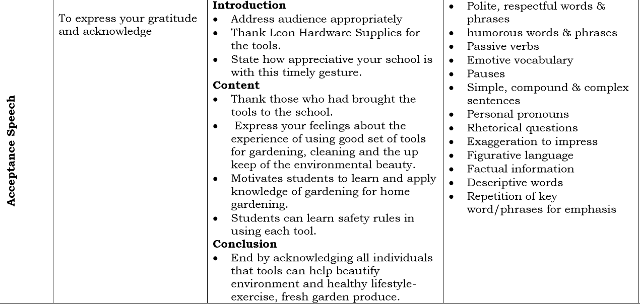
LESSON NO: 72 | TOPIC: PERSONAL WRITING Diary
STRAND | Writing and Shaping
SUB STRAND | Text types/Socio cultural contexts and situations
LEARNING OUTCOME | Plan and write a diary within 30 minutes.
Theme : Unemployment
Plan and write a diary entry about the hardships you and your family faced when your parents lost their jobs during the Covid 19 pandemic.
LESSON NO: 73 | TOPIC: Mass Media, Library , Dictionary
STRAND | Reading / Viewing , Writing and Shaping
SUB STRAND | Text types/Socio cultural contexts and situations
LEARNING OUTCOME | Attempt the activity on mass media, library and dictionary by referring to the notes given in term 1.

There are three parts to this question. All parts are compulsory.
Part I Mass Media (3 marks)
Use your knowledge of Mass Media to answer the questions that follow.
1. List one difference between a magazine and a newspaper. (1 mark)
2. List one similarity between a magazine and a newspaper. (1 mark)
3. Which of the two mediums of communication would you use to get daily updates on the weather in times of disaster? (1 mark)
Part II Library (3 marks)
Use the information shown on the author card catalogue below to answer the questions that follow.
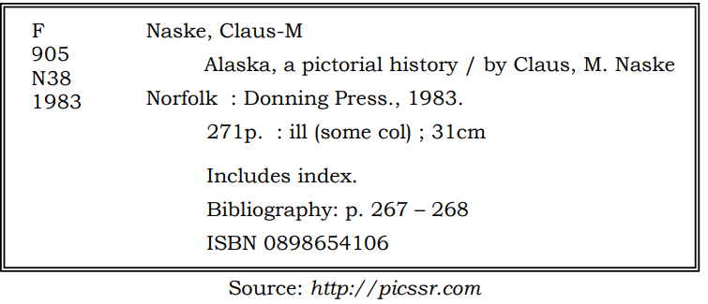
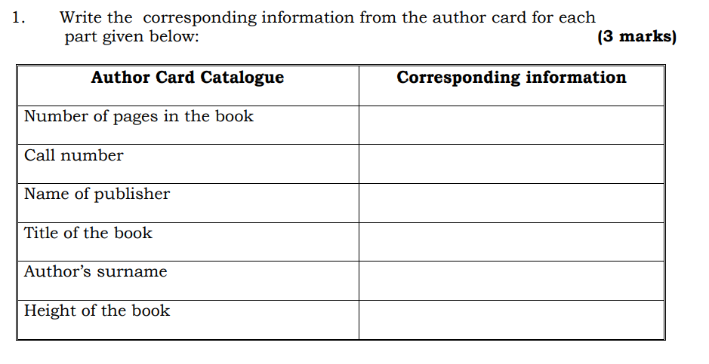
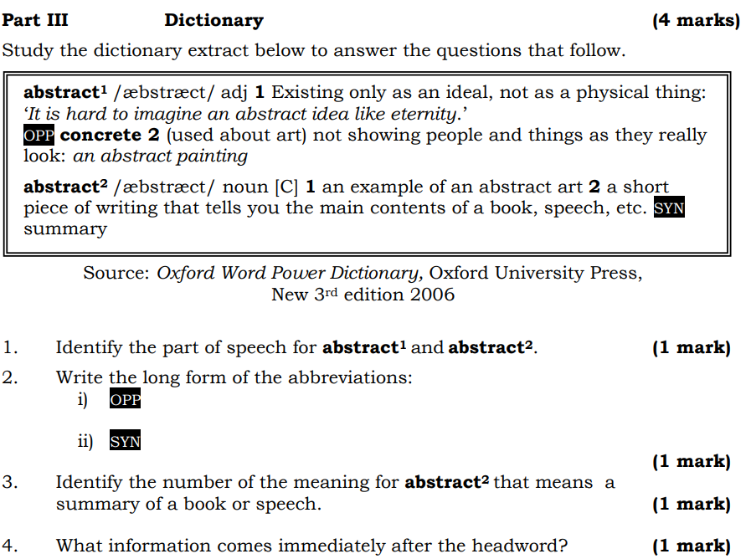

LESSON NO: 74 | TOPIC: Grammar
STRAND | Reading / Viewing , Writing and Shaping
SUB STRAND | Text types/ Language features and rules
LEARNING OUTCOME | Identify the types of pronouns, verbs, nouns, articles, tenses and agreement rules and apply it correctly in sentences.

1. Relative pronoun: who, which, whom, that  -relates two different clauses | 1. This is the man _____ broke the window.  2. The food ____ Pita bought was stolen.  3. That’s the woman ______ house caught fire yesterday.
2. Demonstrative pronoun: this, that, these, those  - used to show/identify nouns | 1. ___________ chair is broken.  2. ___________ clothes are wet.  3. ___________ birds are flying South.
3.Interrogative pronoun: who, which, whom, what, which ever | 1. _________ did she buy?  2. _________ are you talking about?
4. Reflexive pronoun- myself, yourself, themselves, ourselves | 1. You need to take care of ________________.
4. Reciprocal pronoun-used when two or more people do the same thing.eg- each other, one another. | 1.Mary and Tina are talking to ______________.  2. We should love _______ __________.
5. Indefinite Pronoun eg: someboby, somewhere, anything, nothing, no one, everybody, either, , each, enough, everywhere, anybody, few, everyone, anywhere | 1. ___________ one will be fine.  2. _____________ is enough.  3. _____________is going as planned.  4. ______________is possible if you believe.
6. Personal pronoun eg: I, me ,you, your, , he, she, us , our. | 1. Is this _________ book?  2. Sera slipped and broke ______ leg.
7. Phrasal verb- consists of a verb and another element such as adverb or preposition.  Eg: look out, pick up, pass by, move on | 1. ______ _____ while I get my coat. (hold)  2. You’re_____________ _________ with the rent. (fall)
8. Articles eg: a, an, the  a. Definite article: the  b. Indefinite article: a, an | 1. That is _____ excellent pencil.  2.I need ____ kilogram of salt.  3. _____ movie was perfect.
9. Tenses | Change the tense  1. I will go to Lautoka tomorrow. ( present continuous) ____________________________  ______________________________________  2. Dora cleaned the room. (past prefect)  _______________________________________  _______________________________________  3. Jerry was reading for two minutes.. ( past perfect continuous)  ___________________________________________  ___________________________________________
10. Subject verb agreement  -add –s to verb if the subject is singular.  -Do not add –s if the subject is plural.  -Do not add –s if the subject is “I” or “you” | 1. The dog _________ (walk/walks) down the street.  2.The dogs ________ (walk/walks) down the street.  3. I _________ (walk/walks) the dog every day.  4. You _______ (walk/walks) the dog on Tuesday.

Week 7 Worksheet
1a.What is this?  b. Give more examples.___________________  ______________________________________  c. Where will you find this?________________ | 2. What is found in this section of the newspaper?  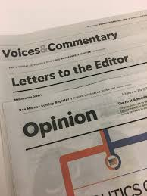

3. Define Periodicals with examples | 4. Dictionary short forms  U – uncountable noun  C – countable noun  Adv – adverb  Adj – adjective  Pron – pronoun  Sing – singular  Pl – plural  WORD ORIGINS  What does the following mean?  [F] -  [B]-  [US] -  [L]-

