RATU NAVULA COLLEGE
YEAR 10 ENGLISH
HOME STUDY PACKAGE
WEEK 6

Compiled by Mrs Ali ( 03/8/2021)

Contents: Lesson 67-70

LESSON NO: 67 | TOPIC: LANGUAGE  ANTONYMS, SYNONYMS AND HOMONYMS
STRAND | Reading and viewing
SUB STRAND | Language features and rules
LEARNING OUTCOME | -Define antonyms, synonyms and homonyms  -use correct antonyms, synonyms and homonyms in sentences.

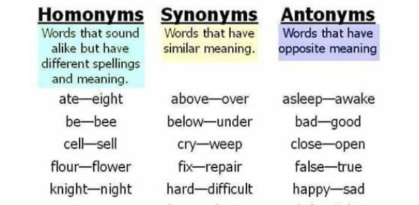

Activity
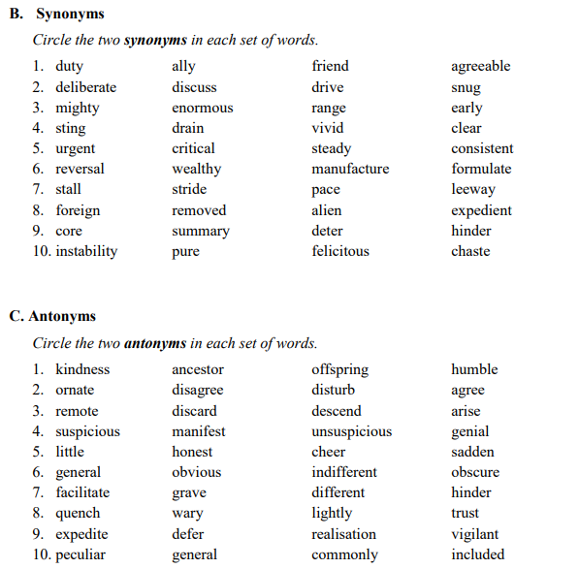

LESSON NO: 68 | TOPIC: LANGUAGE: Auxiliary verbs
STRAND | Reading and viewing
SUB STRAND | Language features and rules
LEARNING OUTCOME | -define auxiliary verbs.  -use correct auxiliary verbs in sentences.

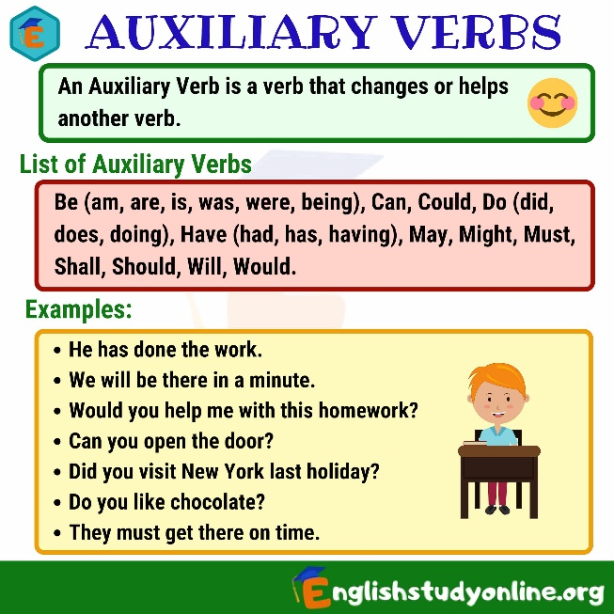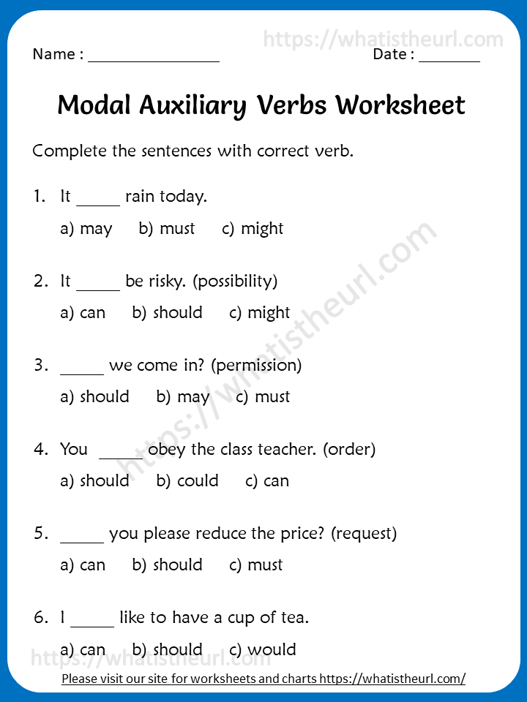
LESSON NO: 69 | TOPIC: FORMAL WRITING: Expository Essay 2
STRAND | Writing and Shaping
SUB STRAND | Text types/Socio cultural contexts and situations
LEARNING OUTCOME | identify the format and style  -plan and write an expository essay correctly within 30 to 40 minutes.
Topic: Causes and effects of unemployment inFiji
Plan and write the essay
Points to consider for the plan
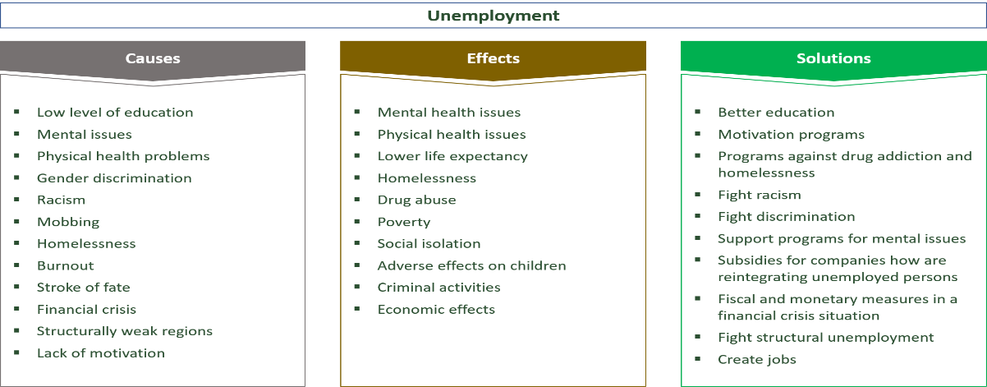

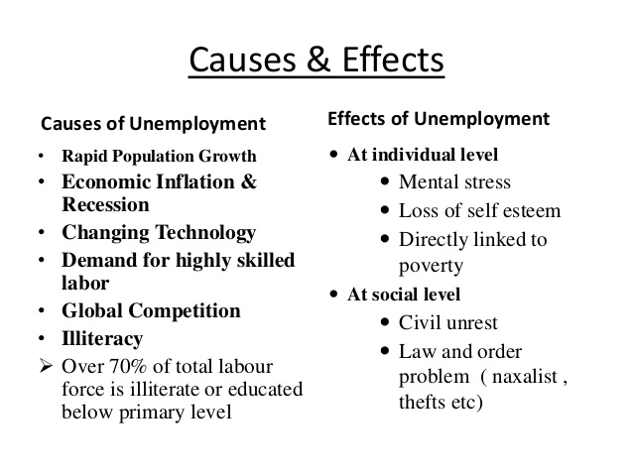

- Covid 19 crisis-closure of hotels/ resorts, businesses.
- Reduced working hours

LESSON NO: 70 | TOPIC: FORMAL WRITING  Formal Letter of Job Application
STRAND | Writing and Shaping
SUB STRAND | Text types/Socio cultural contexts and situations
LEARNING OUTCOME | identify the format and style  -plan and write a letter

Question
Use the information below to write an application letter. Imagine that you have just completed your Fiji Year 13 Certificate Examination and would like to apply for the holiday job advertised in the extract below.
Use the name Falista Jones (for girls) and Joseph Seru (for boys) and your address is: 56 Bonsville Street, Laucala.
Use about 100 - 110 words in the body of your letter. Write a plan for your letter before you start writing.

RODWELL’S IT SHOP, P O BOX 625, LAUTOKA.
VACANCY
Immediate vacancy exists for a Sales Assistant at the above company. We require a mature, responsible and punctual person for the position. Minimum Requirement: - 18yrs old. - Pass Year 12 external examination. All applications should reach the Manager by 6th December, 2020.

Week 6 worksheet Topic : Language and Grammar
