YEAR 10
ENGLISH
WEEK 4
SOLUTIONS

Lesson 59 Act 3 Scene 1 and 2
Scene 1
1. She was worried about how the things for the baby would be bought.
2. I would recommend her to not to take stress as it would affect the baby and have a positive attitude.
3. Before aunt Selina arrives, Iva asks Atama how he would react if the baby was born deformed and he says that a child is a blessing and he would accept it.

Scene 2
1. He is depressed due to the fact that the baby is deformed and does not look like him and he is regretting about his actions.
2. Iva’s side- she advises Iva to kill the baby as it would have a horrible future due to its disability and she can start her life all over again.
3. To seek advice from Church pastor or to his relatives (elders) to break the curse and start life with Iva again.
----------------------------------------------------------------------------------------------------------------
Lesson 60
Personal writing- Diary entry Theme: Budget
Write a dairy entry about how you and your family budget and mention three ways you all managed to survive during the COVID 19 pandemic. Elaborate on what lessons you learnt from your experiences at that time.

Plan – 1 mark
Introduction  -facing hard times due to the Covid 19 pandemic.  -we have a tight family budget now as my parents are unemployed at the moment. | Content  -both parents are unemployed due to economic downfall and closure of hotels.  -currently doing backyard farming.- surviving on rootcrops, bele and fish.  -father goes fishing once a week.  - we no longer buy unnecessary snacks and goods.  -parents rely on FNPF money to buy groceries and to pay bills. | Conclusion  -I have to pen off now…….  -Bye for now.  -Name

Final Write up
Date: 27/7/2021
Time: 8pm
Mood: Sad
Place: In my bedroom

Dear Ted
I needed to tell you that my family is struggling during this pandemic and at the moment, we have a really tight budget.
I understand what my parents are going through as both of them have lost their jobs as they were hotel workers. Both of my parents are unemployed due to economic downfall and closure of hotels.
Currently, my brother, parents and me had been working tirelessly planting green vegetables such as beans, peas, lettuce, cabbage, coriander and eggplant. Through backyard farming, we are surviving on root crops such as dalo, cassava and bele and fish as father goes fishing once a week.
At times I get frustrated mate but we no longer waste money or buy unnecessary snacks and goods, clothes and shoes. Through this experience, I have learnt to adjust and survive with what all we have when life gets tough.
I feel sorry for my parents as for the past few weeks, they are relying on FNPF money to buy groceries and to pay bills. I had pledged to assist them as I complete my worksheets during the daytime and I do not wake up late to cut down on electricity costs.
I better pen off now because I have to wake up early and water the vegetable garden and collect firewood tomorrow morning with my brother.
Bye for now.
William Tuwai.

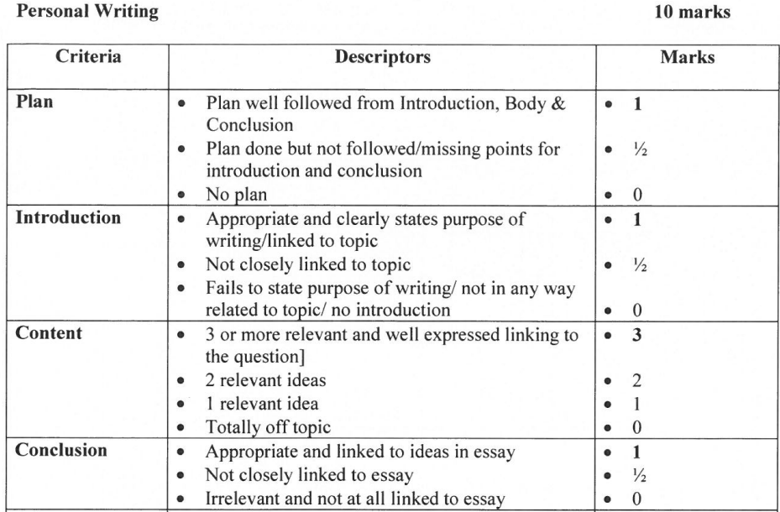
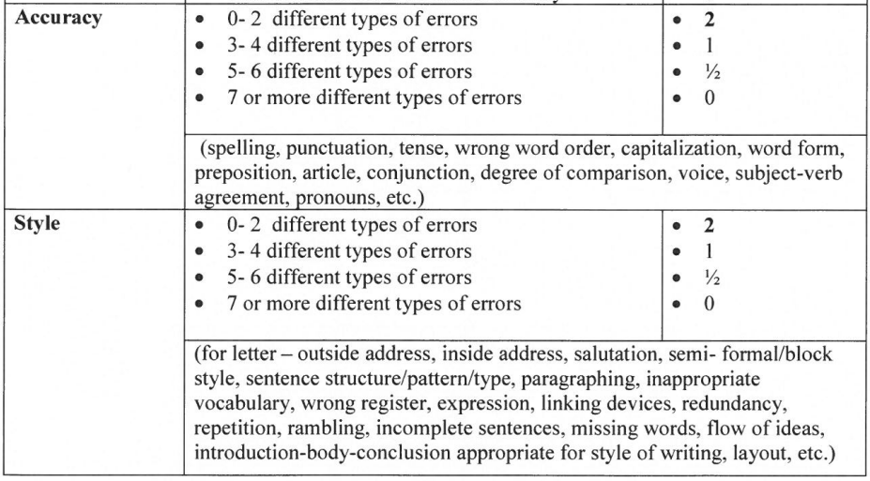
Lesson 61 Language
1. D 2.C 3. B 4. D 5. D 6. C 7. D 8. C 9. C 10. D
Lesson 62 Comprehension 7
1.D 2.D 3.B 4.C 5.B 6.B 7.C 8.D 9.B 10.A

Week 4 Worksheet
Topic : Drama Worksheet
Title : A Child For Iva Playwright : Vilsoni Hereniko
Act 3 Scene 1

a) X – Selina and she came to Atama’s house to help Iva deliver the child.
b) Time to help Iva to deliver the child.
c) Atama is upset as the baby was killed. He regretted disobeying his parents and leaving them to start his new life with Iva.

Act 3 Scene 2
Iva : But I can’t do it. I can’t …. It’s wicked.

Selina : It’s not Iva. And you can do it. It’s so simple and easy. Just take that pillow. It
will be over before you know it. And that child ….. do you think that child can
ever be happy? He does not belong in this world. There can only be misery for
him, and you….

d) Selina told Iva to kill the baby as she believed that the deformed baby will never be happy in the real world thus he would have a miserable life.
e) – We have no right to kill anyone.
- Always listen to your parents advise to avoid problems as teenage pregnancy.

