Compiled by: Mrs. N. Ali

7/6/2021
WEEK 2 YEAR 10 ENGLISH HOMESTUDY PACKAGE (WORKSHEET/NOTES
RATU NAVULA COLLEGE

LESSON NO: 51 | TOPIC: LITERATURE  Drama [Introductory]
STRAND | READING AND VIEWING
SUB STRAND | LANGUAGE LEARNING PROCESSES AND STRATEGIES/  SOCIOCULTURAL CONTEXT AND SITUATIONS
LEARNING OUTCOME | -Know the drama stage terms, structure and types of drama.  -familiarise with the setting and playwright of the drama “A Child For Iva”and the characters.

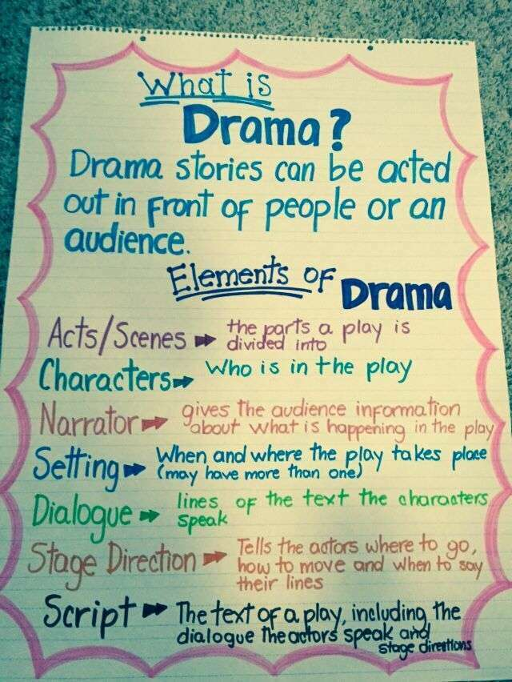
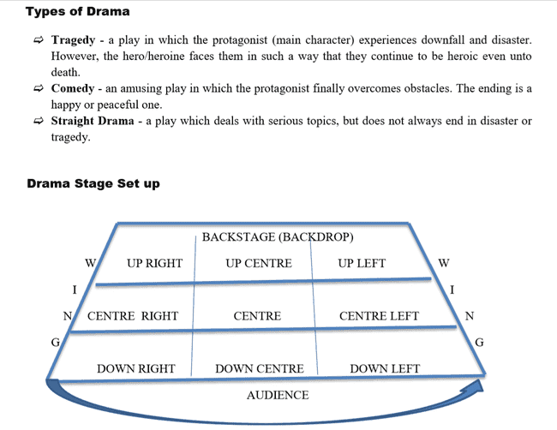
Activity
Fill in the table with reference to the drama Text “A Child For Iva”
What is the title of the play?
Who is the Playwright/Dramatist?

Name the characters.
How many acts are there in this play?

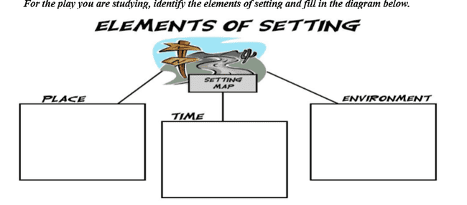
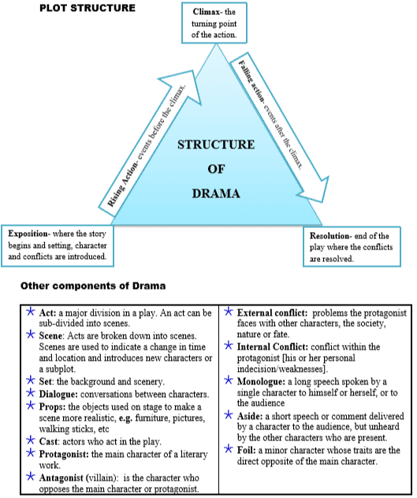

Read the Act 1 of the Drama “A Child For Iva” and answer the week 2 activities.
A Child For Iva Playwirght: Vilsoni Hereniko
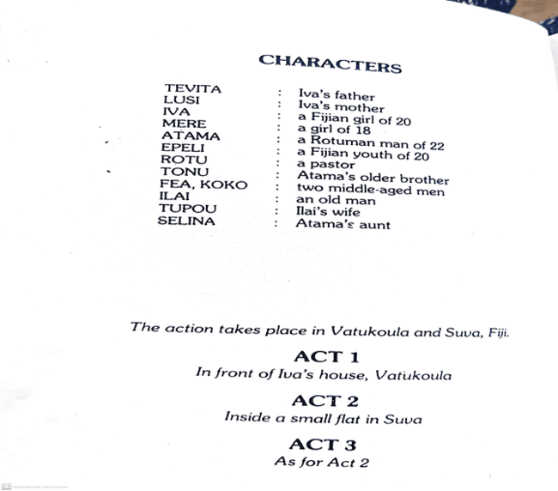

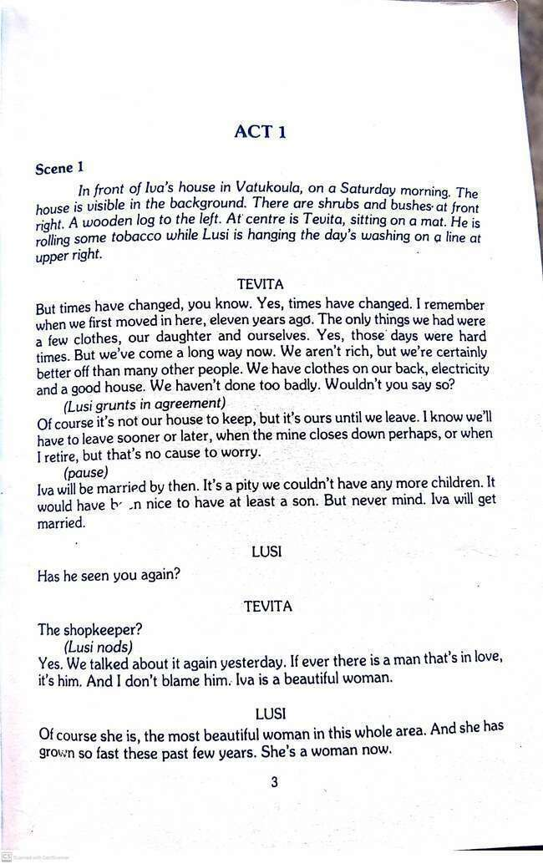
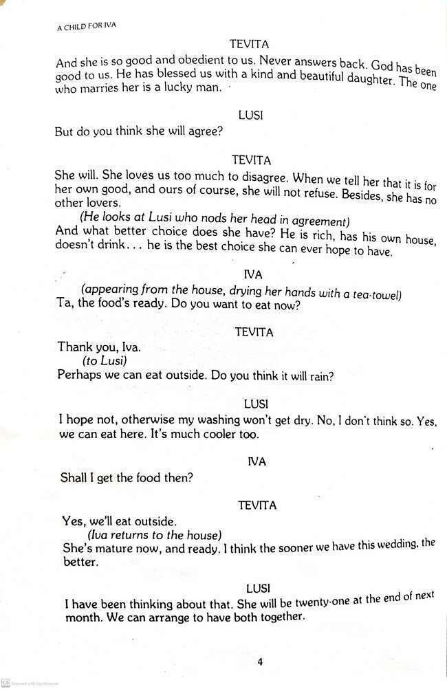
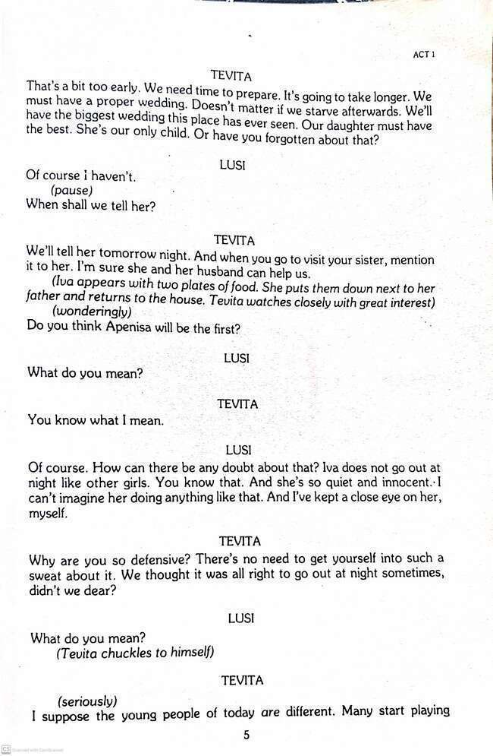
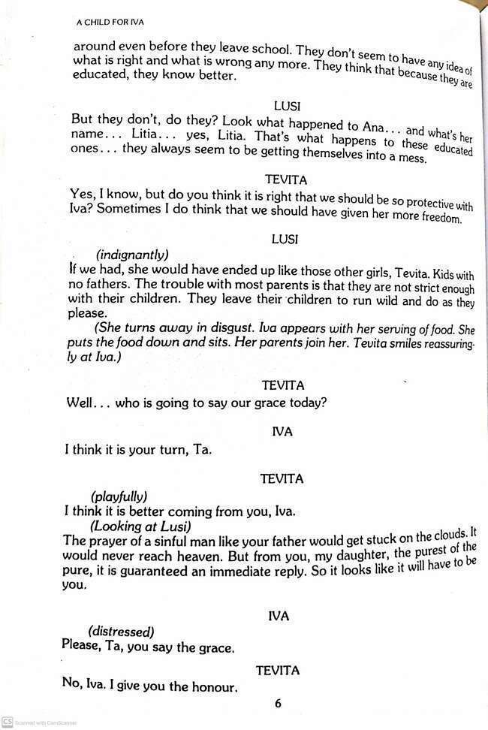
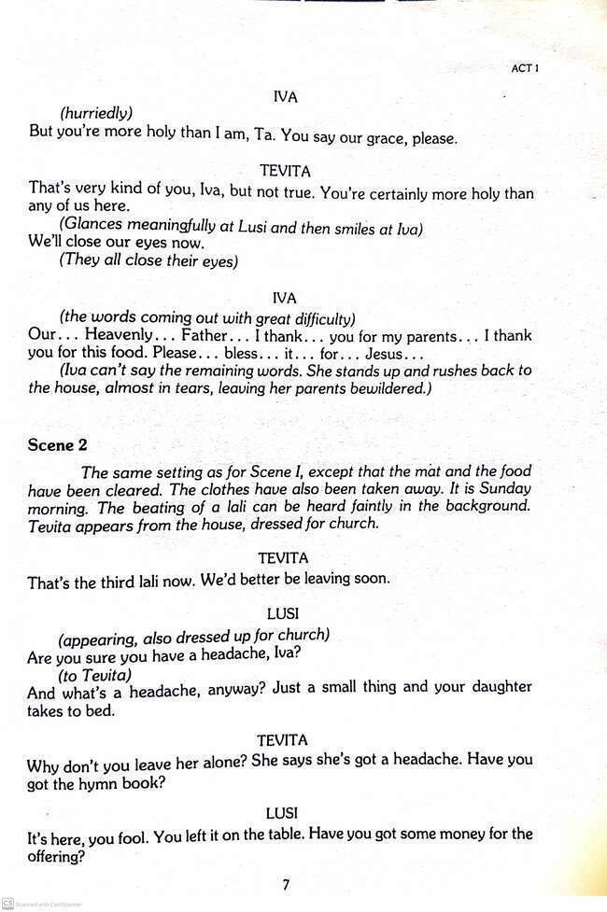
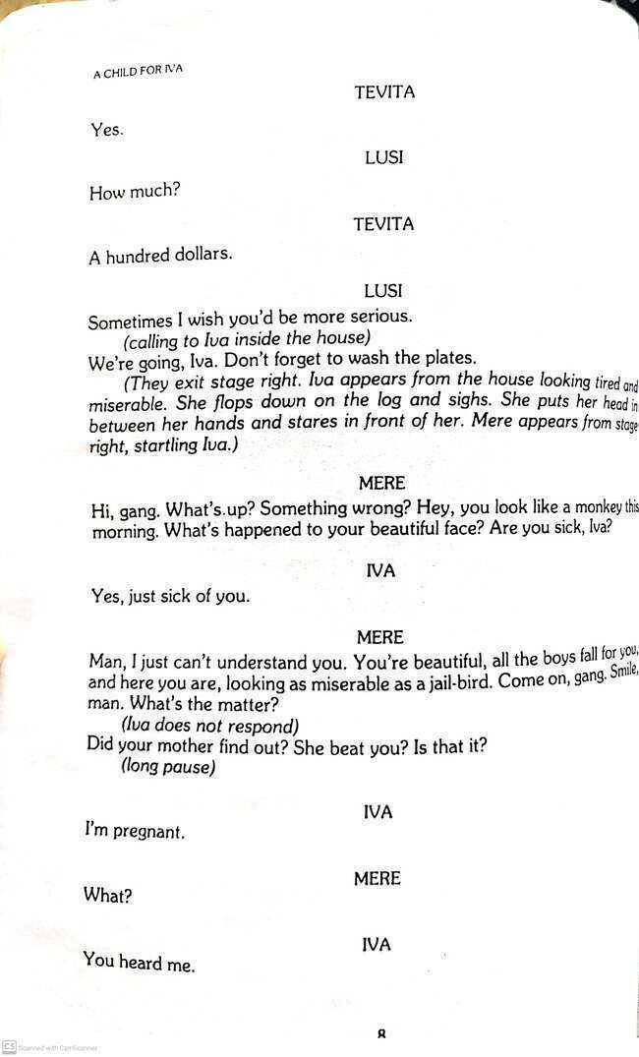
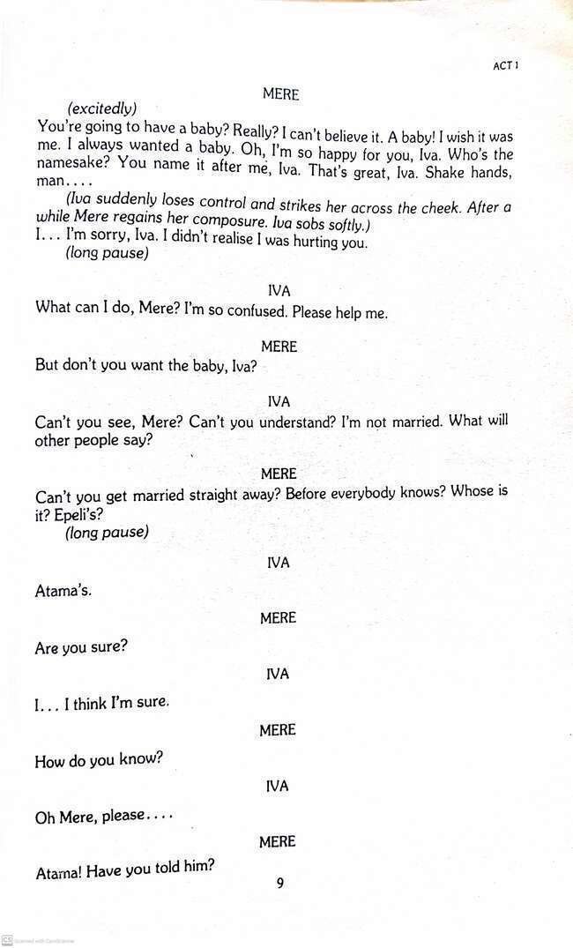
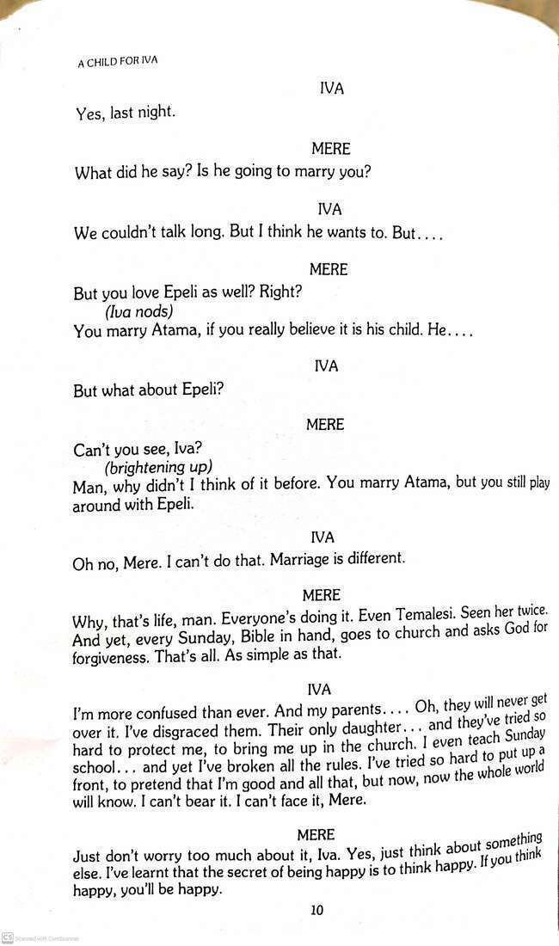
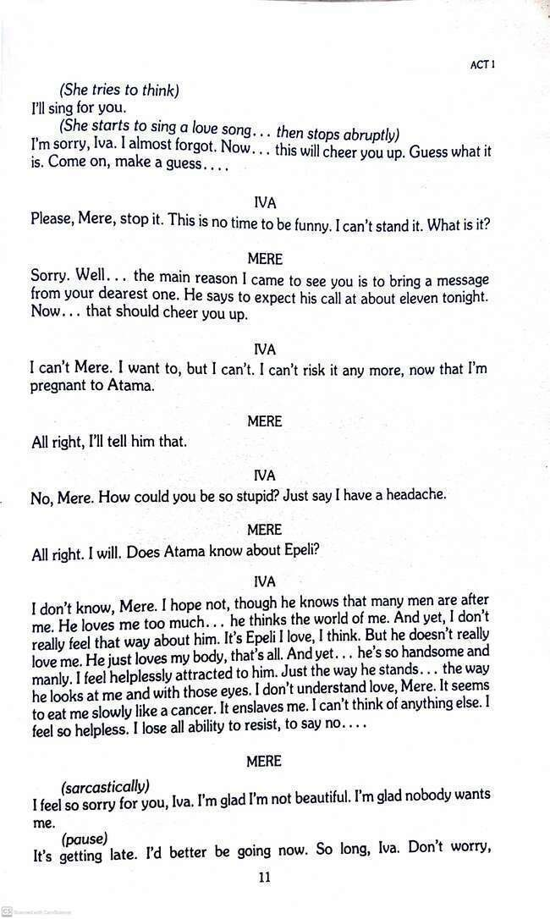
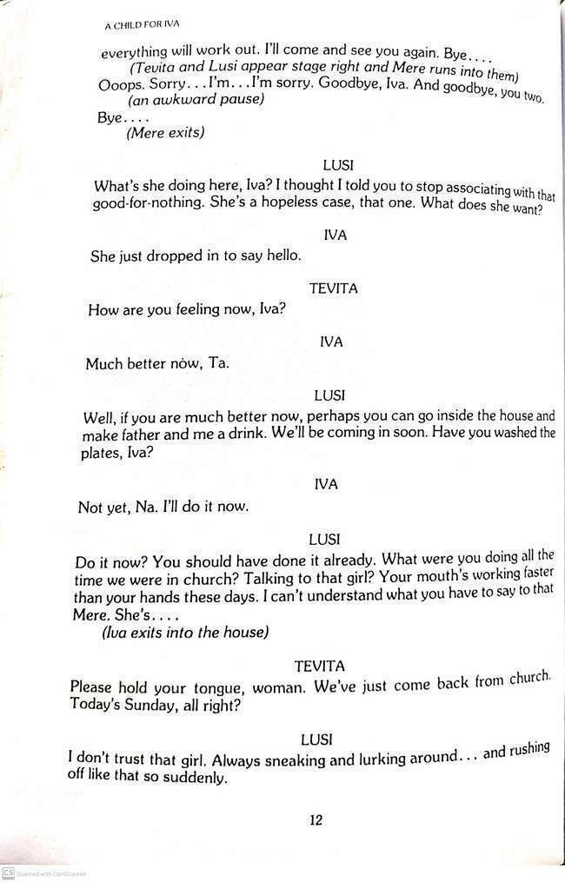
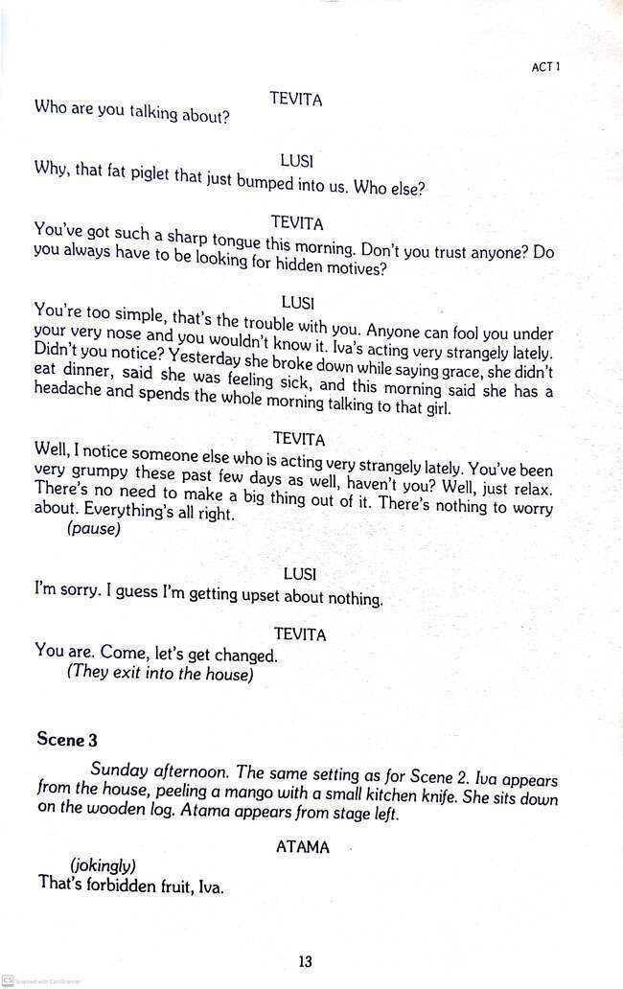
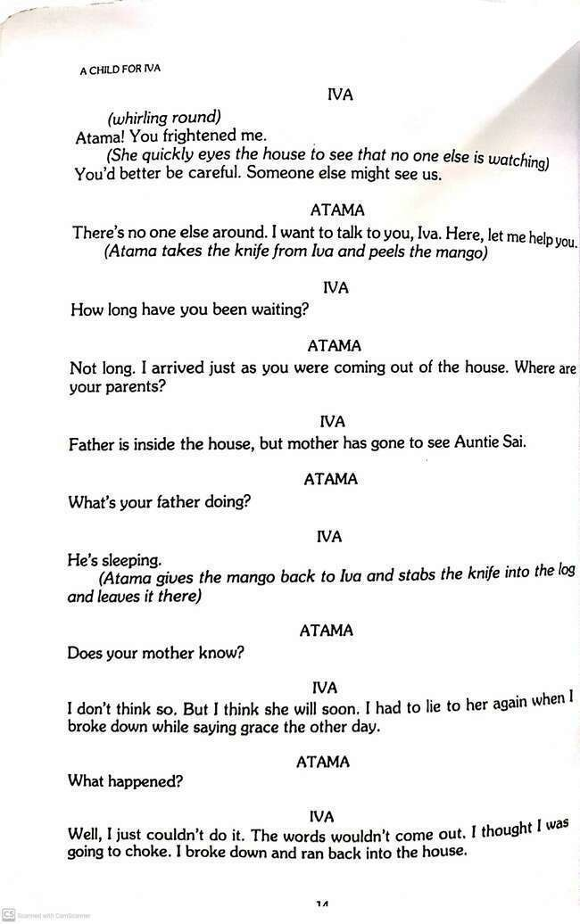

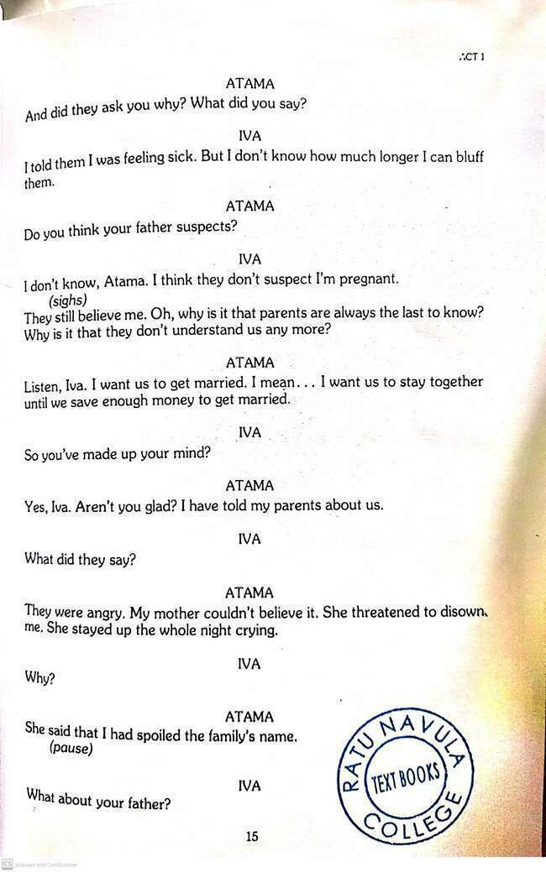
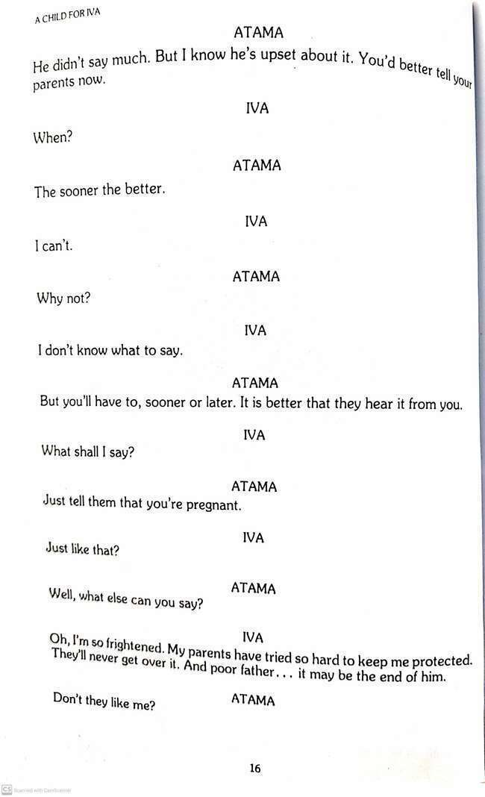
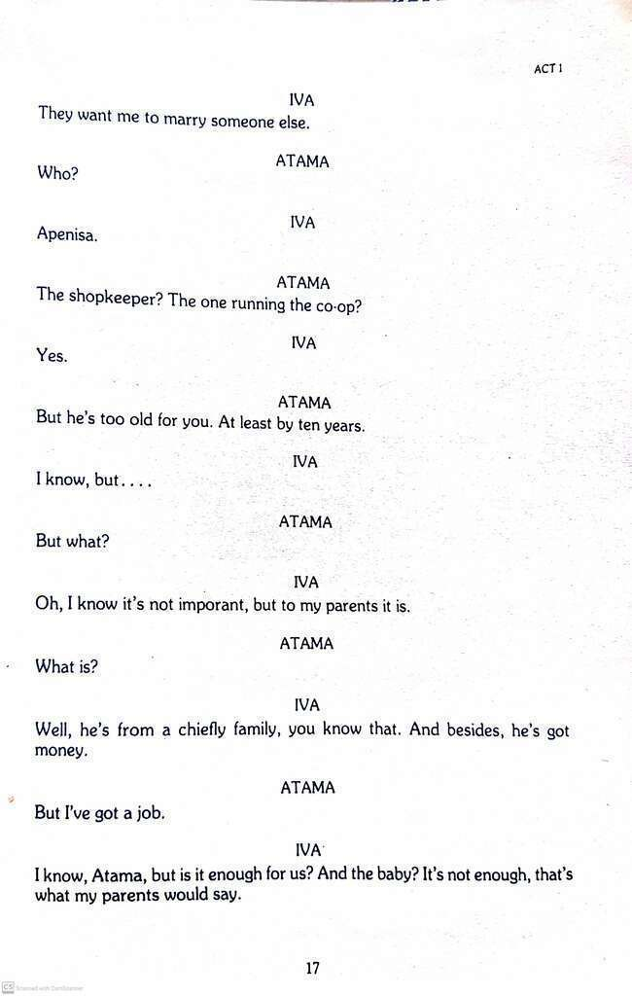
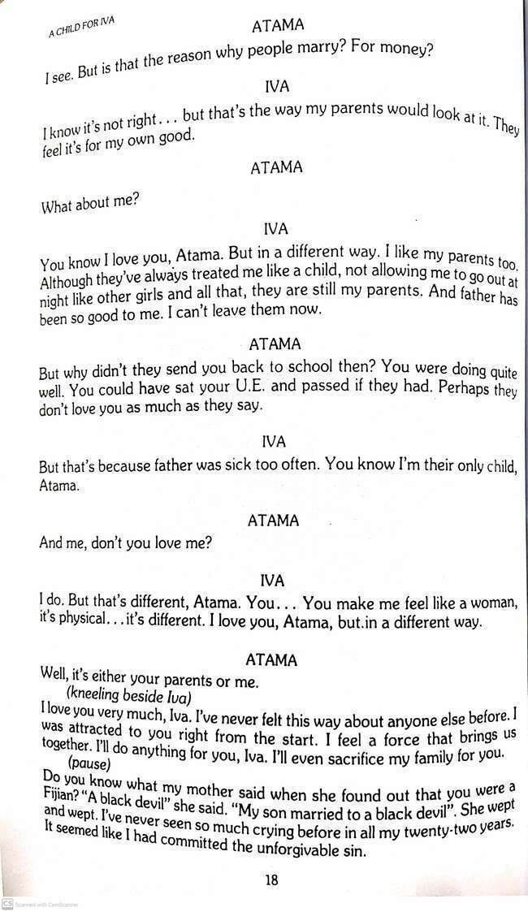
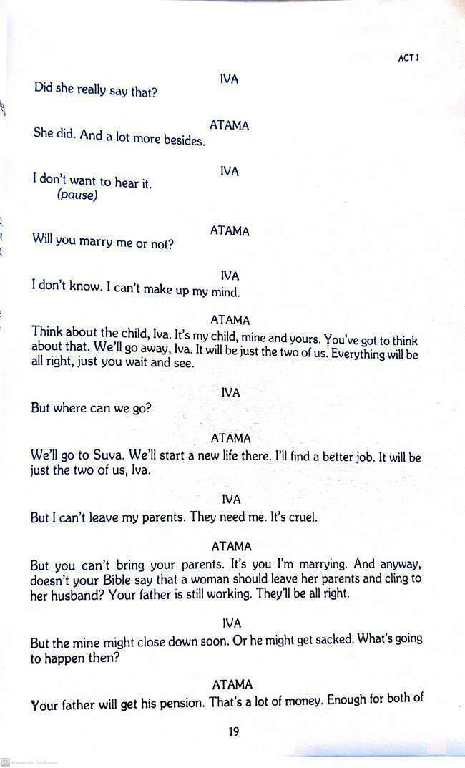
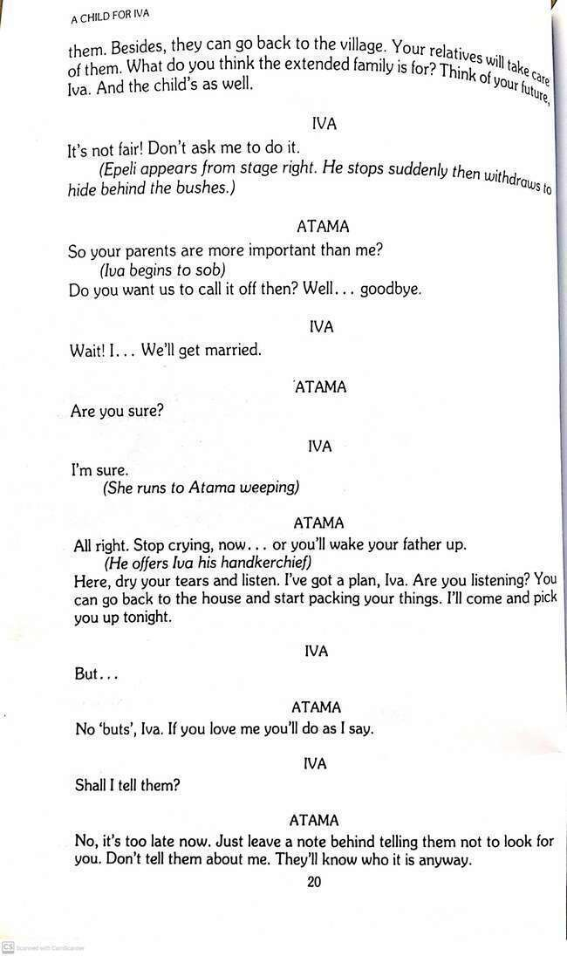

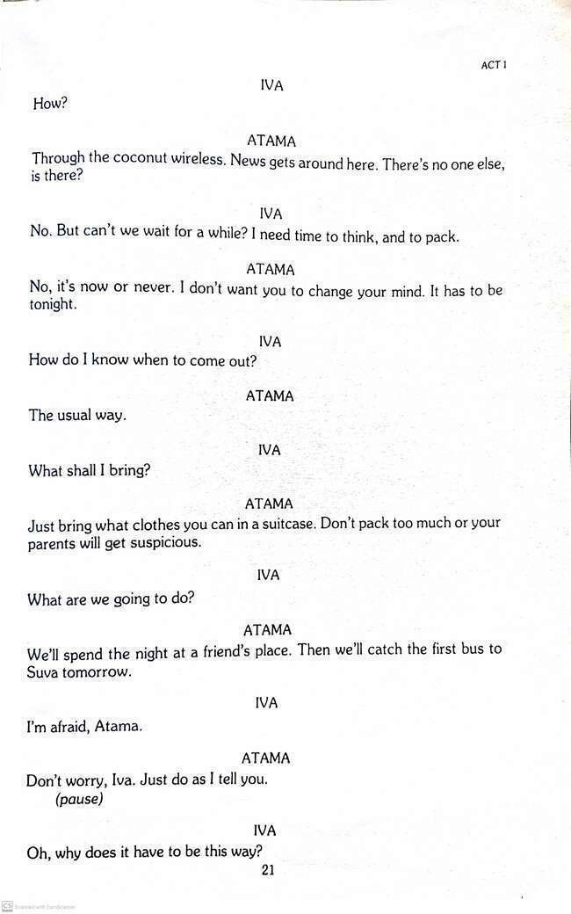

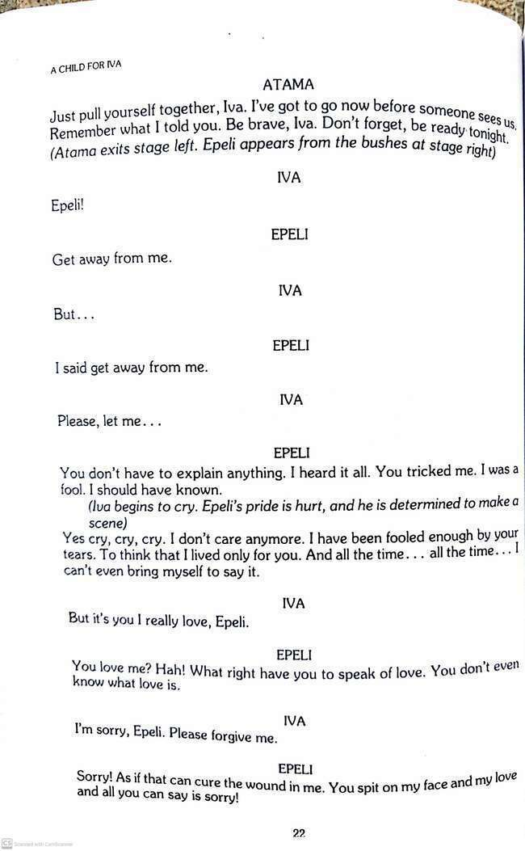
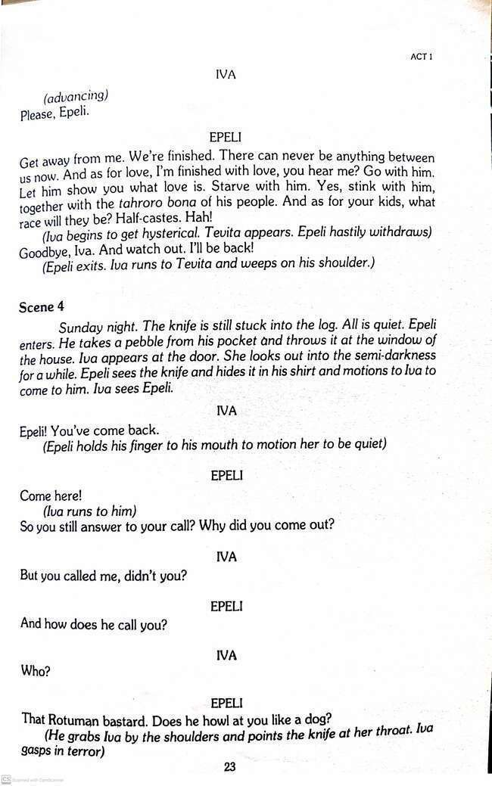
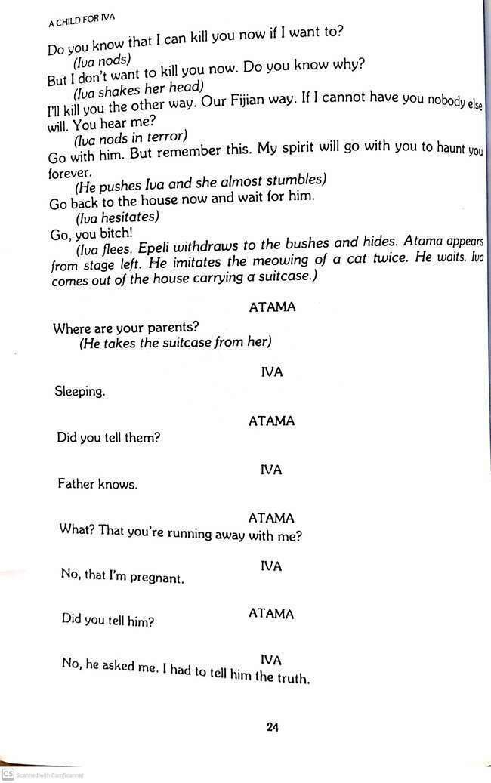
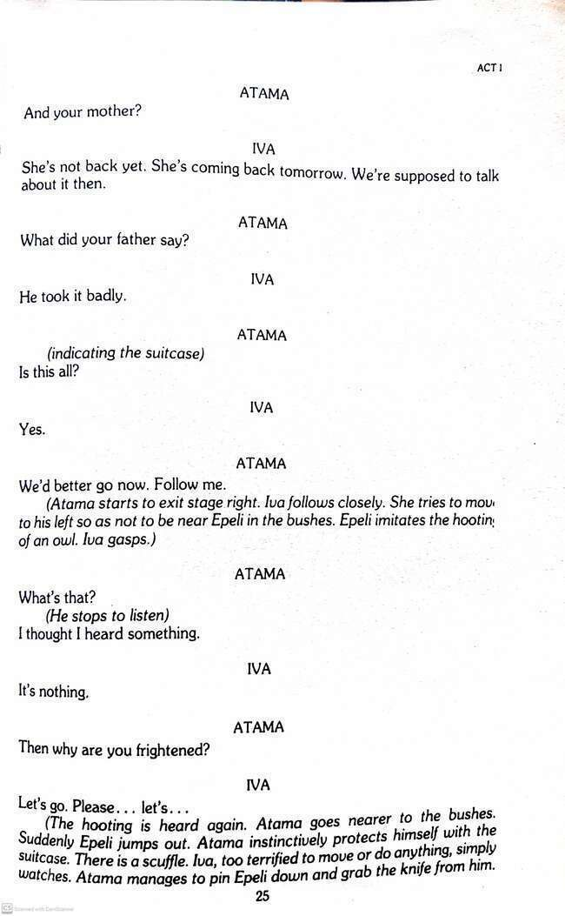

LESSON NO: 52 | TOPIC: LITERATURE  Drama Act 1 scene 1, 2
STRAND | READING AND VIEWING/ LISTENING AND SPEAKING
SUB STRAND | LANGUAGE LEARNING PROCESSES AND STRATEGIES/  SOCIOCULTURAL CONTEXT AND SITUATIONS
LEARNING OUTCOME | -read and analyse Act 1 , scene 1 and 2 of the drama

Act 1 Scene 1 Tevita and Lusi’s expectations from Iva
Plot
- Tevita and Lusi talk about their life over the years and reveal their expectations from the only child, Iva.
- Iva is a beautiful young woman and is busy preparing breakfast for the family. Tevita and Lusi discuss their plans of getting Iva married to Apenisa, a local shopkeeper who is rich.
- Iva brings their food and is asked to pray for the food.
- Iva breaks down in tears and suddenly leaves.

Activity: Read act 1 and answer these questions
1. View the sketch of the scene provided and list three things you learn about the setting of the scene.
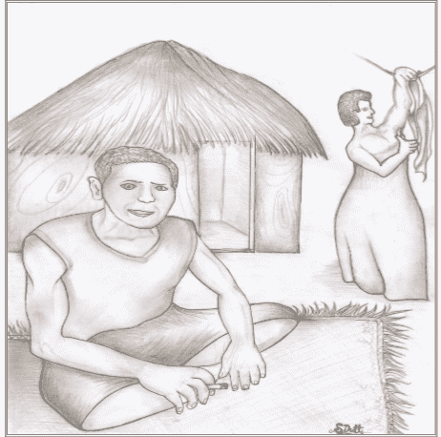 | 1.  2.  3.

2. After reading the scene in class/ groups, answer the following questions:
a. Compare the changes that have taken place in the lives of Tevita and Lusi according to conversation between the two characters.
Before | Now

b. What are the favorable qualities of Apenisa, the shopkeeper?
____________________________________________________________________________________________________________________________________________________________
c. Match the characters listed with their qualities
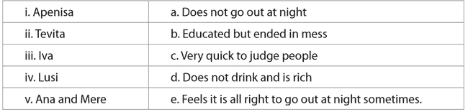
d. Discuss two lessons you learned from the scene.
____________________________________________________________________________________________________________________________________________________________
e. Rewriting (Reported Speech)
1. Tevita told Lusi “Perhaps we can eat outside. Do you think it will rain?”
____________________________________________________________________________________________________________________________________________________________
2. “Why are you so defensive? There’s no need to get yourself into such a mess about it,” Tevita told Lusi.
____________________________________________________________________________________________________________________________________________________________

Act 1 Scene 2 Iva Tells that She Is Pregnant
Plot
- Tevita and Lusi leave for church on Sunday.
- Iva does not go to church as she claimed to have headache.
- When they leave, Mere who is slightly younger than Iva come to chat with Iva. Iva tells Mere that she is pregnant and worried for two reasons; she is unmarried and the child is Atama’s and not Epeli’s whom Iva loved.
- Moreover, she feels that she has disgraced her parents who had trusted her and tried to bring her up with good values.
- When Mere leaves, Tevita and Lusi come back.
- Lusi tells Tevita that she does not like girls like Mere.

Activity
Read scene 2 and answer the questions
a. Compare Mere and Iva’s views about marriage.
Mere’s view of marriage | Iva’s view of marriage
b. Why does Lusi dislike Mere?
______________________________________________________________________________
c. Which of the two; Epeli or Atama you think is a better choice for Iva? Give reasons for your answer.
__________________________________________________________________________________________________________________________________________________________________________________________________________________________________________

d. Mere is happy when she finds out that Iva is pregnant. In three sentences write why people are happy to hear such a ‘good news.’
__________________________________________________________________________________________________________________________________________________________________________________________________________________________________________
2. If you were to act in this scene, which character would you pick? Explain your choice.
____________________________________________________________________________________________________________________________________________________________

LESSON NO: 53 | TOPIC: LITERATURE  Drama Act 1 scene 3, 4
STRAND | READING AND VIEWING/ LISTENING AND SPEAKING
SUB STRAND | LANGUAGE LEARNING PROCESSES AND STRATEGIES/  SOCIOCULTURAL CONTEXT AND SITUATIONS
LEARNING OUTCOME | -read and analyse Act 1 , scene 3 and 4 of the drama

Act 1 Scene 3 Atama and Iva make plans
Plot
- On Sunday afternoon, Atama comes to meet Iva.
- Atama had told his parents about Iva and they are very angry.
- Iva is frightened to tell her parents because she feels that she will disappoint them.
- Atama plans to take Iva to Suva and save enough money to get married.
- So, Iva is to pack her bags and wait for Atama at night.
- When Atama leaves, Epeli comes.
- He is angry with Iva for betraying him.

Activity Read scene 3 and answer these questions
- View the sketch of the scene. List two other details that could be added to make the sketch look more realistic to the scene.
______________________________________________________________________________________________________________________________________________________
- Skim through the scene again and identify phrases (two or more words) that relate to financial fields.
___________________________________________________________________________

- What are the reasons for Iva’s parents choosing to marry Iva to Apenisa who is ten years older? ___________________________________________________________
- List some of the ways Atama tries to convince Iva to join him to Suva.
________________________________________________________________________________________________________________________________________________

Act 1 Scene 4: Atama and Iva Elope  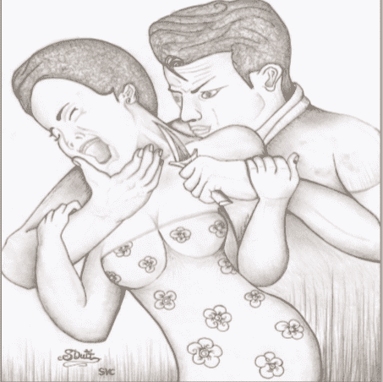 | Plot  - Epeli comes back to Iva at night and threatens Iva with a knife and later tells Iva that he would take revenge the ‘Fijian’ way.  - He then hides in the bush close to Iva’s house.  - Atama comes and starts to leave with Iva when Epeli attacks him.  - Atama is able to overpower Epeli and leave with Iva.

Activity Read scene 4 of act 1 and answer these questions.
- In a short paragraph of about four sentences, describe what is shown in the sketch.
________________________________________________________________________________________________________________________________________________________________________________________________________________________________________________________________________________________________
- i. Quote two abusive words used by Epeli.
________________________________________________________________________
ii. What does this reveal about Epeli’s character?
________________________________________________________________________
________________________________________________________________________
C. Complete the following using five to seven words. Note: you may not necessarily use ideas from the scene.
1. If i cannot have___________________________________________________________

2. My spirit will _____________________________________________________________

3. I had to __________________________________________________________________

4. We’re supposed __________________________________________________________

LESSON NO: 54 | TOPIC: Conditionals (revision)
STRAND | Reading and Viewing /Writing and Shaping
SUB STRAND | Language features and rules
LEARNING OUTCOME | -identify the style of writing sentences using zero, first, second and third conditionals.  -rewrite sentences correctly using conditionals.
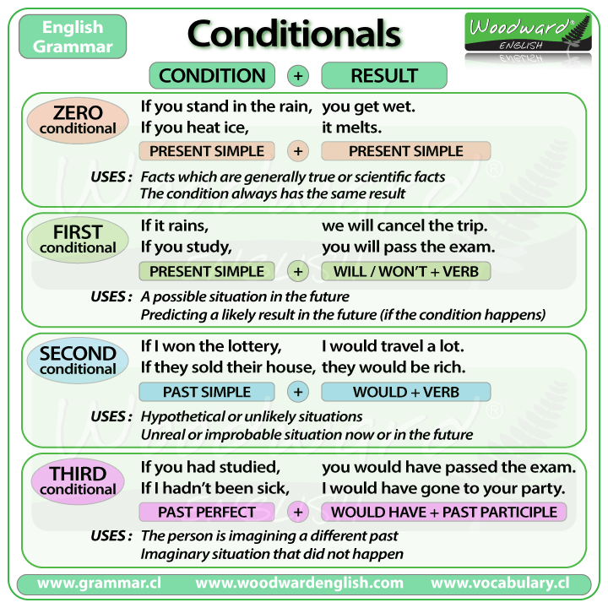

Activity 1
Rewrite sentences using zero conditional.
Eg: If you ask me, I answer.
- She /arrive, please call me. _________________________________________________
- My mum/ be busy,I help her. _________________________________________________
- I can’t run, I/ eat too much. ____________________________________________________
- You/ buy today, you save money. _______________________________________________
- It/ be hot, I drink water. ______________________________________________________
- We wait for you, you/ come with us. ____________________________________________
- You can sit here you/ want. ___________________________________________________

Activity 2 First Conditional
Complete the Conditional Sentences (Type I ) by putting the verbs into the correct form.
1. If you (send) …………………….this letter now, she (receive)………………………………… . it tomorrow .
2. If I (do)……………………… this test, I (improve ) ………………………………. my English.
3. Peggy (go ) …………………………… shopping if she (have) …………………………. time in the afternoon.
4. Simon (go) ……………………………. to London next week if he (get ) ……………………… a cheap flight.
5. If they (study / not ) ………………………..harder, they (pass / not ) …………………………... the exam.
6. If it (rain ) ……………………. tomorrow, I (have to / not ) ………………………………water the plants.

Activity 3 Second Conditional
Complete the Conditional Sentences (Type II ) by putting the verbs into the correct form.
1. If I ( be ) ……………………… rich, my life ( change ) ……………………… completely.
2. I ( invite ) …………………………..all my friends if ( have ) ……………………….. a house by the beach.
3. If we (have) …………………… a yacht, we (sail) ………………………… the seven seas.
4. If they (tell) ………………………… their father, he (be) ………………………very angry.
5. We (help ) ………………………… you if we (know ) …………………………..how.
6. My brother (buy ) ………………………….a sports car if he (have ) ……………………the money.

Activity 4 Third Conditional
Complete the Conditional Sentences (Type III ) by putting the verbs into the correct form.
1. If you (study ) ………………………… for the test, you (pass ) ……………………………it.
2. If you (ask ) …………………………me, I (help ) ……………………………………you.
3. If you (speak ) …………………………… English, she (understand) ……………………… ………………… .
4. I (write ) …………………………………………....you a postcard if I (have ) …………………………….. your address. 5. If it (not/ start ) …………………………… to rain, we (walk ) ………………………………..to the museum.
6. If she (take ) …………………………. the bus, she (not / arrive ) ……………………………… ……………… on time.

WEEK 1 SOLUTIONS
LESON 47 SOLUTION
A. Simple Sentences
1. Mr. Prasad won a lottery and built a big house.
2. Rika stood on tip toe to reach for the mango.
3. The cyclone stopped and we continued our fishing trip.
4. Joana is going to Australia to pursue her tertiary studies there.
5. I believe the lady was honest and loaned her one thousand dollars.
6. Solo finished breakfast and went to office.

B. Compound sentences
1. Kim plays soccer and rugby well.
2. Alumeci must be asleep as there is no light in her room.
3. Viliame speaks Hindi and he also speaks English.
4. Tokasa is quite sociable but her brother is quite reserved.
5. There was little hope of success but I tried hard.
6. Aporosa has been working hard and he will pass his examination.

C. Complex Sentences
1. John yelled to his neighbors so that they could come to his help.
2. Mrs. Singh would be very grateful once she is relieved of all this trouble.
3. Due to fear of being caught, they proceeded very cautiously.
4. Every precaution was taken contrary to the failure of the plan.
5. To the amazement of everyone, she worked very well.
6. The problem could not be solved because it was too difficult.

D.
1. complex sentence 2. complex sentence
3. complex sentence 4. compound sentence
5. complex sentence 6. compound sentence
7. simple sentence. 8. complex sentence
9. complex sentence 10. complex sentence

Lesson 48 – Comprehension solution
Passage 1
1. A 2. A 3. A 4. C 5. C 6. B/D
Passage 2
True/False
1. True 2. True 3. False 4. True
5. False 6. True 7. False 8. True

Short Answers
1. It is about corona virus symptoms, effects and preventative methods.
2. It is called corona as it is a Latin name for crown. Under the microscope, the virus looks like a crown with spikes ending in little blobs.
3. Symptoms include: dry, itchy cough, sneezing and even hard to breathe.
4. The elderly will get sicker with corona virus.
5. Immediately call the doctor.
6. To avoid the spread of germs going far in the air.
7. To avoid the virus entering your body.
8. It is better to stay at home rather than loitering unnecessarily.
Lesson 49- Subject Verb Agreement Solutions
No | Rule | Answer
1 | Everyone (singular subject) singular verb | has
2 | Each ( singular subject) singular verb | is
3 | Brothers (plural subject 2) plural verb | are
4 | Mother (singular subject 2) singular verb | is
5 | Samples (plural subject) plural verb | need
6 | Mary and John (plural subject) plural verb | play
7 | Dogs (plural subject) plural verb | Have
8 | Cat (singular subject 2) singular verb | Is
9 | boy (singular subject ) singular verb | walks
10 | Girls (plural subject) plural verb | Walk
11 | Tests (plural subject) plural verb | Come
12 | Slaughter (singular subject) singular verb | Has
13 | Teacher (singular subject 2) singular verb | Was
14 | Tests (plural subject) plural verb | Come
15 | Roommates (plural subject) plural verb | Have

Lesson 50 Conversation/ Dialogue writing solution
Activity
Theme : Obedience
Plan and write a conversation between you and your friend regarding the breech of curfew hours during school holidays.
Plan 1 mark
Mention briefly the main points for the introduction, content and conclusion.
Write up – 9 marks
Introduction- write 1-2 sentences about who the two friends are, name the friends, mention the setting such as travelling in the bus, talking during recess break in school about any incident related to breech of curfew hours (8pm till 5am ) [1mk]
Content- have 3 ideas [3 marks]
-follow the format as in the sample
Eg Peter : _________________________ [name of friend : dialogue]
Tom : _________________________

-the two friends must talk/ converse about who broke the curfew (neighbor/ relative), discuss the situation such as gathering (birthday/ grog party), the neighbours called the police, the men were arrested, and were released/ bailed out. They were disobedient as they did not follow the covid safety protocols set by the government.
- suggest to your friend what one should do during this covid pandemic.
Features to be included are: friendly tone , use voiced hesitation eg: um…. , er…., unvoiced hesitation eg: …………. , repetition eg: they….. they , slangs eg: yeah! Bro! mate! , interjections eg: oh! Gosh! And at least one incomplete sentence eg: the police came and………

Do not use: mobile test type writing, slangs, vulgar language, vernacular words or expressions.

Conclusion- write one / two sentences how the conversation ended. Eg: The siren rang. It was the end of recess. The two friends slowly moved towards their classroom to prepare for period 3 which was the basic science class. [1 mark]
Accuracy : / 2 marks (here, we look at the grammatical errors)
Style :/ 2 marks (here, we look at the format)
-miss a line after introduction and before conclusion.
- friendly/ personal tone , friendly tone , use voiced hesitation eg: um…. , er…., unvoiced hesitation eg: …………. , repetition eg: they….. they , slangs eg: yeah! Bro! mate! , interjections eg: oh! Gosh! And at least one incomplete sentence eg: the police came and………

Do not use: mobile test type writing, slangs, vulgar language, vernacular words or expressions

