RATU NAVULA COLLEGE
YEAR 10 ENGLISH
HOME STUDY PACKAGE
WEEK 4

Compiled by Mrs Ali ( 20/7/2021)

Contents: Lesson 59-62

Read the Act 3 of the play: “ A Child For Iva” and do the activities for lesson 59.
LESSON NO: 59 | TOPIC: LITERATURE  Drama Act 3- Scene 1,2 and general notes
STRAND | READING AND VIEWING/ LISTENING AND SPEAKING
SUB STRAND | LANGUAGE LEARNING PROCESSES AND STRATEGIES/  SOCIOCULTURAL CONTEXT AND SITUATIONS
LEARNING OUTCOME | -read and analyse Act 3 , scene 1 and 2 of the drama.

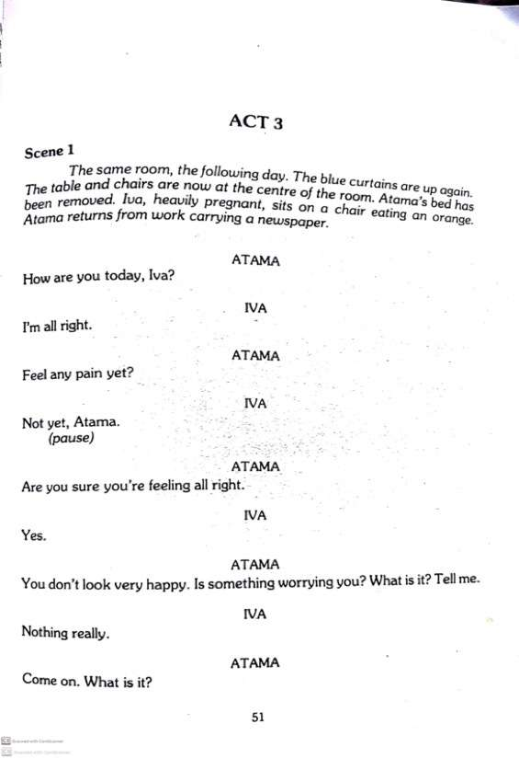

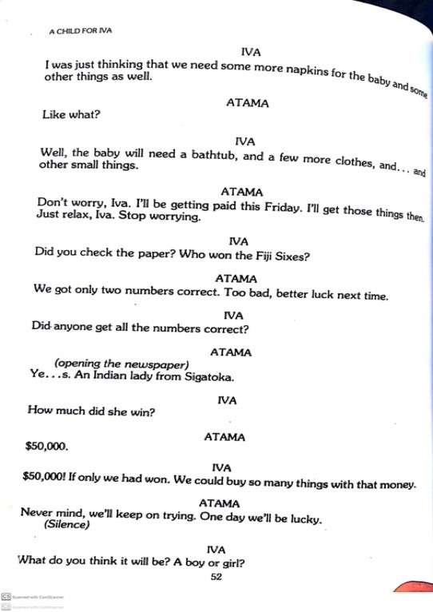
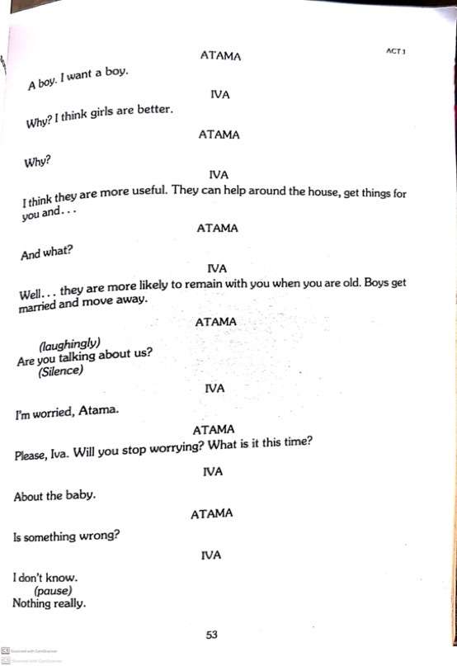

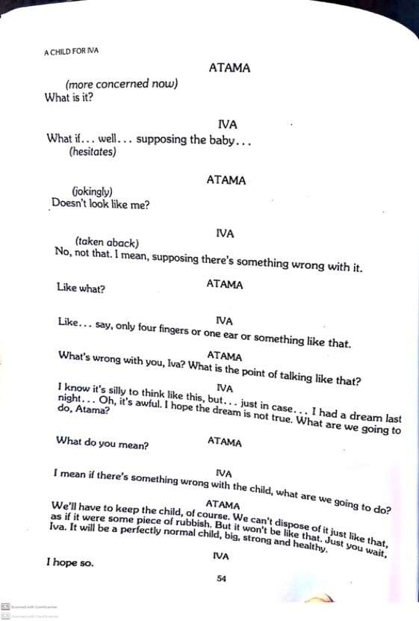
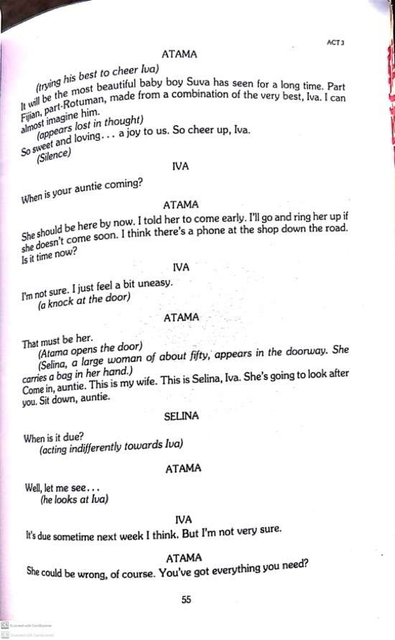
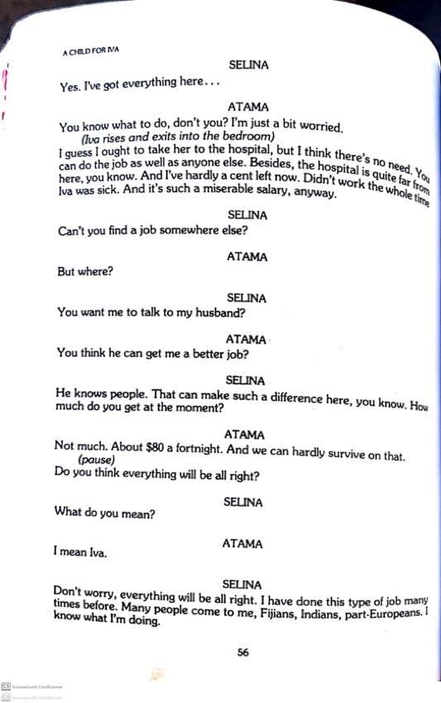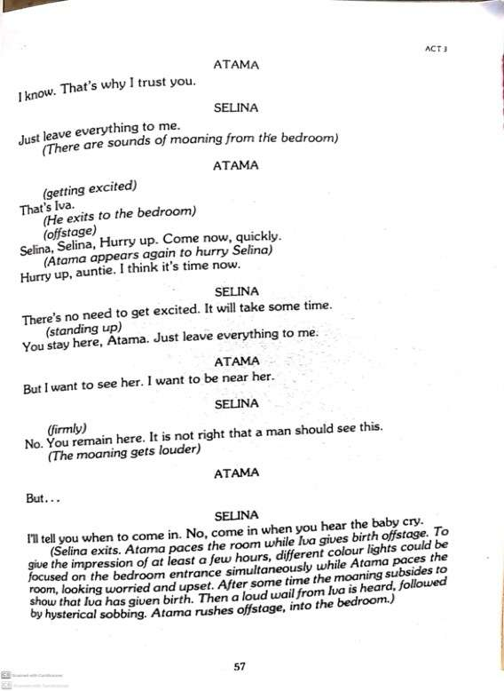

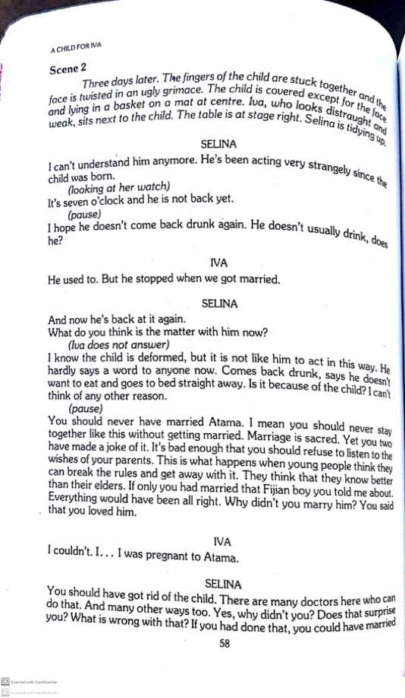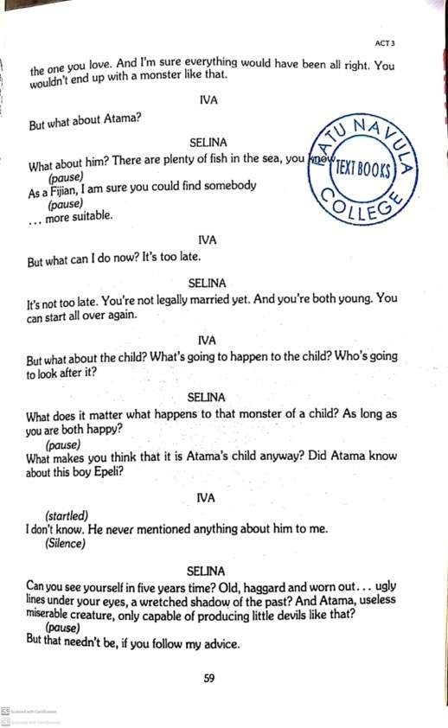

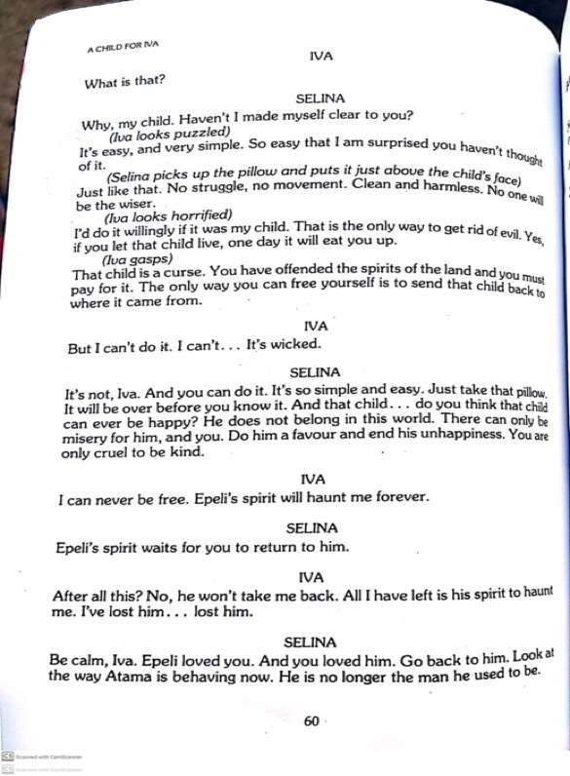

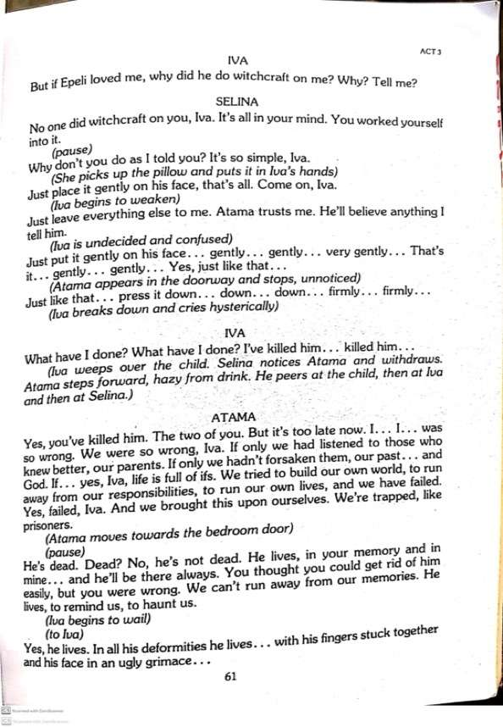
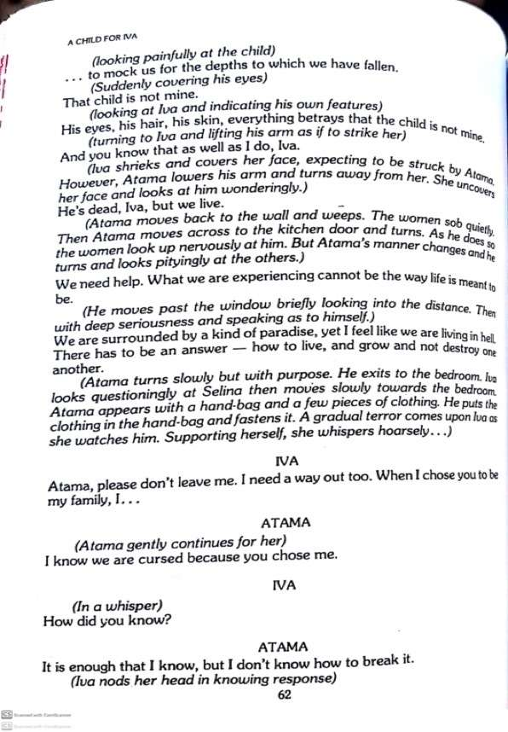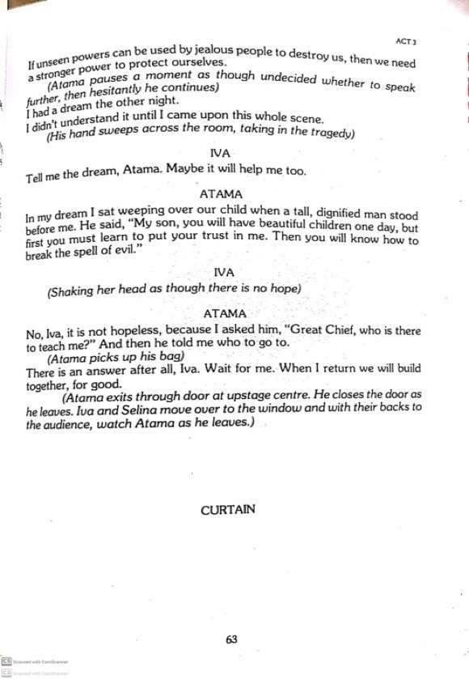
Act 3 Scene 1 Iva’s Delivery
Plot
- Iva has recovered.
- She is worried about buying things for the baby.
- She asks Atama how he would react if the child is deformed and Atama replies that he would accept it.
- Atama’s aunt, Selina comes.
- She is in charge of Iva’s delivery.
- Iva is in labour pain and Atama gets excited.
- He wants to be with Iva but Selina tells him to wait outside.

  - Why was Iva worried at the beginning of the scene?
________________________________________________________________
  - If you were in place of Atama, what advice you would have given to Iva?
_________________________________________________________________
3. Before aunt Selina arrives, ______________________________________________
Scene 2: Smothering of Deformed child
- The child born is deformed.
- Atama has got a habit of drinking a lot and staying out.
- Selina is worried and talks to Iva about the future.
- She encourages Iva to kill the evil child to end everyone’s misery.
- Iva is convinced and kills the child.
- Only after killing the child, she realizes what she has done.
- Atama comes in drunk and tells everyone it was their mistake and they should have listened to their parents.
- He tells Iva that he had a vision to make their lives better.
- He leaves promising to return and asking Iva to wait.

Read act 3 scene 2 and answer these questions
  - Why does Atama come home late and drunk?
__________________________________________________________________
  - Whose side do you think is Aunt Selina- Atama or Iva? Give a reason for your choice.
____________________________________________________________________________________________________________________________________
  - Where do you think Atama will go after the scene finishes?
__________________________________________________________________

Drama General Notes A Child For Iva By Vilsoni Hereniko
Character Study
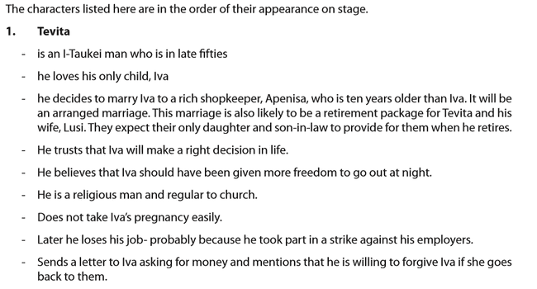
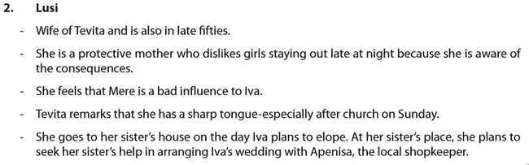
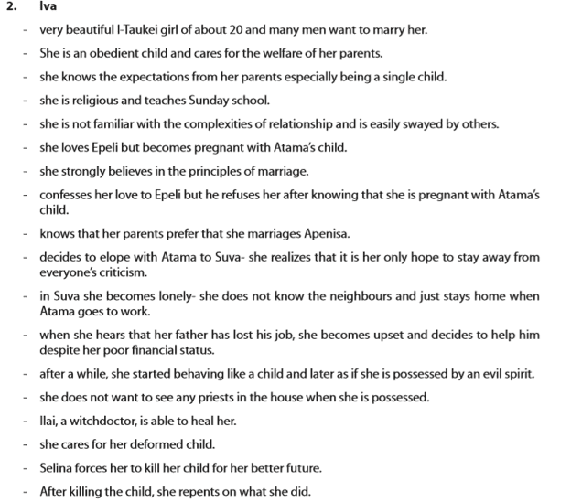
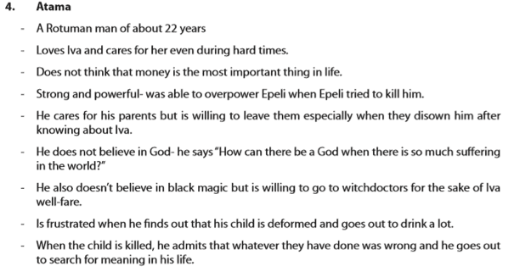
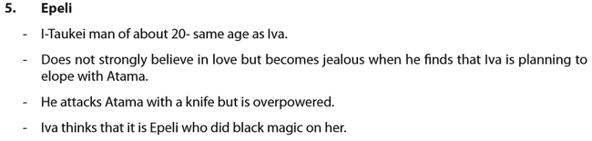
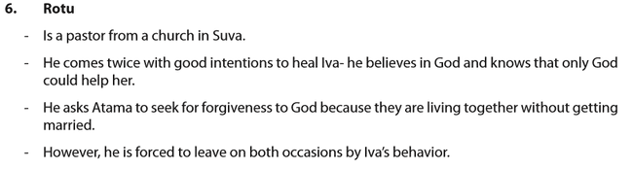
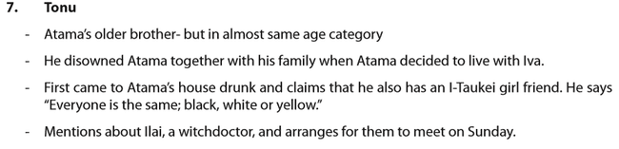
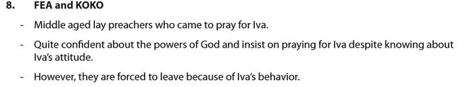
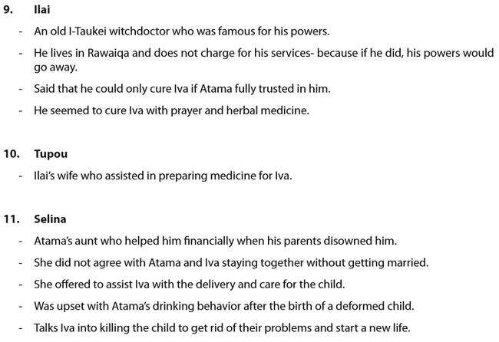
THEMES
  - Teenage Pregnancy
- This is a major problem in Fiji whereby young people who are involved in unprotected sexual intercourse end up shouldering an important responsibility of parenting.
- In the story, Iva and Atama have no other option but to leave their parents and live on their own when Iva becomes pregnant with Atama’s child.
- This also affects Iva emotionally as she did not really love Atama but loved Epeli.
- since she becomes pregnant with Atama’s child, her chance of being with Epeli ends and she has to live with Atama for a better future of her child because a child with no father can receive rude comments from the society.
- A possible cause of Iva’s early pregnancy is that she lacked adequate information on the contraceptives that could prevent unwanted pregnancy.
- This happens to students who drop out of school early just like Iva- who left school when her father was ill for a while.

  - Obedience to Parents
- In the play, we see that both Iva and Atama suffer because they did not take heed of their parents’ advice.
- For Iva, her parents had high expectations from her to keep up the family name especially when she was the only child. Her parents did not allow her to go out late at night. Her parents preached abstinence from sexual intercourse before marriage. This is also what she learned from church. Even if Iva had discussed her pregnancy openly with her parents, she could have come up with a better arrangement than eloping with Atama to Suva.
- Likewise, Atama is disowned by his family after he tells them of his relationship with Iva- he tells Iva that he had never seen his mother cry so much in his life.
- Towards the end of the play, Atama remarks “if only we had listened to those who knew better, our parents. If only we hadn’t forsaken them…”
- This shows that we need to follow our parents advice since they have been through life and had more experience regarding ways to deal with relationship issues.

  - Racial Tolerence
- A lot of racial discrimination is present in the play and the playwright shows that this leads to intolerance and conflict.
- The main reason for these remarks is that Atama being a Rotuman plans to marry an i-Taukei, Iva. When Atama’s mother found out that he is planning to marry Iva, she remarks “My son married to a black devil.”
- However, Atama’s older brother, Tonu, seems to be more understanding when he comes to help Iva. He touches on the importance of cultural integration when he tells Atama “i don’t care what race you marry. everyone is the same; black, white or yellow.”

STYLE USED
1.Use of Acts
- The playwright has used 3 Acts to stage the play.
- Each Act represents a different phase in the development of the play;
- Act 1- Iva mentions that she is pregnant and elopes with Atama.
- Act 2- Atama and iva live in suva and iva gets lonely and then sick
- Act 3- delivery of the child and smothering of the deformed child.

2.Use of Local Names
- Although the play is in English all characters have either i-Taukei or Rotuman names.
- This helps to make the story more realistic as it takes place in local settings around Fiji.
3.Use of Humour
- Although the play deals with serious issues, the playwright brings in few humorous characters and scenes to make audience laugh.
- One such character who helps create humour is Mere who does not take her life seriously. While sympathizing with Iva’s situation, she firstly decides to sing her a romantic song and later remarks; “i’m glad i’m not beautiful. i’m glad nobody wants me.”
- A scene that creates creates humour is Act 2 scene 3 when Iva chases Fea and Koko. She initially lifts her sulu and then lifts Fea’s sulu. This causes Fea to be disgusted and leave.
4. Use of Informal Expressions informal words and slang are mostly used by Tonu and Mere, for example, “bro” and “play around”
- Conversations involving older characters are mostly formal.
- Sarcastic comments are also used by Mere, for example, her expression noted above to create humour. This also helps to give an informal tone to the language.

LESSON NO: 60 | TOPIC: PERSONAL WRITING Diary
STRAND | Writing and Shaping
SUB STRAND | Text types/Socio cultural contexts and situations
LEARNING OUTCOME | Plan and write a diary.

Question
Theme: Budget
Write a dairy entry about how you and your family budget and mention three ways you all managed to survive during the COVID 19 pandemic. Elaborate on what lessons you learnt from your experiences at that time.

PLAN and WRITE this diary in the writing book.

LESSON NO: 61 | TOPIC: LANGUAGE Multiple choice questions
STRAND | READING AND VIEWING
SUB STRAND | Language features and rules
LEARNING OUTCOME | -Use correct grammar rules and circle the correct answer.

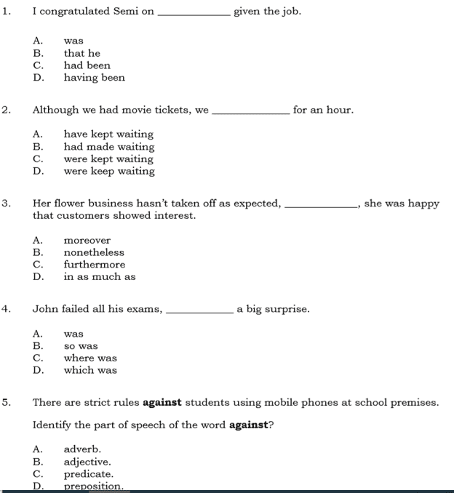
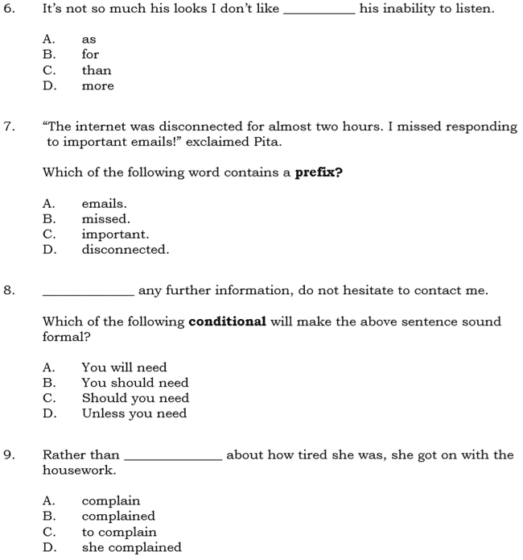
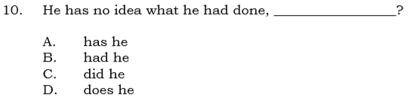

LESSON NO: 62 | TOPIC: Comprehension 7
STRAND | Reading and Viewing
SUB STRAND | TEXT TYPES: MEDIA TEXT, EVERYDAY COMMUNICATION & LITERARY TEXT
LEARNING OUTCOME | -Read with understanding and analyse the passage by answering given questions.  -recall important details.

Read the passage and answer the questions that follow.
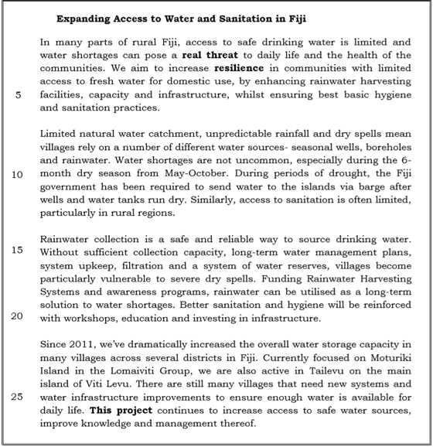
Adapted from: https://www.globalgiving.org (FY10CE 2018)
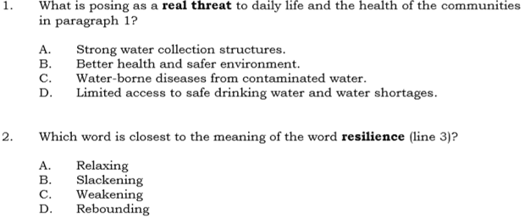
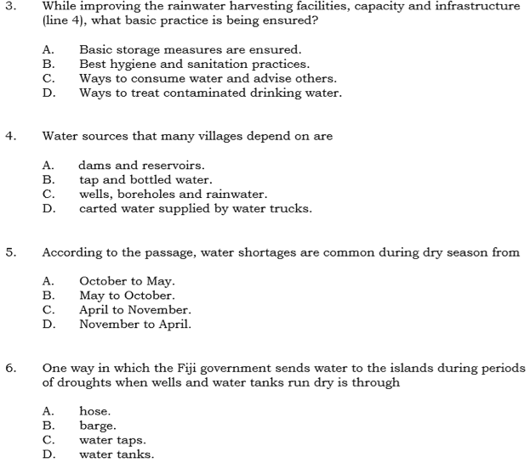
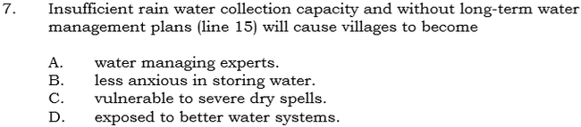
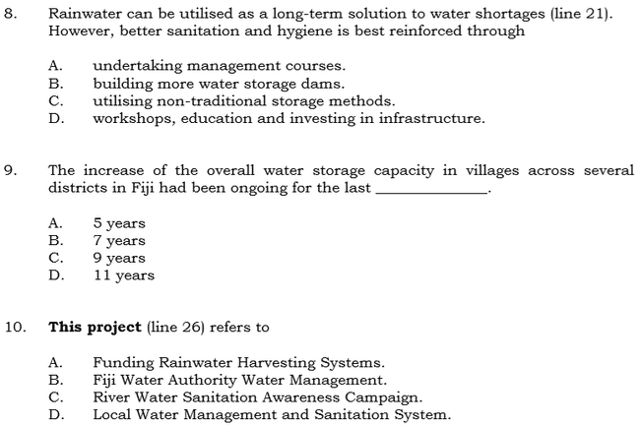

Week 4 Worksheet
Topic : Drama Worksheet
Title : A Child For Iva Playwright : Vilsoni Hereniko
Act 3 Scene 1
Atama : I Know. That’s why I trust you.

X : Just leave everything to me.

Atama : That’s Iva. X, X, Hurry up. Come now, quickly. Hurry up, auntie. I think it’s
time now.

a) Who is X and why is she at Atama’s house?
b) What does Atama mean by saying “I think it’s time now.”?
c) What are some issues Atama is upset about in this scene?

Act 3 Scene 2
Iva : But I can’t do it. I can’t …. It’s wicked.

Selina : It’s not Iva. And you can do it. It’s so simple and easy. Just take that pillow. It
will be over before you know it. And that child ….. do you think that child can
ever be happy? He does not belong in this world. There can only be misery for
him, and you….

d) What advice did Selina give to Iva and why?
e) What lesson have you learnt from this extract?

