RATU NAVULA COLLEGE
WEEK 3 STUDY HOME PACKAGE FOR YEAR 10 ENGLISH
July 13, 2021
COMPILED BY: mRS. ALI

CONTENTS: * lESSON 55-58
* WORKSHEET ON DRAMA

Read act 2 of the drama “ A Child For Iva” and attempt lesson 55-57 activities.
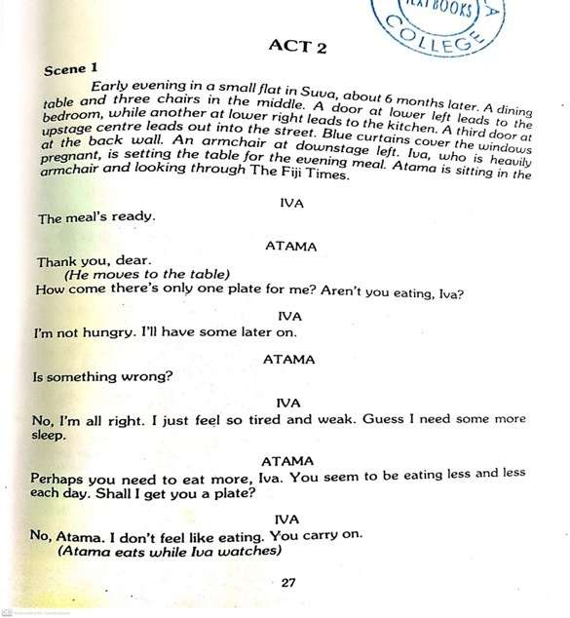

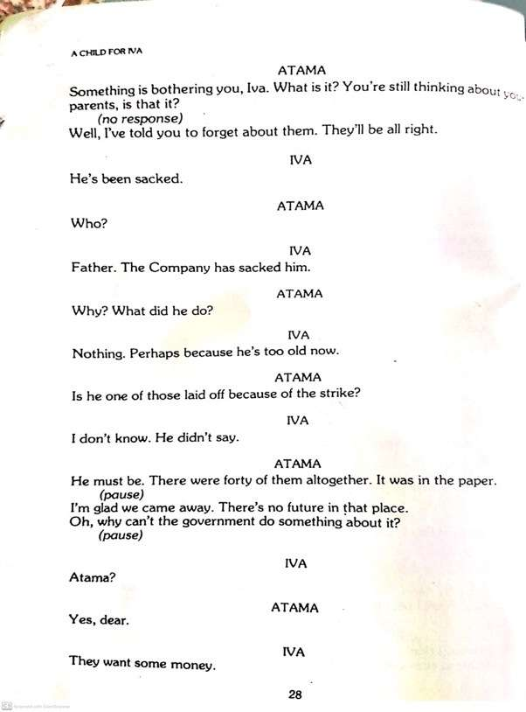
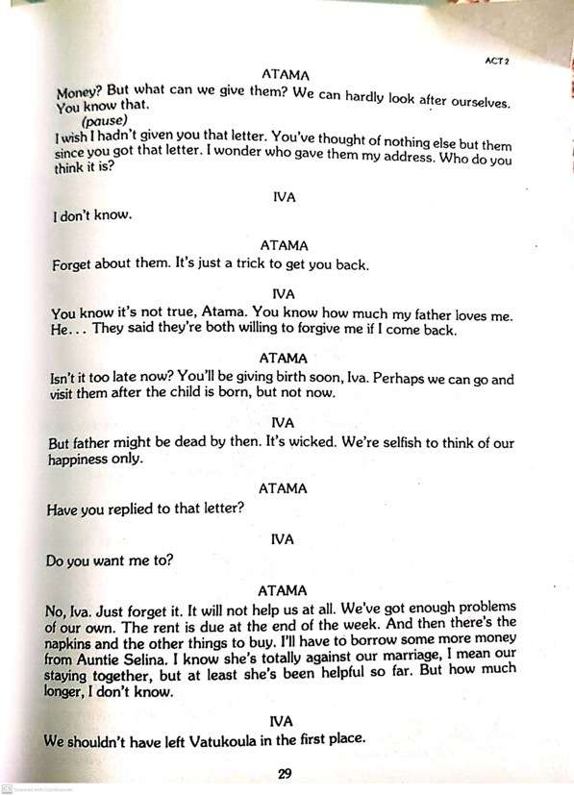
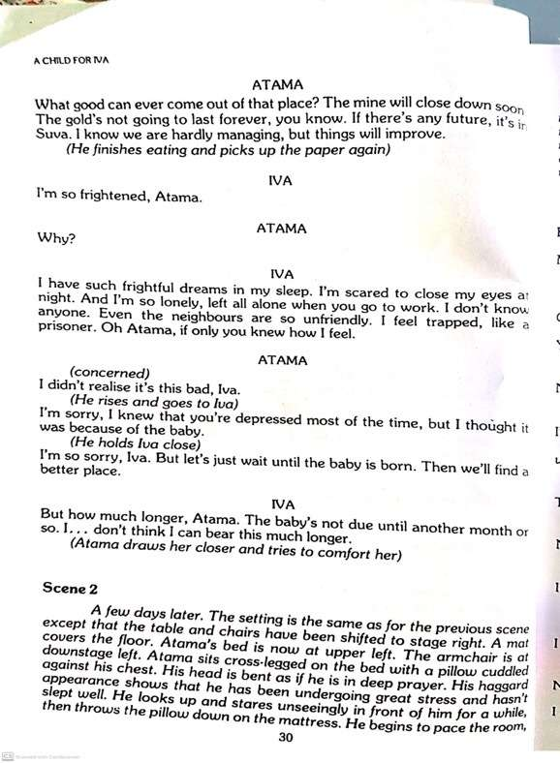
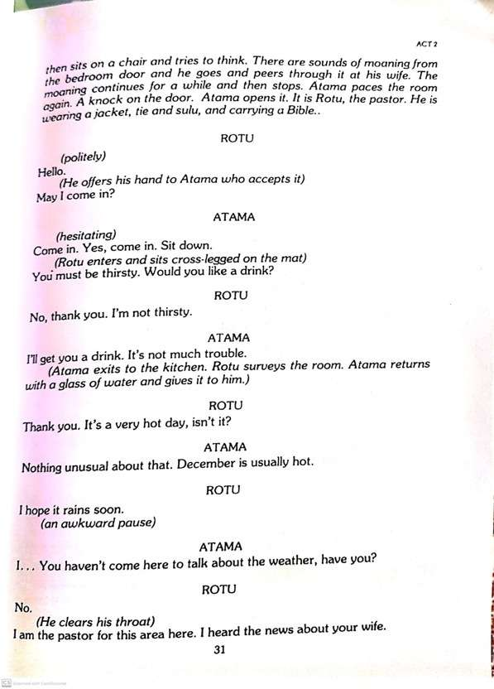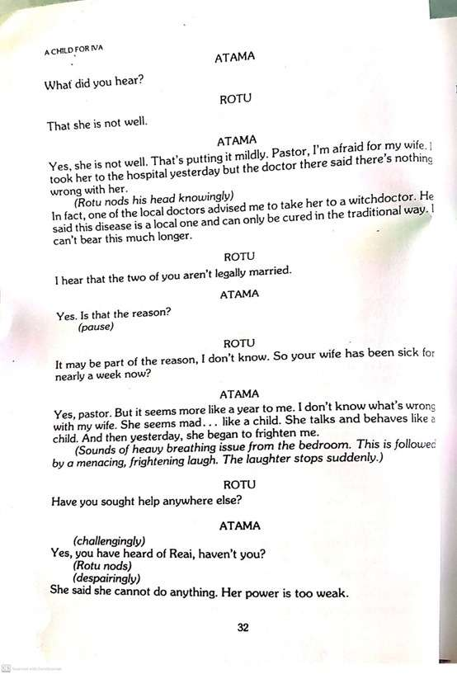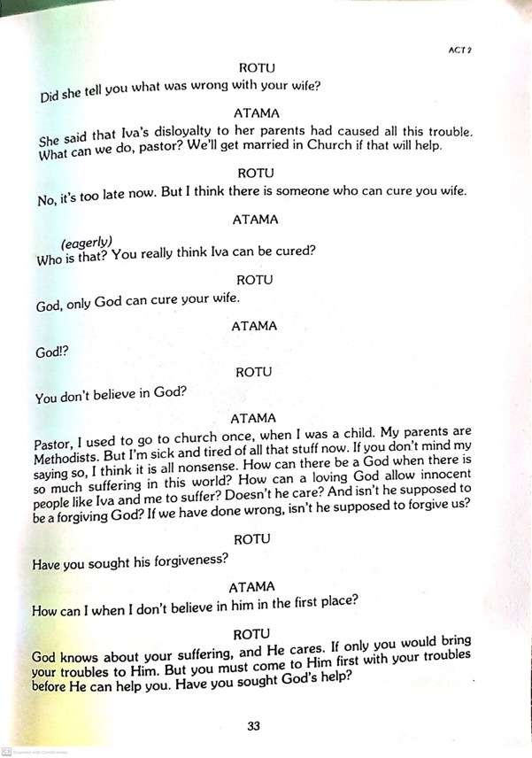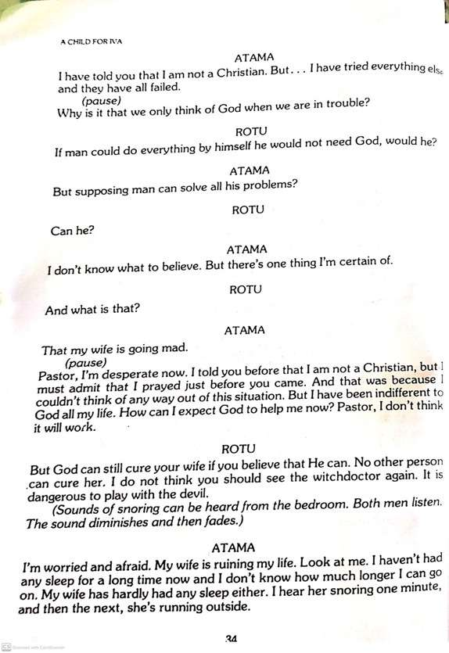
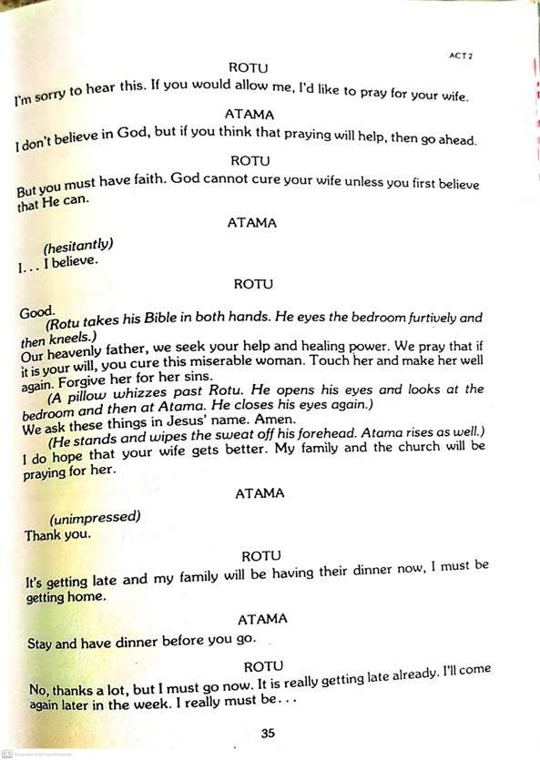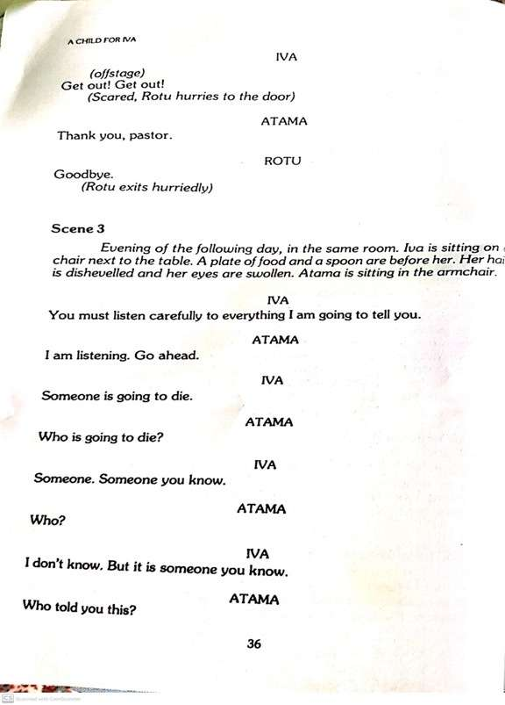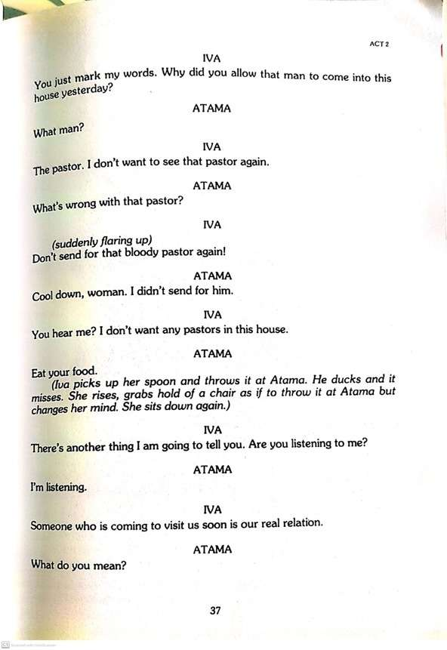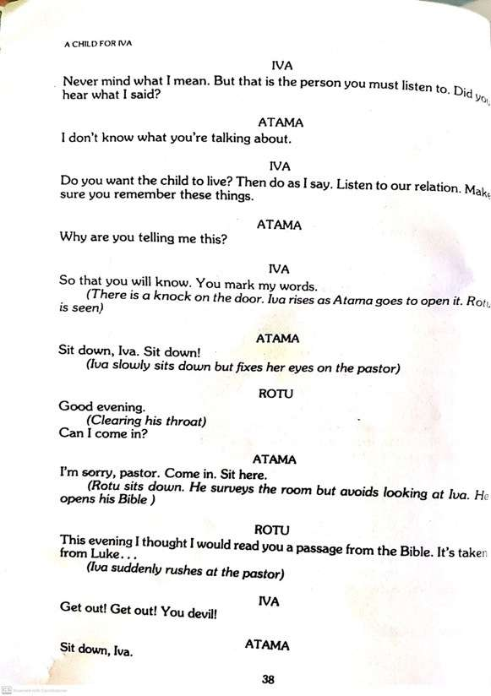
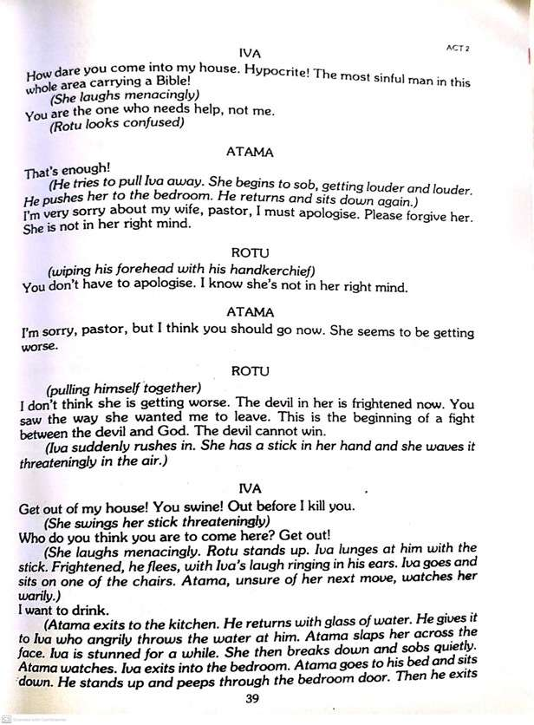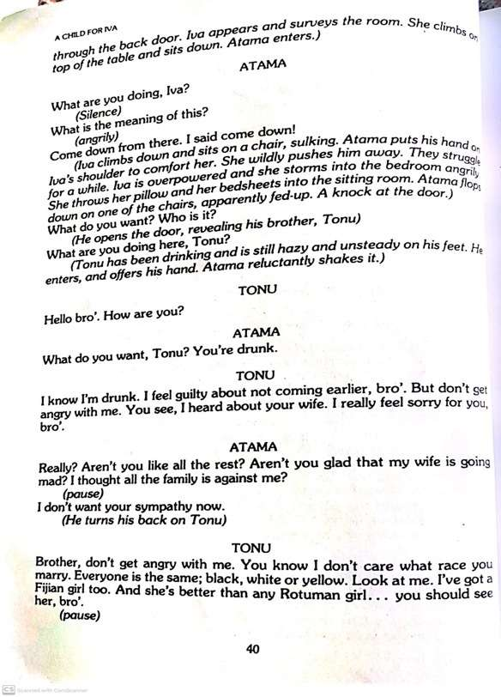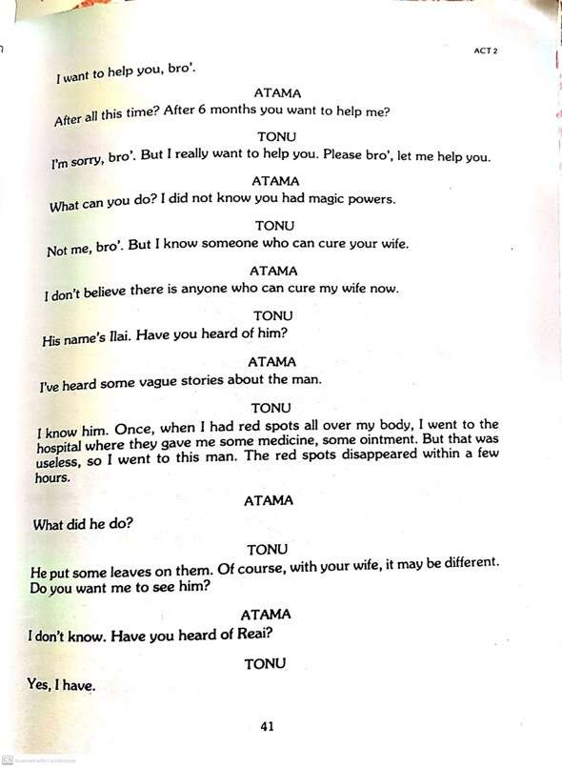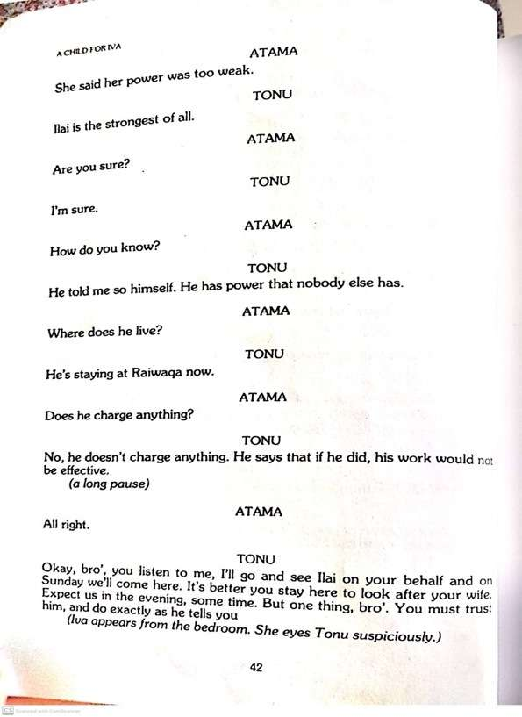
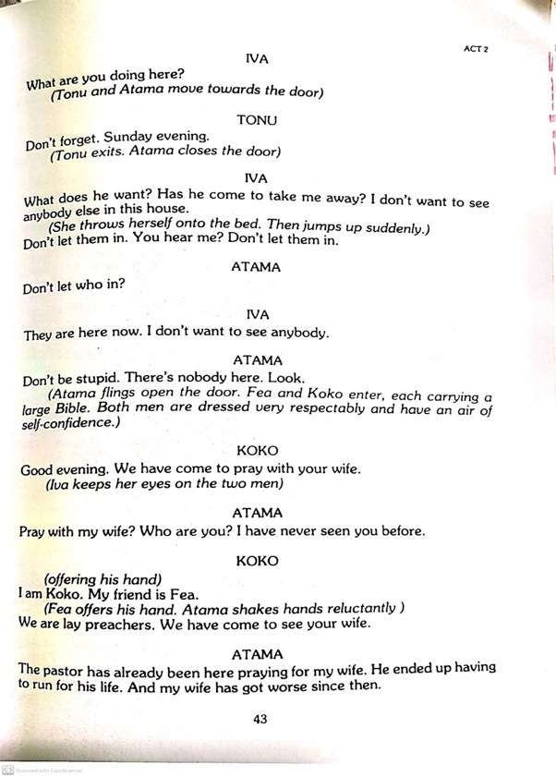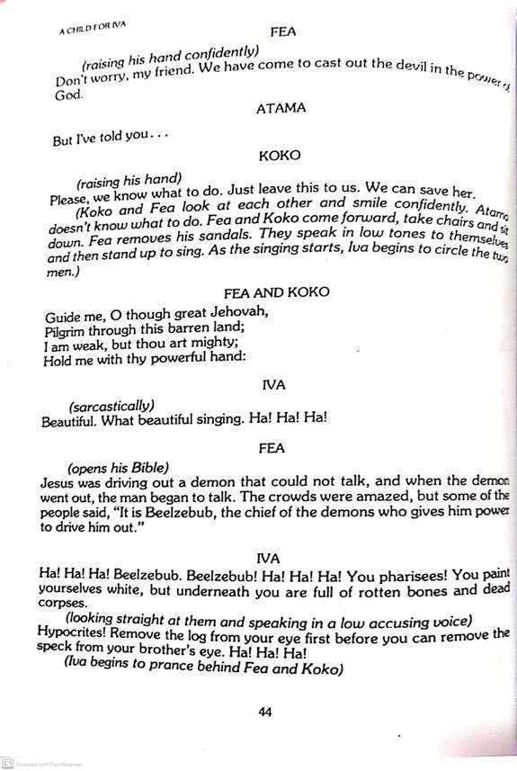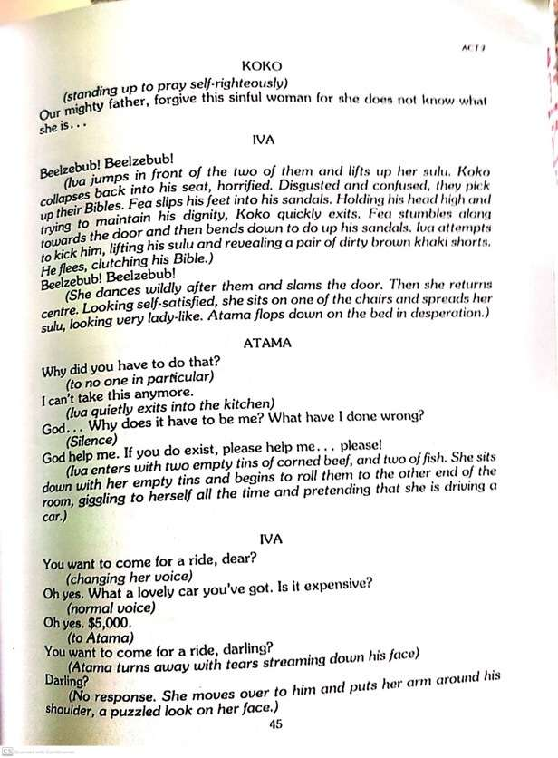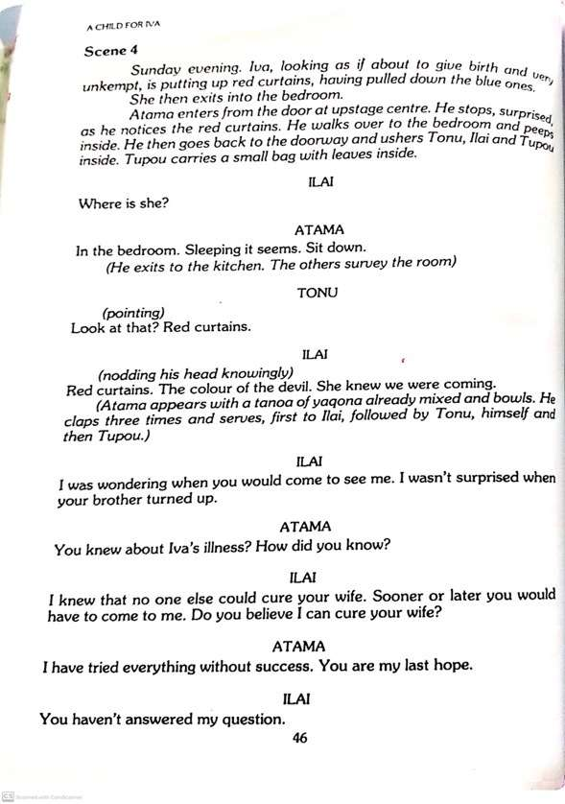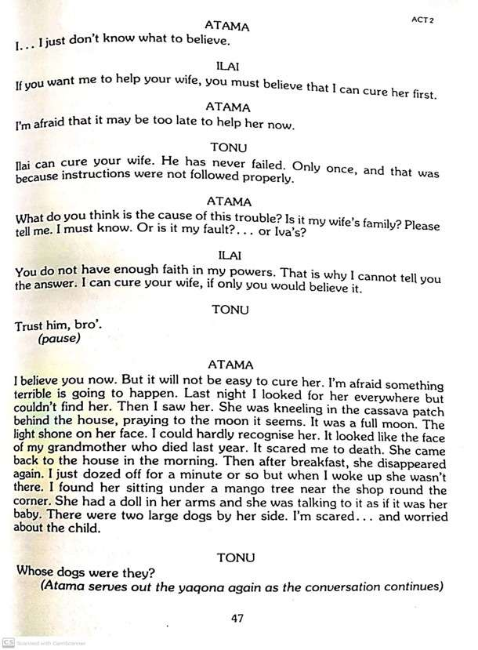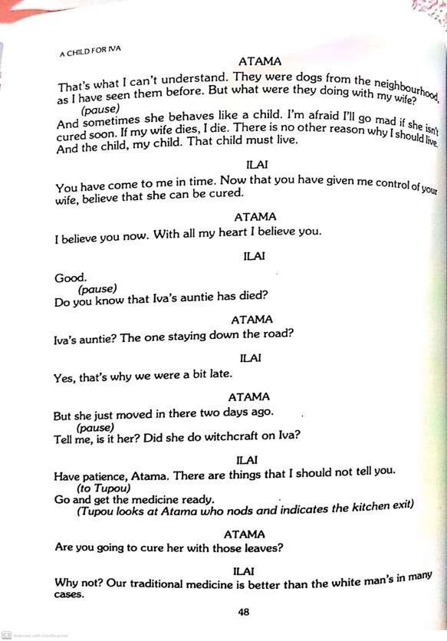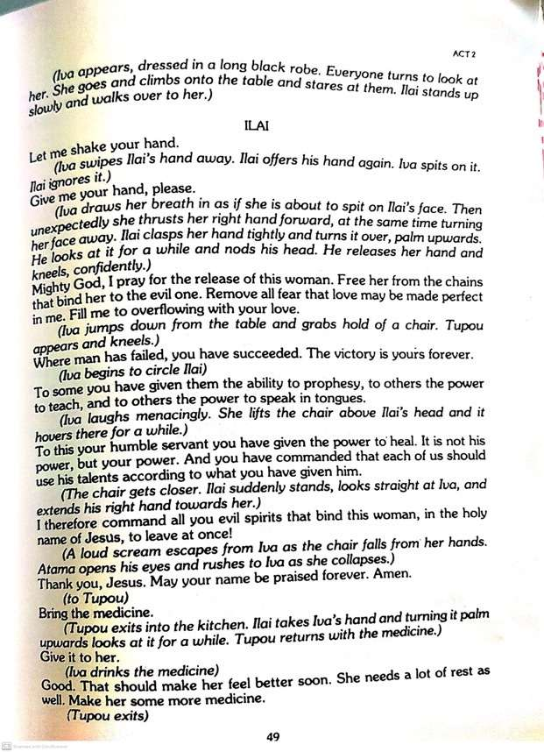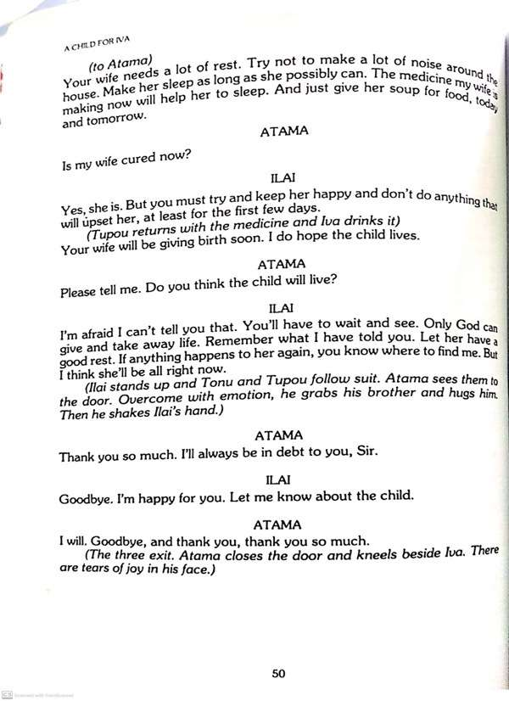

LESSON NO: 55 | TOPIC : LITERATURE  Drama Act 2  Scene 1,2
STRAND | READING AND VIEWING/ LISTENING AND SPEAKING
SUB STRAND | LANGUAGE LEARNING PROCESSES AND STRATEGIES/  SOCIOCULTURAL CONTEXT AND SITUATIONS
LEARNING OUTCOME | -Read and analyse Act 2 , scene 1 and 2 of the drama.

Act 2 Scene 1 Iva’s Depression
Plot
- After 6 months of staying in Suva, Iva becomes heavily pregnant.
- Atama has found a job but it is not sufficient to meet all requirements especially of the upcoming child.
- Iva tells Atama that she does not feel like eating and is always tired.
- She is depressed after knowing that her father had lost his job and needed money.
- Iva further admits that she feels imprisoned in the flat as she is lonely and does not know any neighbours.

Activity Read Act 2 Scene 1 and answer these questions
- After listening to the dialogues read by selected students, in pairs;

- Recall and tell whatever has been mentioned about Iva’s father.
__________________________________________________________________
- Discuss why Iva’s father could have been sacked.
__________________________________________________________________
__________________________________________________________________

- Read page 29 closely and list all the reasons given by Atama for not giving money to Iva’s parents.
__________________________________________________________________
__________________________________________________________________

- What other reasons are provided by Iva for her depression?
___________________________________________________________________
__________________________________________________________________

Act 2 Scene 2: Iva’s Strange Behaviour (Madness)  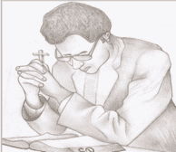 | Plot  - After two days from last scene, Iva has started acting strangely and Atama is very worried.  - A local pastor, Rotu, comes because he has heard about Iva. Rotu thinks that Iva’s sickness may be because they are not married and Atama tells him that a witchdoctor (Reai) had suggested that it is because of Iva’s disloyalty to her parents.  - Rotu prays and just as he is leaving, Iva shouts for him to get out of the house.
1. When the doctors said that there’s nothing wrong with Iva, what do you think are the two possible causes for the change in Iva’s behavior? (Clue: use your own ideas from what you have observed from your society and consider Iva’s depression in the previous scene)
________________________________________________________________________________________________________________________________________________
2. What are the reasons provided by Atama for not believing in God?
________________________________________________________________________________________________________________________________________________
3. What suggestions does the pastor give Atama for believing in God?
________________________________________________________________________
4. Notice how Rotu and Atama begin their conversation (page 31).
What two discussions take place before they reach the main topic?
________________________________________________________________________
________________________________________________________________________

LESSON NO: 56 | TOPIC: LITERATURE  Drama – Act 2 Scene 3,4
STRAND | READING AND VIEWING/ LISTENING AND SPEAKING
SUB STRAND | LANGUAGE LEARNING PROCESSES AND STRATEGIES/  SOCIOCULTURAL CONTEXT AND SITUATIONS
LEARNING OUTCOME | -read and analyse Act 2 , scene 3 and 4 of the drama

Act 2 Scene 3 Iva’s condition Worsens
Plot
- Iva tells Atama that she doesn’t want any pastors in the house.
- Shortly after, Rotu returns and decides to read the Bible.
- Iva firstly tells him to get out.
- But when insists on staying, she chases him with a stick.
- Tonu, Atama’s older brother, comes in drunk and offers to help.
- Tonu has heard about Ilai who lives in Raiwaqa and is confident that Ilai is the best witchdoctor.
- He would make arrangement for Ilai to visit Atama on Sunday.
- When Tonu leaves, two lay preachers come; Koko and Fea.
- Iva embarrasses them and forces them to leave.

Activity Read Act 2 Scene 3 to answer these questions.
  - What are two things told by Iva to Atama from pages 36 to 38?
____________________________________________________________________________________________________________________________________
  - Explain what you understand by the term ‘hypocrite.’
__________________________________________________________________
  - Why do you think Tonu is using short sentences?
__________________________________________________________________
  - Where do you think Tonu lives? Give a reason for your answer.
__________________________________________________________________
  - In two sentences, write Tonu’s plan in helping Atama.
____________________________________________________________________________________________________________________________________
  - What is the meaning of the names of the two lay preachers?
____________________________________________________________________________________________________________________________________
7. Explain what do you understand by ‘you paint yourselves white, but underneath you are full of rotten bones and dead corpses (page 44).
_______________________________________________________________________________________________________________________________________________
- Discuss what happened to Fea and Koko when they came to pray for Iva?
________________________________________________________________________________________________________________________________________________________________________________________________________________________________________________________________________________________________

Act 2 Scene 4 Iva is cured
Plot
- Tonu comes on Sunday evening with Ilai and Tupou.
- Atama is very worried because Iva’s condition had worsened.
- Atama admits that he trusts in Ilai’s powers.
- Iva comes and Ilai prays for her.
- After the prayer, Iva collapses.
- Ilai tells Atama that his wife is now cured and needed rest.
- Atama is to keep Iva happy.
- Ilai is not sure about the fate of the unborn child.
- Recall and tell whatever has been mentioned about Ilai.
__________________________________________________________________________________________________________________________________________
- Discuss why Ilai does not charge for his service.
__________________________________________________________________________________________________________________________________________
- Why do you think Ilai wants total trust from Atama before he could cure Iva?
_____________________________________________________________________
- Ilai says “our medicine is better than the white man’s in many cases.” Do you agree with the above statement? Give reasons for agreeing or disagreeing on the topic and write it in a paragraph.
_______________________________________________________________________________________________________________________________________________________________________________________________________________

LESSON NO: 57 | TOPIC: PERSONAL WRITING Conversation
STRAND | Writing and Shaping
SUB STRAND | Text types/Socio cultural contexts and situations
LEARNING OUTCOME | Plan and write a dialogue.

PLAN and WRITE a conversation based on the given picture in the writing book
The theme is transportation and punctuality.
(source:www.fijisun.com )

LESSON NO: 58 | TOPIC: Comprehension 6
STRAND | Reading and Viewing
SUB STRAND | TEXT TYPES: MEDIA TEXT, EVERYDAY COMMUNICATION & LITERARY TEXT
LEARNING OUTCOME | -Read with understanding and analyse the passage by answering given questions.  -recall important details.

Dead birds fell from the sky in Cakaudrove; Experts investigate
By:LUKE RAWALAI 9 April, 2020

1  6  9  14  20 | Residents of Peceliema Settlement, near Naweni Village in Cakaudrove, were witnesses to a strange phenomenon, when birds mysteriously began falling from the sky on Monday afternoon.  A video circulated on Facebook showed residents watched as birds nose-dived to the ground, fatally wounding themselves on impact.  Roko Tui Cakaudrove Filimone Naiqumu said their conservation officer, a veterinarian from the Agriculture Ministry and personnel from the Biosecurity Authority of Fiji had been dispatched to investigate the incident.  Meanwhile, in an interview, regional program coordinator for BirdLife International Pacific Partnership Secretariat Mark O’Brien said after watching the videos, his initial view was that the birds may have died from poison.  “It may be a natural pesticide that people used that was misapplied or used in wrong doses,” he said.  Mr O’Brien added the birds could have also contracted the poison from insects or invertebrates that fed on plants treated with the wrongly prepared weedicide.  “When you look at the distribution of birds in Fiji, Mynah birds are found in agricultural farmlands, and they are, maybe, the only species that eat insects and invertebrates from the grass, and I guess that this is how they may have contracted the toxin.  “Maybe since these insects or invertebrates are dead in numbers, birds find it easy to eat them by flocking to feed which is why there are a lot of them infected.  “Let’s not rule out the probability that there are other species of birds also dead in other areas of the forest so we need to await the results of investigations by personnel.”  (Source: The Fiji Times Website)
Questions
1. The antonym of the word phenomenon (line 2)is
A. occurrence B. miracle C. normality D. sensation

2. The word fatally in line 5 is
A. a noun B. an adverb C. an adjective D. a verb

3. According to the regional program coordinator for Bird Life International Pacific Partnership Secretariat, Mr. Brian, ________________________________________________________________
___________________________________________________.
4. The main purpose of this passage is to _________________________________________
___________________________________________________.
5. Mynah birds are ___________________________________________________________ and they may have contracted this toxin from_____________________________________
___________________________________________________.

B . Interpret the Cartoon
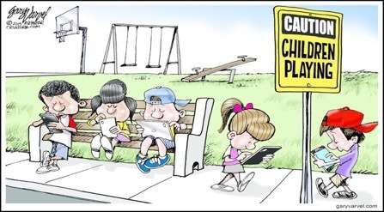
The main message shown in this cartoon is _______________________________________
_____________________________________________________________________________

Week 3 Worksheet on Drama
