YEAAR 10 BASIC TECHNOLOGY

STRAND:HAND TOOLS AND APPLIANCES

Lesson 1: Geometrical Tools
Learning Outcome: Identify the tools & its uses

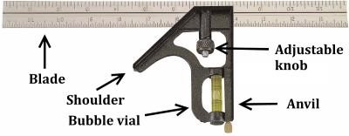
- Combination Square

- A combination square is a tool used for multiple purposes in woodworking.

- The combination square can be used for leveling,

- As a try square, to determine the squareness of a piece of joint

- It can also be used as a saw guide.

2. Sliding Bevel

- A sliding bevel is a tool which can be set to different angles to aid marking out.

- It is composed of two parts, the stock and the blade. The stock is usually made from rosewood which is a high quality material. The blade is made from hardened and tempered steel. It is used to mark lines at any angle on a work piece.

How to use a Sliding Bevel

To make a new angle

- Loosen the wing nut adjustment so that the blade is free to rotate.
- Swing the blade until the desired angle between the handle of the bevel and the blade side is made. This may be best achieved by placing a protractor on the inside of the bevel itself (so that the protractor is resting on the wing nut) and measuring out the desired angle.
- Lock the T bevel into place by tightening the wing nut.
- Lay the T bevel on your working surface and draw the angle by tracing along the inside of the T bevel blade and handle.
- Cut away.

To transfer an existing angle

- Loosen the wing nut adjustment so that the blade is free to rotate.
- Lay the T bevel against the surface of the angle cut to be copied.
- Rotate the inside edge of the blade to the existing angle until it matches the angle being transferred.
- Tighten the wing nut until it locks the blade and handle in position.
- Place the T bevel on the working surface and transfer the angle.
- Draw out the angle by tracing along the bevel on the inside edge of the blade and handle.

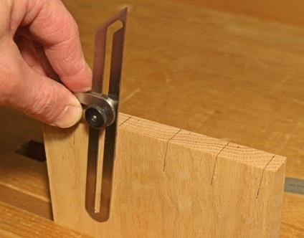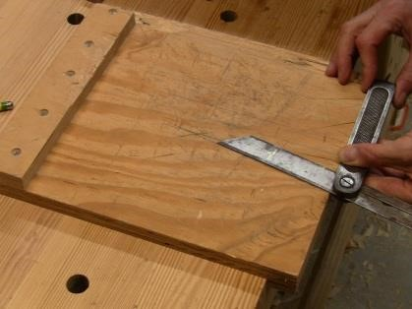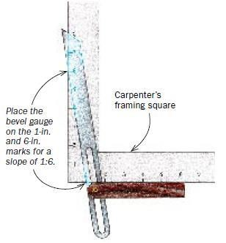
Setting the sliding Bevel to a slope of 1:6 for a d
ove tail joint

Lesson 2: Holding & Supporting tools
Learning Outcome: Understand the use of the tools & its parts

- Sash Cramps

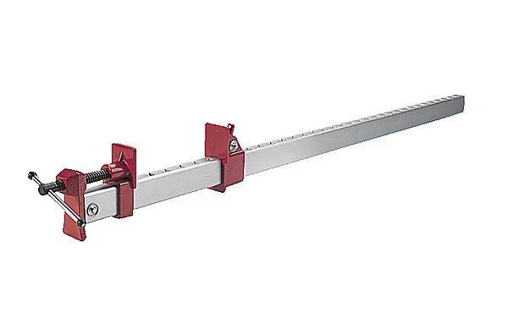
- Sash clamps are used to clamp work together when it is glued. They vary in size and are normally used in pairs.
Head

Slide

Bar

Thread

- When in use, the sash clamp is placed below the work to be glued / assembled.

- The slides are arranged on either side and scrap wood is placed between each face and the work. This protects the work when the thread is tightened.

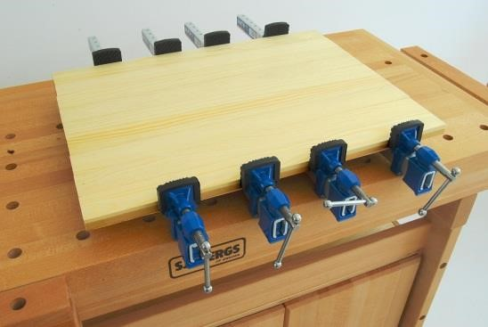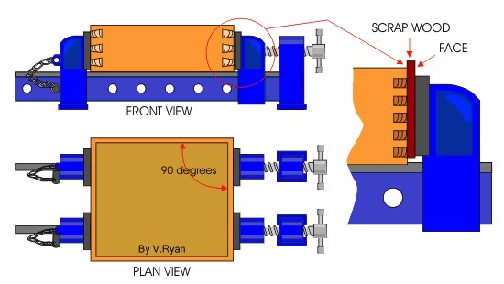

Lesson 3: Hand Saws
Learning Outcome: Identify the types of saws & its use
- Hand saws are hand-held tools, manually-driven, that are designed to cut through softer materials mainly wood.
- There are many different types of hand saws that vary based on how and what they cut.
(i) Keyhole Saw
- A keyhole saw is perfect in cutting holes in wood and curves.
- It is used for cutting holes in soft woods or in drywall, such as cutting a hole in a wall for a new electric switch.
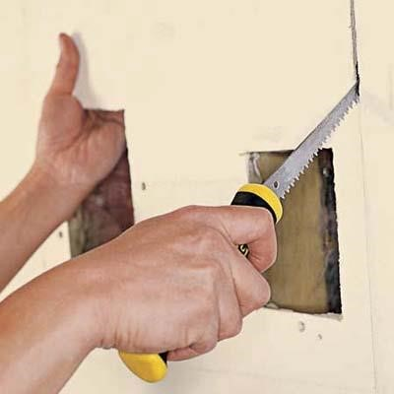
Blade

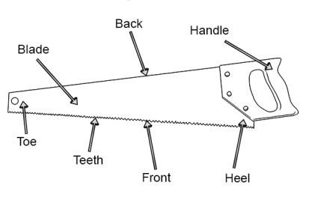
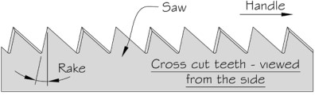
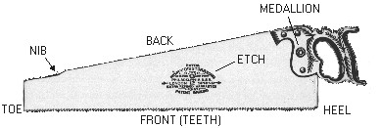
- Cross Cut Saw
- A cross cut saw has wide alternating bevel teeth perfect for rough cutting on wood grains where tearing out is not important.
- It is used to cut large pieces of timber or cuts through a tree across the grain of timber.
- Panel Saw
- Panel saws are perfect for cutting small pieces of wood.
- It is especially used for cutting light boards like plywood across the grain.

- Rip Cut Saw

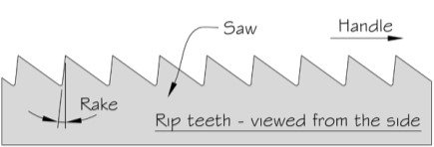
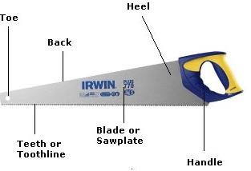
- A rip cut saw is an aggressive, push stroke handsaw with sharpened teeth top.
- It is specially designed for making cut parallel to the direction of the wood grain.

- Back Saw

- Back saws are used for trimming and fine woodcutting.
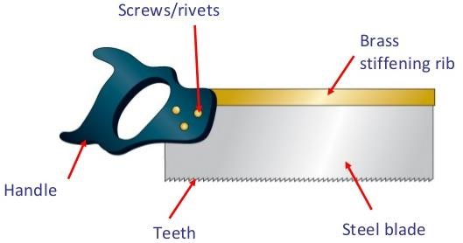
Its teeth are smaller compared to other types of hand saws
- It is used for making fine accurate cuts in small pieces of wood such as cutting of joints, angles with and across the grain.
- Coping Saw
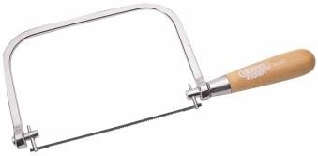
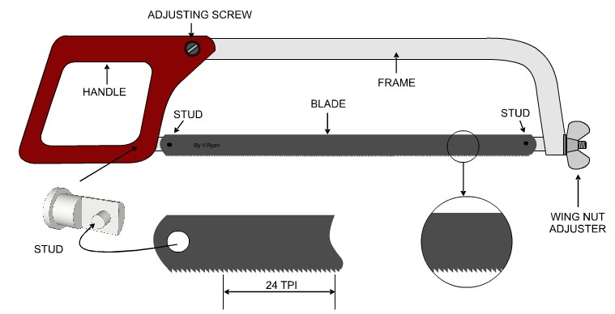
- Coping saws are perfect for cutting complex patterns on wood.
frame

blade

handle

- A coping saw is a pull stroke hand saw.

- Hacksaw
- Hacksaws have fine, disposable blades held in Tension by front and back pins.
- It is used to cut rods, bars, angle plates to required lengths and sheet metals to specific size and shape.
ACTIVITY

- Name the hand tool in the diagram given below and state the process being carried out.
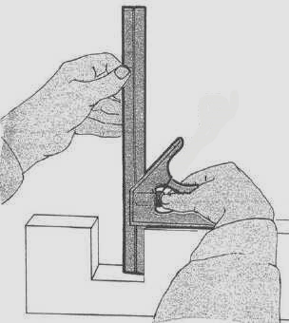

- Name the part of the hand tool marked X given below

- Given: A sketch of a 45° set square on the right and corner A labelled.
Required: Redraw the set square to a scale of 1:1 starting from corner A given below.

