RATU NAVULA COLLEGE
YEAR 10 BASIC SCIENCE
WEEK 1 (28/06) – WEEK 2 (09/07)
2021

INSTRUCTIONS
- Greetings my year 10 Basic Science students, I hope that you have been enjoying your home stay holidays. I know that pen and paper is on hold but I would like to encourage you to try and spend at least few hours to go through your notes and complete the prepared set of notes before 15/06.
- No need for you to copy the notes. Just get hold of some highlighters in order to highlight important points.
- Since most of you are well acquainted with the net ,this will be a very good time to cruise the net and goggle search some science topics and terms at home in the convenience of your room, thus, bringing school laboratory closer to you.

- Ask your parents and guardian to assist you at home. Stay safe and follow the COVID -19 Rules and Regulations.
- Looking forward to seeing all of you after the lockdown period. Praying for your safety.

Lesson 18 /19 Conservation Methods(2 hours)
L/O Explain the traditional and contemporary methods of conserving the marine ecosystem for its protection.
Traditional Methods
Indigenous methods of cultivating crops, food preservation and traditional fishing methods in conservation. Example:
- Traditional fishing methods: harpoons, throw nets, drag nets, fish drive(yavirau),
- Cultivation Methods: shift cultivation- moving from a used land to another un used land for farming, Rotation cultivation – Replacing a crop with another e.g. dalo replaced with yams or cassava. Mulching – adding mulch prevents erosion. Growing grass on slopes- prevents soil from being washed away. Terrace cropping- slows down and gives water time to be absorbed into the soil and enriching the soil.
- Preservation Methods: Preservation of staple carbohydrates foods by cooking in a pit Davuke or lovo). Drying and grilling of fish. Storing pickles in coconut milk.
Contemporary Methods
Modern methods of conservation. Example:
- Protect animals and plant species by introducing laws.
- Restore wastelands and country sites.
- Restore areas naturally e.g. reintroducing species.
- Replace by using alternative resources for coal and oil e.g. solar energy.
- Preserving rare animals in nature reserves and zoos.
- Recycling or reprocessing of unwanted products (e.g. newspapers, scrap metals, glass and sewage).

Lesson 20/21 Public Awareness and Career(2 hours)
L/O Raising awareness to educate the community on conservation and exploring career opportunities in the field of medical and environment.
Ways of Raising Public Awareness
- Seminars
- Workshops/conferences
- Awareness of materials (brochures, posters, videos, stickers etc.)
- Exhibitions
- Public awareness events
- Visitors days
- Field days
- Media ( news papers, radio, TV)
- Websites and other internet based tools
Careers opportunities in the Medical and Environment field
Environmentalist, botanist, zoo keeper, Ecologist, biologist, nurse, science teacher, doctor, pharmacist, chemist etc.
Student Activity
Prepare an A-4 size poster on conservation.

STRAND 2: MATTER
Lesson 22 Structure and constituents of an atom (2hours)
L/O : Explore and identify the structure of an atom
Structure of an atom
electron
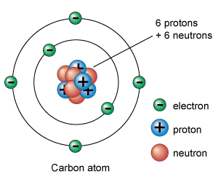
An atom is the smallest particle of something that cannot be divided. It is the building block of matter.
Protons- positively charged ion, tightly packed together in the nucleus.
Neutrons – are neutral particle (no charge), found in the nucleus.
Electrons – negatively charged ion, moves around the nucleus in shells or orbit.
Protons and neutrons are heavier than electrons. The negatively charged electron balances the positive charged proton .i.e. the number of protons is equal to the number of electrons. For e.g. the above carbon atom have 6 protons, therefore, the number of electrons is also 6.

Student Activity
Fill in the blanks:
The positively charged particles are called_______. The negatively charged particles are called________. The number of protons and the number of electrons in an atom are________. Protons and neutrons are present in the________.

esson 23 - The Periodic Table (2 hours)
L/O – Identify the elements in the periodic table with relation to their atomic number and mass number.
PERIODIC TABLE
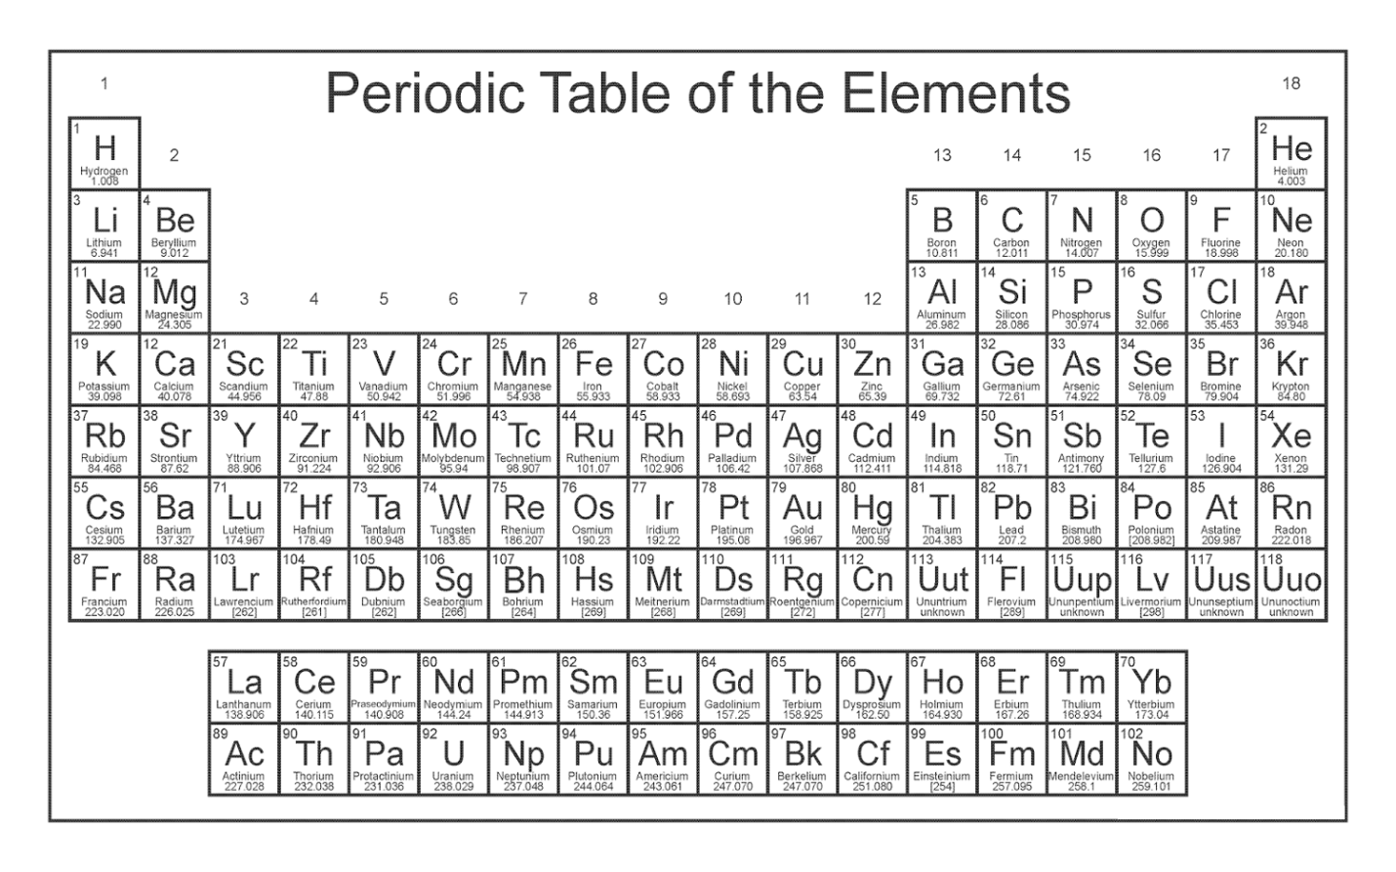

The first twenty elements
1. | Hydrogen | 11. | Sodium
2. | Helium | 12. | Magnesium
3. | Lithium | 13. | Aluminium
4. | Beryllium | 14. | Silicon
5. | Boron | 15. | Phosphorous
6. | Carbon | 16. | Sulphur
7. | Nitrogen | 17. | Chlorine
8. | Oxygen | 18. | Argon
9. | Fluorine | 19. | Potassium
10. | Neon | 20. | Calcium
In the periodic table, each row is called a period and each column is called a group.
Atomic Number (Z)
- It is the number of protons of any atom. It tells you the element of an atom. For e.g. any atom with 6 protons is called carbon.
- The atomic number is always the smallest number.
Mass Number (A)
- The mass number is the total number of protons (p) and neutrons (n) in an atom. It is the biggest number.
- Another name for mass number is atomic mass.

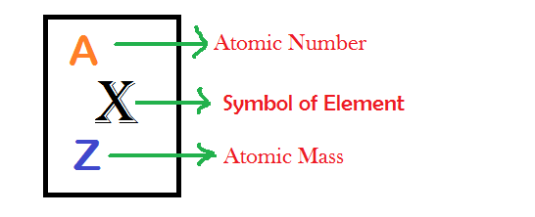

E.g. Carbon atom

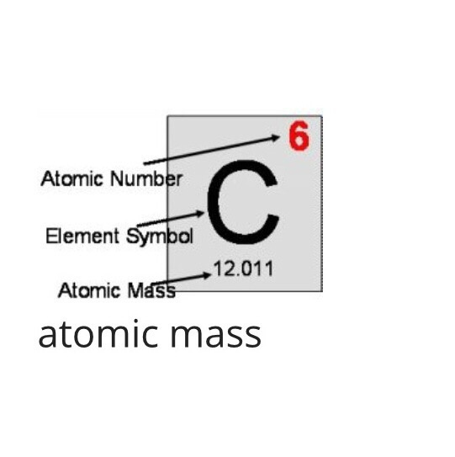

Symbol | C
Atomic Number | 6
Atomic Mass | 12
No. of protons | 6
No. of electrons | 6
No. of neutrons | 12-6=6

Isotopes
Two atoms of the same element have different number of neutrons (or have different atomic mass).
For example:
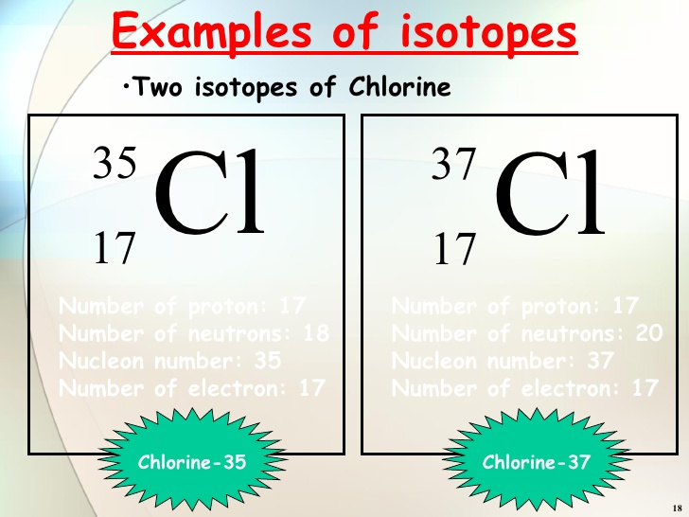
Number of protons | 17 | Number of protons | 17
Number of electrons | 17 | Number of electrons | 17
Number of neutrons | 35 – 17=18 | Number of neutrons | 37 – 17 = 20

The number of protons and electrons for Chlorine are same but the number of neutrons is different.

Lesson 24- Electron Structure (2 hour)
L/O – Draw the electron structure of an atom.

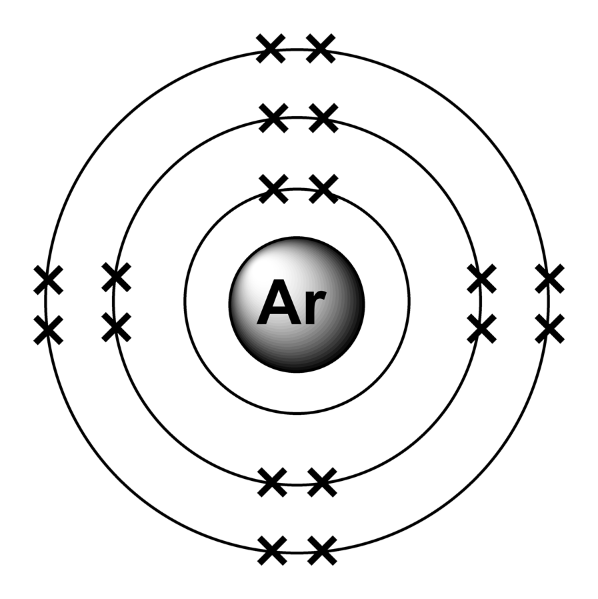  1st shell  2nd shell  3rd shell | - 1st shell can carry only 2 electrons  - 2nd and 3rd shell can carry only 8 electrons  - 4th shell can carry only 18 electrons  - Given on the left is the electron structure of Argon of atomic number: 18 with electron configuration: 2,8,8  - Last shell is called the valence shell.  - Outer electrons in the valence shell determine the property of an element.  - If 8 electrons in the valence shell, it makes the atom stable and unreactive.

Student Activity
1.Complete the table below:
Element | Name of Element | Symbol | Mass Number | Atomic Number | No: Proton(s) | No: Electron(s) | No:  Neutron(s)
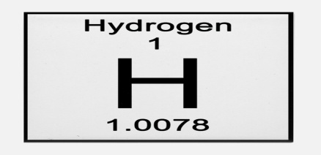

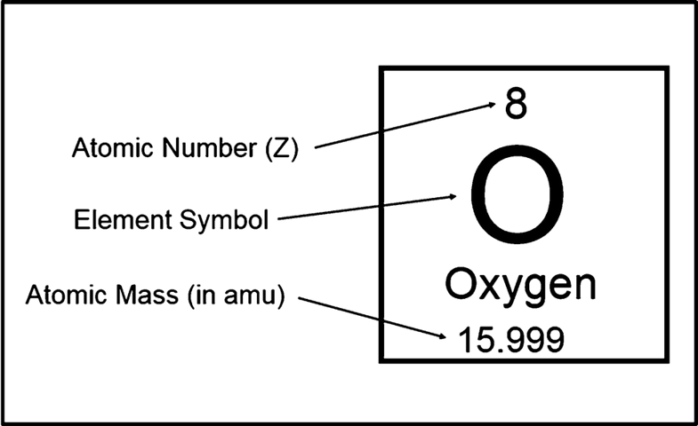

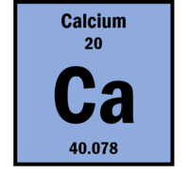

2. Given the Oxygen atom:
(i) Give the electron Configuration of oxygen: _____________________
(ii) How many electron shells make up the Oxygen atom? ___________
(iii) How many electrons are in each shell? _____________________________
(iv) Draw the electron structure diagram of oxygen.

esson 25 – Properties of Common element (2 hours)
L/O Justify the properties of common element in relation to their position in the periodic table.

- The atomic number increases from left to right.
- The valence shell remains the same but the number of valence electron increases.
- There are 8 groups labelled in Roman numerals.
- GROUP I- Alkali Metals( Lithium, Sodium, Potassium)
Physical Properties- metals, light, silvery, shiny, low melting and boiling point.
Chemical Properties – Lithium is the least reactive, Potassium is the most reactive.
Colour – Lithium (red), Sodium (yellow), Potassium (lilac)
- GROUP II – Alkaline Earth Metals(Calcium, Magnesium, Beryllium)
Physical Properties – shiny, silvery white, low density and melting point.
Chemical Properties – reactive and unstable
Has two electrons in their outer shell.
- GROUP VII – Halogens(Fluorine, Chlorine)
Physical properties – non metallic, low boiling and melting point, toxic
Chemical properties – react with metals to form compounds called salt.
Colours – Fluorine (pale yellow), Chlorine (yellow/green)
State at room temperature – Fluorine/Chlorine (gases)
Halogens in Greek means ‘salt producing’.
- GROUP VIII Inert gases ( Helium, Argon, Neon)
Physical Properties – noble gases
Chemical Properties – does not undergo chemical reactions, very stable, extremely low reactivity.
Uses – Argon used in electric bulbs, preventing tungsten filament to burn out. Helium inflates balloons, shield of welding.
Reactivity Series
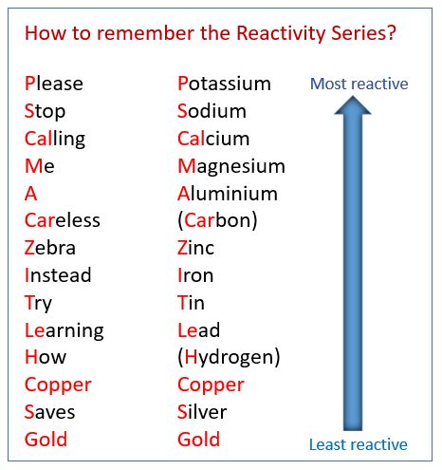

Student activity
- Out of the following which is the most reactive metal?
- Gold B. Iron C. Silver D. Potassium

- Write down the name of group I and II of the periodic table:
I - _________________________ II- _______________________
- State a general property of this group of elements

Lesson 26 – Metals and Non Metals (2hours)
L/O – List properties of metals and non metals.
Properties of Metals and Non Metals
Metals | Non Metals
- Left of the periodic table  - Most are solid except for mercury  - High bpt and mpt  - Very good conductor of heat and electricity  - Shiny(silvery except for copper/gold  - Strong material  - Malleable – easily beaten to sheets  - Ductile – pull to wires  - High density- heavy  - Sonorous – ringing noise  - React with oxygen to form basic oxide.  - Group 1 metals are most reactive | - Right of periodic table  - Gases, liquid or solid in room temperature.  - Low mpt and bpt  - Good insulator  - Dull  - Brittle- break easily  - Low density  - React with oxygen to form acidic oxide.

Student Activity
- Metals are malleable, ductile and
- Brittle
B. have low density
C. have low melting point
D. good conductors of electricity.
2. The property of non metals which can be breakable is called
A. flexibility B. brittle
C. insulator D. contraction

Lesson 27 – Uses of Metals and Non Metals(2hours)
L/O – Demonstrate the difference between metals and non metals
Metals | Non Metals
- Aluminium – bodies of planes since it has low density  - Making sauce pans since it is a good conductor of heat and it is non toxic  - Cooking foil and milk tops since it is malleable and strong  - Copper – electrical wire as it is a good conductor.  - Water pipes due to its low reactivity  - Bell making due to its ringing sound(sonorous)  - Gold – electrical connections on circuit boards due to its conductivity.  - Jewellery due its lack of reactivity so it does not rust and it is shiny.  - Steel – cheap and strong so it is suitable for building material, car parts, kitchen sinks, cutlery.  - Lead – suitable for fishing line sinkers and roof sealing due its malleability  - Automobile industry(batteries) since it is rust resistance. | - Carbon(graphite) – Lead of pencil and electrodes in electrolysis in dry cell since it is soft and smooth.  - Carbon (diamond) – Drill bits for cutting stones since it is hard.  - Jewellery since it is colourless and transparent.  - Neon gas –light used for bill boards due to its poor conductivity.  - Chlorine – Kill germs in drinking water, used for making plastics, bleaching powder and liquid due to its acidic and solubility in water.  - Phosphorous – Making matches since it reacts easily with oxygen.
Alloys – Mixtures of metal with other substances in order to improve its property. E.g. Steel(Iron and a little bit of carbon). Brass(copper and zinc)

Activity
Testing material for conductivity

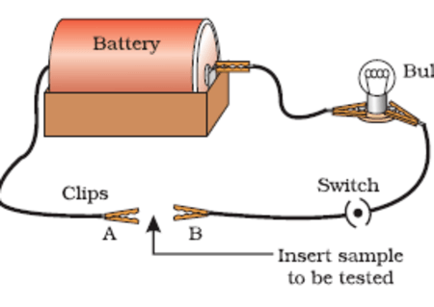
Use electric current if the light bulbs lights up than it is a metal and if not it is a non metal.
Student activity
- Carbon element example graphite are used in
- Jewellery C. making matches
- Chip D. lead of pencil
- Brass is an alloy of copper and
- Tin C. iron
- Zinc D. magnesium

- We use different metals for different purpose as they have different properties. Complete the table below:
Metal | Property | One use
Iron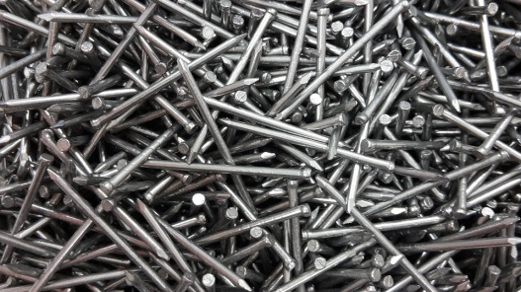 | Strong and durable, lasts long

- Match the substances in List A with the correct uses from List B.
List A |  | List B
(i) | Aluminium | G | Make computer chips
(ii) | Silicon | H | Diamond is an example
(iii) | Carbon | I | Galvanises iron
(iv) | Lead | J | Fishing line sinker
(v) | Zinc | K | Metal in electrical lines
 |  | L | Metal in electrical appliances

Lesson 28 – Heating and Cooling of metals(1 hour)
L/O – Experiment on metals by heating and cooling them.
Three ways of heating and cooling method:
Annealing | Heat a metal till red hot and slow cooling | Soft and flexible
Quenching | Heat a metal till red hot and dip in water. | Hard and brittle
Tempering | Heat till blue and slow cooling | Hard and springy.

Student Activity
- Quenching a metal changes its properties. Quenching makes a metal
- Soft and brittle. C. hard and brittle
- Hard and springy D. soft and springy
- A student has a steel wire that is springy. She wants to make a permanent bend in it at a certain place, but it is too springy to stay bent.
- What could she do to the part of the wire that needs to be bent?
_________________________________________________________
_________________________________________________________
- How could she later make the part of the wire springy again but not too brittle?
_________________________________________________________
_________________________________________________________

Lesson 29 Work on Metals (1 hour)
L/O Experiment on metals by doing work on them
Work is when we use force and make something move.
Methods of changing metal shape.
- Hammering – metals are beaten into shapes.
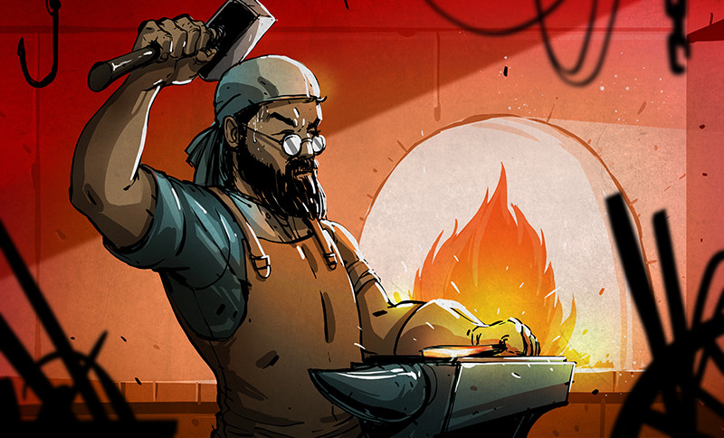
- Rolling – Large blocks of metals are rolled back and force between heavy rollers e.g. making flat sheet or corrugated iron roofing. 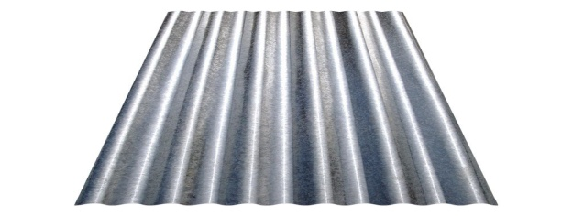

- Pressing – a sheet of metal is pressed down .e.g. car bodies.
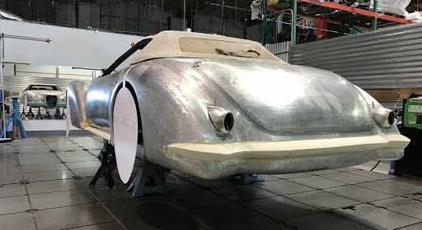

- Pulling – long piece of metal is pulled out through a hole, the metal becomes longer and thinner.e.g. making wire and nails.
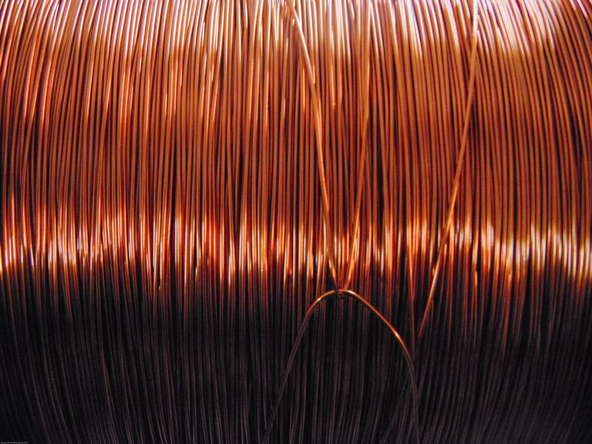
- Spinning – a flat piece of metal is held at its center and spun around e.g. saucepans and cooking pots.
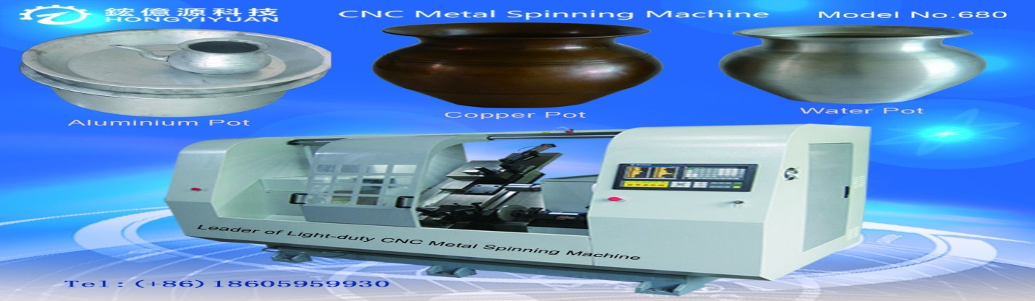

- Twisting – heating a metal bar until red hot and twist the heated part.
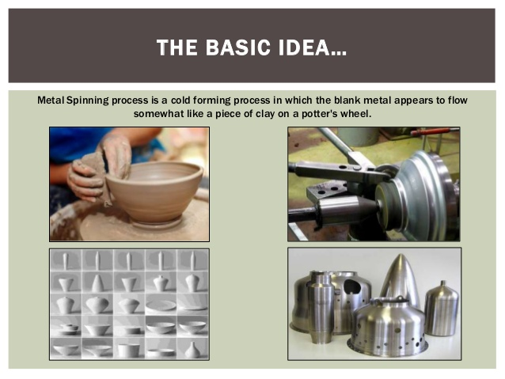
During the work on metals process the metal becomes work hardened meaning hard and brittle.

Student Activities
- Name two ways of changing the shape of a metal.
_____________________________________________________
_____________________________________________________
2. Two shiny objects found by a student were both hit with a hammer. The first object, X, broke into pieces while the second one, Y, spreads out.
What two conclusions can you draw from the above observations?
- X - _________________________________________________
Y - _________________________________________________

Lesson 30 Magnets (1 hour)
L/O Explain the difference between magnetic and non – magnetic metals.
Metals that are attracted by a magnet and can form a magnet when magnetized are called magnetic metals. The only magnetic metal is iron and if a metal has iron in it .e.g. steel.
A magnet is a metal that can attract other metals. Only certain materials can become magnets. A material that can become a magnet is called a magnetic substance
Types of magnets
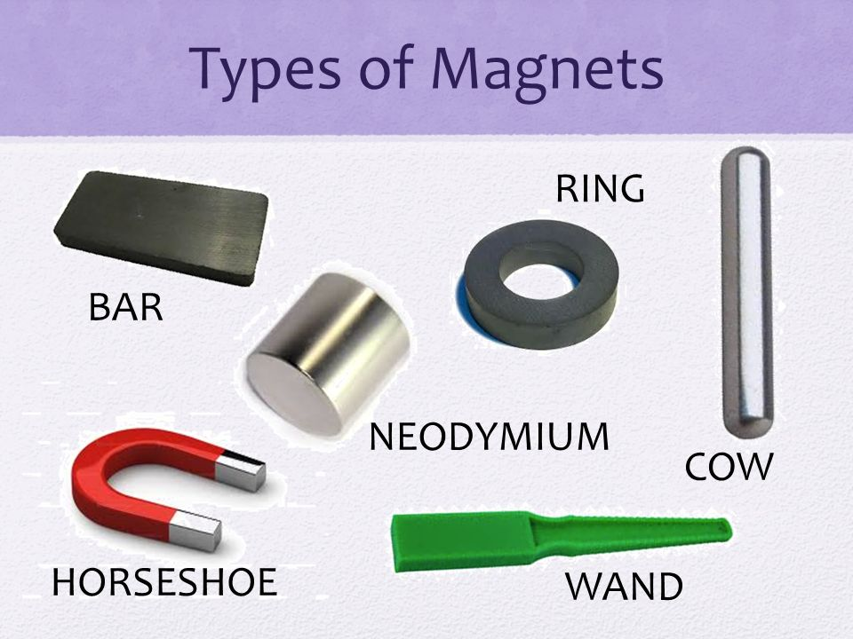
Uses of magnets
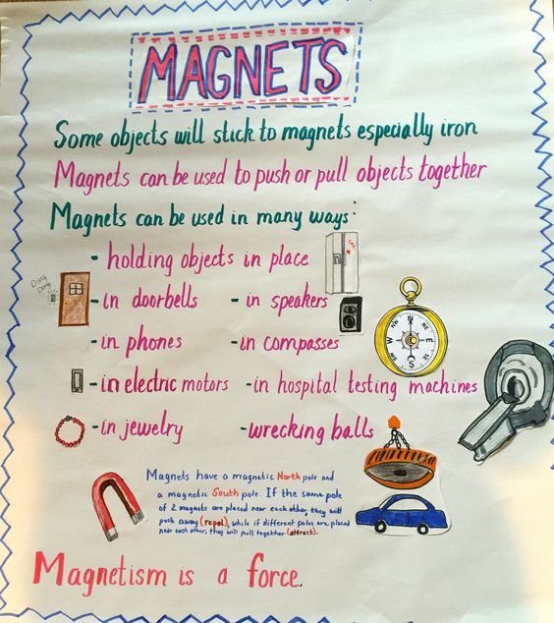
Student activity
- Which of the following is the best magnetic metal?
- Lead B. Iron C. Copper D. Aluminium

- Name three materials that uses a magnet.
_____________________________________________________
_____________________________________________________

Lesson 31 Making a magnet (1 hour)
L/O Discuss how a non – magnetic can be made magnetic.
How to make a razor blade magnetic?
- Obtain a strong magnet.
- Place the razor blade on the table.
- Take the magnet and rub the end of the along the razor in one direction several times.
- Then run the other end of the magnet in the opposite direction several times.
- Move the razor blade closer to some staple pins, the blade should act like a magnet.
Electromagnetism
Copper is non magnetic but it can become magnetic if electric current passes through like the set up given below. This is called electro magnetism.
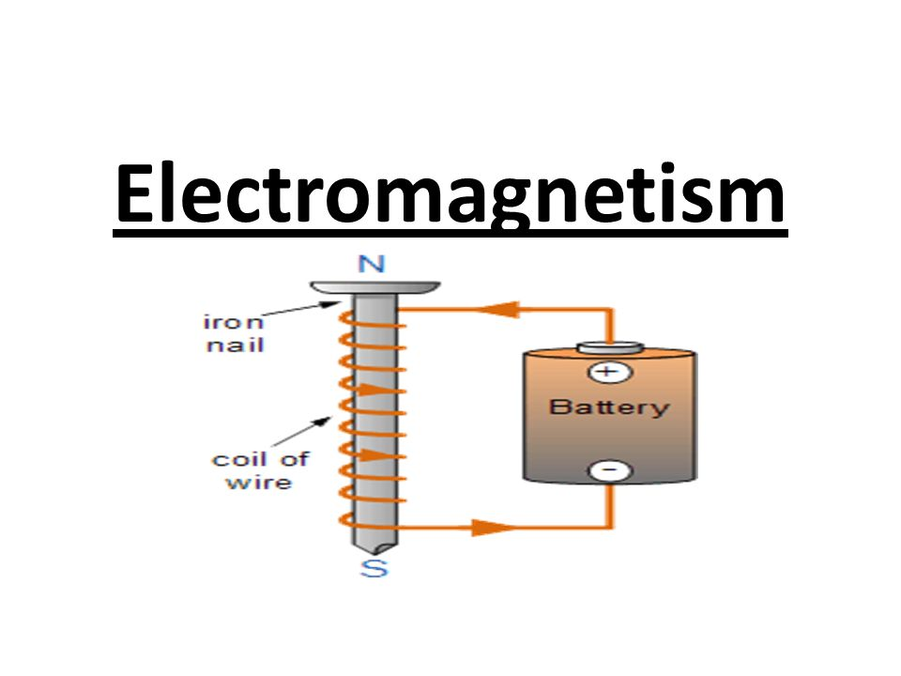
Passing electric current will attract metallic materials .e.g. pins.

Hanging magnet
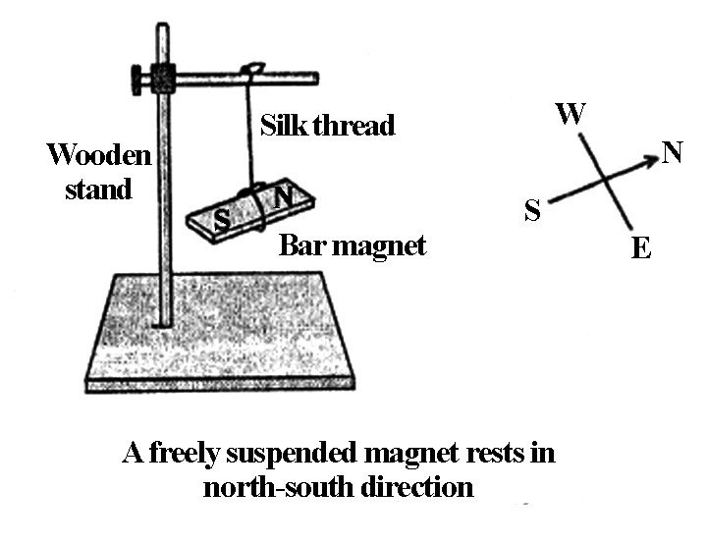
A magnet has two sides, the North pole and the South pole. A freely suspended magnet will always point toward the North – South direction as shown in the diagram above.

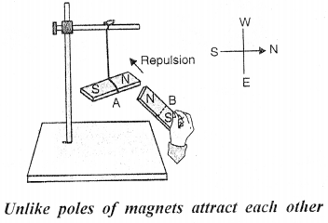
Therefore, like poles repel each other.

Student activity
- Draw and label a diagram to show how to make a piece of copper wire behave like a magnet.

- Complete the diagram below:
- Label the correct pole on each end of the magnets below so that the magnets attract each other.

