RATU NAVULA COLLEGE
TEAR 10 BASIC SCIENCE
WEEK 6 LESSON NOTES

LESSON 48 FORCES
LO - understand forces and its importance

MACHINES

A machine is anything that can make our work easier. Machines make our work easier in three
different ways:
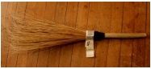  1. Broom |   2. Airplane
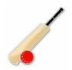  3. Cricket Bat | 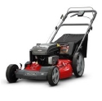  4. Lawn Mower
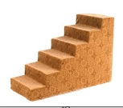  5. Steps | 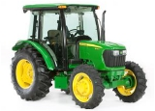  6. Tractor
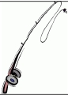  7. Fishing Rod | 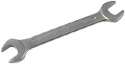  8. Spanner

1. It multiplies the force we use.

2. It multiplies speed [make things go faster].

3. It changes the direction of force.

LESSSON 49 GEARS
LO _ understand gears and its uses

Gear wheels are wheels with teeth on them. The teeth of one gear usually fit into the teeth of
another. Gears are used to transfer the force from one wheel to another. In a bicycle, the large
gearwheel attached to the pedals is connected to the smaller gear wheel on the back wheel by
the chain.
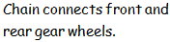
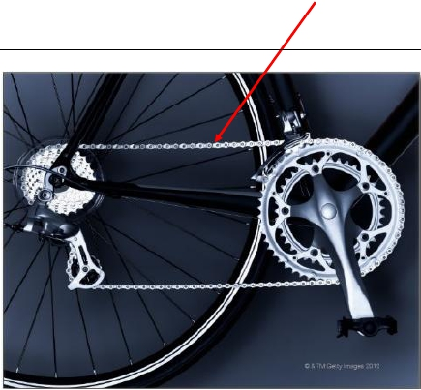

One gear can make another one turn faster, but it can also make it turn in a different direction.
When you turn a big gear to the right, the little one will move to the left. This is good for many
machines where the direction needs to change in order for the machine to work.

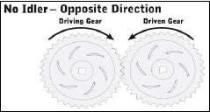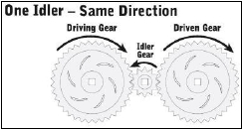

An idler gear is a gear wheel that is inserted between two or more other gear wheels.

Gears can speed things up or slow things down. Look at the diagram below. The large gearwheel has more teeth on it than the smaller gear wheel. The larger gear wheel is called the
driving gear because it is attached to the motor and therefore supplies the force.
The smaller gear wheel is called the driven gear.
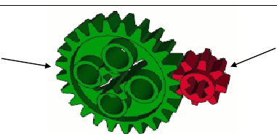
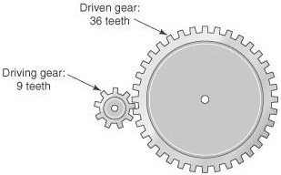

This arrangement of gears turns the driven gear faster. Machines that use a larger driving gear
include hand beaters and hand drills. In these machines the drill bits have to rotate very fast to
do their job. When driving gear turns clockwise, driven gear will turnanticlockwise.

Machines that have a smaller driving gear than the driven gear are for slow rotation.

This arrangement is used in rotating displays in shops where the displays have to rotate slowly
so that you can see the goods.

Uses of Gears

Gears are everywhere! Some rides at an amusement park or festival use large gears which make
them spin in circles (like the spinning Ferris wheel duringfestivals). Hugewind turbines use
gears to convertthe slow motion of the blades into much faster motionto make electricity.

Gears are in small things too, like tiny music boxes or remote controlled cars. They areused in

clocks to make the minute and the hour hand go around. They are used in motors:big car motors and little motors that make your toys move. Most of the time they are hidden away inside so you
can't see them, but if you look at a can opener, you will be able to see two gears. Turning the
handle will make one of the gears move and the other one will move in the opposite direction.
You can also see gears on a bicycle. With some bikes, the wheels will move at different speeds
when you pedal because of gears connected by achain.

LESSON 50
LO - understand wheel and axle and its uses
WHEEL AND AXLE
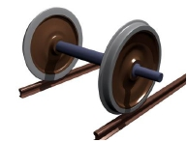
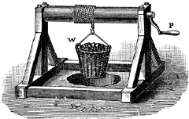

A wheel and axle is a simple machine made up of two circular objects of different size.
The axle (a small wheel) is attached to the center of a larger wheel. All wheels need an axle.
The wheel and axle must move together to be a simple machine. A wheel and axle lifts or moves
loads. Effort applied tothe wheel turns the axle, or effort appliedto the axle turns the wheel.
They move together. When effort is applied to the wheel, the wheel and axle spreads the force
over a greater distance. If the radius of the wheel is two times larger than the radius of the axle,
everytime you turn the wheel once, the force will be multiplied by two. A wheel and axle can
produce a gain in either effort or distance, depending on how it is used.

Examples of a wheel and axle can be found in doorknobs, roller skates, pencil sharpener with
a handle, steering wheels of a car, screwdrivers, treadle sewing machine, winder of a watch and wheels of a car.
Because the wheel is larger than the axle, it always moves through a greater distance than the
axle. Such a situation multiplies the force applied to the axle, but always requires a trade off
by moving the effort over a greater distance. Steering wheels and screwdriversare common
examples. Changing the diameter of either the wheel or the axle controls themechanical
advantage (the amount of help that using a simple machine provides) of awheel and axle
system. As the diameter of the wheel increases (and the axle stays thesame), the mechanical
advantage increases and a greater force is applied to the axle.

Note:
- When the wheel turns the axle, force is multiplied.
Examples: door knob, screwdriver, steering wheel of a car, winder of a watch

- When the axle turns the wheel, speed is multiplied.
Examples: treadle sewing machine, roller skates

RATU NAVULA COLLEGE
Y10 BASIC SCIENCE NOTES
WEEK 7
LESSON 51
LO- understand pulleys and its uses

PULLEYS

Lifting a bucket of sand is hard work. However, by using a pulley system, you can pulldownwards to move the bucket upwards. This is easier than pulling the bucket upwards
directly.

A pulley is a grooved wheel with a rope over it. A single pulley does not multiply force but
simply changes the direction of force.

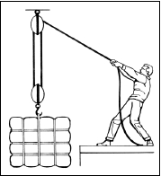

To multiply force, you need to use more than one pulley. This allows you to lift very heavy loads by using only a small effort.

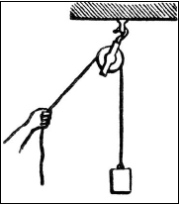

How can pulleys make our work easier?

A single pulley changes the direction of a force, which can make it much easier for us tomove
something. Pulleys can also provide us with a mechanical advantage when we useseveral
together and more rope. This process lessens the amount of force required to liftsomething.
Using multiple pulleys decreases the amount of force necessary to move anobject by increasing
the amount of rope used to raise the object. The mechanical advantage(MA) of a pulley system
is equal to the number of ropes supporting the movable load.
[A system of pulleys (more than one pulley) multiplies force.]

In today's highly-technical world, engineers still use pulleys to make difficult tasks easier.
Without them, our lives would be much more difficult.

USES OF PULLEYS

Pulleys are used in many ways everyday. What kind of pulleys can you think of? Some common
examples are large construction cranes that use pulleys to lift heavy objects with what would
normally be a very underpowered motor, weight machines at a gym, some elevators, flagpoles,
window blinds, bicycle rings/chains, clotheslines, water wellbucket/rope, zip lines, motors, rock
climbing devices, and sailing and fishing boats.

LESON 52
LO- understand lever and its uses

LEVER
Levers are one of the basic tools that were probably used in prehistoric times. Levers were first
described in about 260 BC by the ancient Greek mathematician Archimedes (287 - 212BC).

A lever is a simple machine that makes work easier for use; it involves moving a load about a fixed point called the pivot or fulcrum(F). A force called the effort(E) is applied at one point of
the lever. This helps to overcome another force called load (L) at another point.

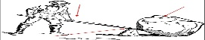

Examples of levers: scissors, pliers, hammer claws, nut crackers, tongs, arm, wheelbarrow,
see-saw balance, spanner, car jack and many others.

Levers make use of the turning effect of forces to produce:

• a large force
• a large movement

The closer the fulcrum is to the load, the less force (effort) you need to use. There are different types of levers around us. Some levers have the fulcrum between the load and the
effort, but much closer to the load[as shown in the above diagram].

This means that you only need a small effort to exert a large force. Some levers have the
fulcrum at the end of the lever.

Examples of fulcrum at the end of the lever:

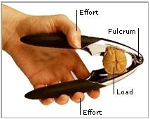

Examples of fulcrum between effort and load:

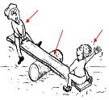

The unit of Force is Newton (N).

A lot of things we do in our everyday life make use of the turning effect of a force. The turning
effect of a force is the ability of a force to make something turn about a certain point. Thus, we
say the turning effect of a force depends on:
• the size of the force

• the distance of the force from the pivot

The unit for Work Done is Joules (J).

A force is said to do work when it acts on a body so that there is a displacement. Thus, a force
does work when it results in movement.
The figure below shows a lever e.g. a board, supported at the center by a fulcrum.

If one person pushes down on the left side with a force F₁, a distance d₁ from thefulcrumand
another person pushes down on the right side with a force F₂, at adistance d₂ from the fulcrum,
they will be in balance if F₁d₁ = F₂d₂ .

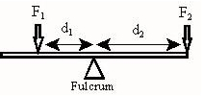

Work done can be calculated by multiplying the force by thedistance it moves.

LESSON 53
L0- calculate work done and mechanical advantage

Therefore,

Work Done = Force(N) x Distance(m)

F₁d₁= F₂d₂

Note: The distance (d) is always taken from the fulcrum.

Mechanical Advantage

We use simple machines to make tasks easier. While the output work of a simple machine
can never be greater than the input work, a simple machine can multiply input forces OR
multiply input distances (but never both at the same time).Mechanical Advantage is the
ratio of Load Force to Effort Force or Effort Distance to Load Distance.

or

Note:
- Mechanical Advantage has no unit.
- When Mechanical Advantage is more than 1 ( MA > 1 ), force has been multiplied.
- When Mechanical Advantage is less than 1 ( MA < 1 ), speed has been multiplied.
- When Mechanical Advantage is equal to 1 ( MA = 1 ), direction has been changed.

EXAMPLES

SOLUTION
- F1 d1 = f2 d2
60 ×5 = T × 20
300 = 20 T
300/20 = 20T /20
- = T

- MA = Load / effort
= 60/20
= 3

- MA > 1
Force being multiplied

RATU NAVULA COLLEGE
Y10 BASIC SCIENCE NOTES
WEEK 8

LESSON 54 INCLINED PLANE
LO- understand inclined planes and its uses

Inclined plane is a simple machine. Three simple examples are the ramp, wedge and screws.

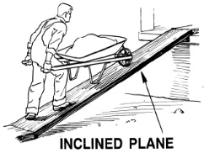

1. THE RAMP

The inclined plane is simply a flat surface raised at an angle, like a ramp. It is a way of lifting a
load that would be too heavy to lift straight up. The angle (the steepness of the inclined plane)
determines how much effort is needed to raise the weight. The steeper the ramp, the more
effort is required.

The ramp makes life easier not by altering the amount of work that is needed, but by altering
the way in which the work is done. Work has two aspects to it:

i. the effort that you put in and

ii. the distance over which you maintain the effort.

If the effort increases, the distance must decrease, and vice versa. It reduces the effort
needed to raise an object by increasing the distance that it moves.

2. WEDGE

A wedge is a simple machine made up of two inclined planes put together. These 2 planes
meet and form a sharp edge. Wedges are used to push two
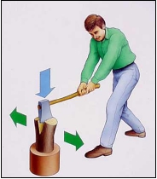
objects apart, or cut an object into pieces. It can also hold
objects in place.

A A wedge gets in between objects and splits it apart. An object like wood, can be split apart

3. SCREW

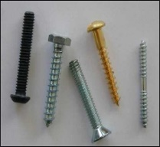
A screw is a simple machine made up of
another simple machine. It is an inclined
plane wrapped around a cylinder.
The screw has 2 parts. The inclined plane is
the thread that wraps around the screw.
The cylinder is the long rod.

Other examples of inclined planes:

- ladder
- staircase
- road winding up a hill
- screws and bolts
- wedges – ‘V’ shaped wood or metal used in splitting wood e.g. axe head and chisel

LESSON 55 VELOCITY AND MOTION
LO- understand velocity and motion

LINEAR MOTION

Linear motion is motion along a straight line. Linear motion is the most basic of all motion.
According to Newton's first law of motion, objects that do not experience any net force will
continue to move in a straight line with a constant velocity until they are subjected to a net
force. Under everyday circumstances, external forces such as gravity and friction can cause
an object to change the direction of its motion, so that its motion cannot be described as linear.
Linear motion is measured in two parts: speed and direction. Together these make up the
velocity.

VELOCITY

The symbol for velocity is v.
The velocity of an object refers to an object's speed and the direction in which the object moves. Velocity is a vector quantity that refers to "the rate at which an object changes its
position" . The units for velocity are the same as for speed.

Velocity is calculated by dividing the change in an object's displacement by the time taken
for the change in displacement to occur.

Distance–time graphs
On a distance–time graph:
• a horizontal line means the object has stopped.
• a straight line sloping upwards means it has a steady speed.

The steepness or gradient of the line shows the speed.
• A steeper gradient means a higher speed.

• A curved line means the speed is changing.

If the direction of travel is being considered:
• A negative distance is in the opposite direction to a positive distance.
• A straight line sloping downwards means it has a steady speed and a steady velocity in the
negative direction.

Example
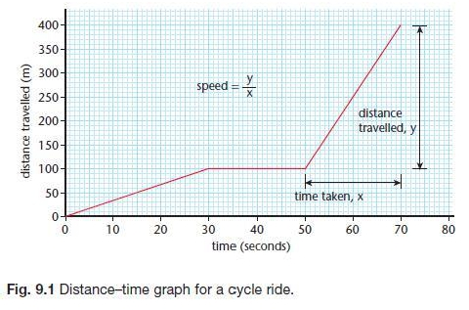

EXAMPLES
Between 30 s and 50 s the cyclist stopped. The graph has a steeper gradient between 50s and
70s than between 0s and 20s – the cyclist was travelling at a greater speed.

To calculate a speed from a graph, work out the gradient of the straight line section as
shown above in the graph above.

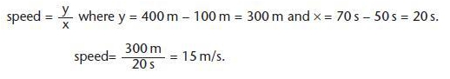

LESSON 56 DISPLACEMENT AND SPEED
LO- understand displacement and speed

DISPLACEMENT

Displacement is a vector quantity that refers to "how far out of place an object is"; it is the
object's overall change in position. Displacement must give attention to direction.

Example
Brian walked 20km from Suva to Nausori. The distance travelled would be 20km but his
displacement would be 20km East of Suva.

SPEED

Speed is the distance travelled in a certain time. It is usually measured in meters per second
[m/s or m.s-1]

Example

A sprinter runs 100m in 10seconds. Calculate the average speed in m/s.

Solution:

LESSON 57 ACCELERATION
LO- calculate acceleration

ACCELERATION

When an object changes velocity, that is, speeds up, slows down or changes direction, it is said
to accelerate. Acceleration, a, is calculated by dividing the change in velocity by the time taken
for the change in velocity to occur.

The unit for acceleration is m/s2 or m.s-2.

Acceleration also is used to describe change in speed.

The unit for acceleration is m/s2 or m.s-2.

Acceleration also is used to describe change in speed.

Note:
- Change in Speed = Final Speed Original Speed
- An object at rest (not moving) has a speed of 0 m/s.

Deceleration is used to describe motion when an object slows down. It uses the same equation
as acceleration. When an object slows down, the change in speed is negative, and so is the acceleration. The word deceleration is used to describe objects which have negative acceleration.

Example 1
A boy riding a bike takes 10 seconds to reach his maximum speed which is 15 m/s.
What is his acceleratio

Example 2
A ball is rolling on the ground at 5 m/s. It takes 4 seconds to come to a stop. Calculate the acceleration.

Example 3
A parachutist in free fall eventually opens her parachute and finds that in 1.8 seconds she
slows down from 50 m.s⁻¹ to 5 m.s⁻¹. Calculate the acceleration of the parachutist.

We can say that the parachutist is decelerating at 25m.s-2 or accelerating at -25m.s-2 .

FREE FALL
A free falling object is an object that is falling under the sole influence of gravity. Any object that
is being acted upon only by the force of gravity is said to be in a state of free fall.

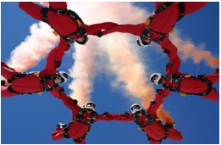
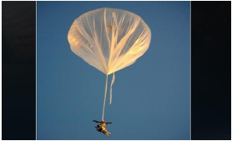
There are two important motion characteristics that are true of free-falling objects:

• Free-falling objects do not come across air resistance.
• All free-falling objects (on Earth) accelerate downwards at a rate of 9.8 m/s².

Under such conditions, all objects will fall with the same rate of acceleration, regardless of their mass.

There are two important motion characteristics that are true of free-falling objects:

• Free-falling objects do not come across air resistance.
• All free-falling objects (on Earth) accelerate downwards at a rate of 9.8 m/s².

