WEEK 3 – DISPATCH NOTES- YEAR 10-
BASIC SCIENCE
Lesson 33 – Types and uses of plastics
Learning Outcome: Identify the various uses of plastics
Plastics are manmade raw materials, such as, cellulose, coal, natural gas, salt and crude oil.
Types and Uses
Types of Plastics | Properties | Uses
- PVC – Polyvinyl Chloride | Strong, flexible, water resistant | Pipes, raincoats, toys
- Polystyrene | Light weight, odorless, cheap | Cups, bowls, computer disks, packaging material
- Polythene | Light weight, flexible, feels waxy | Bags, pails, food wrapper
- Bakelite | Tough, withstand heat, resists wear | Radio, camera, plugs

PVC – polyvinylchloride Polystyrene
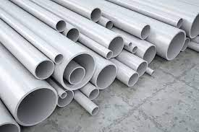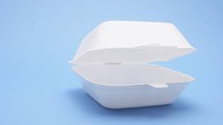
Polythene Bakelite
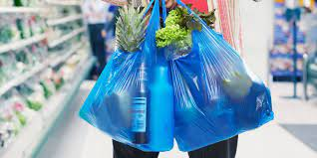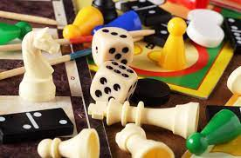

Activity
Name five materials in your surrounding that are examples of polyvinylchloride (PVC), polystyrene, polythene and bake lite.

Lesson 34: Advantages and disadvantages of plastics
Learning Outcome: Identify the advantages and disadvantages of plastics
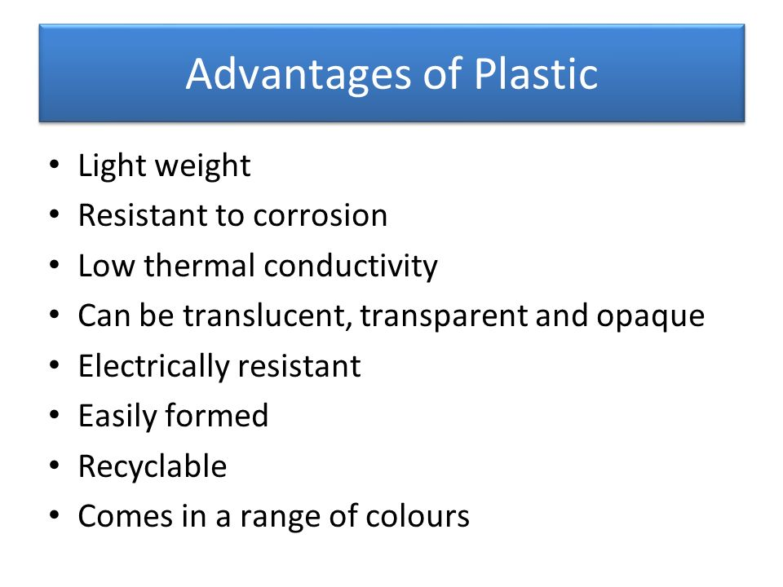

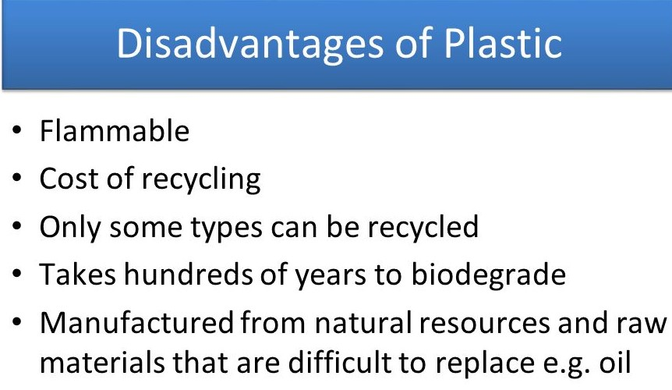

Activity
List two advantages and disadvantages of plastics

Lesson 35 - Effects of plastic to the environment.
Learning Outcome: Describe the environmental effects of plastics.

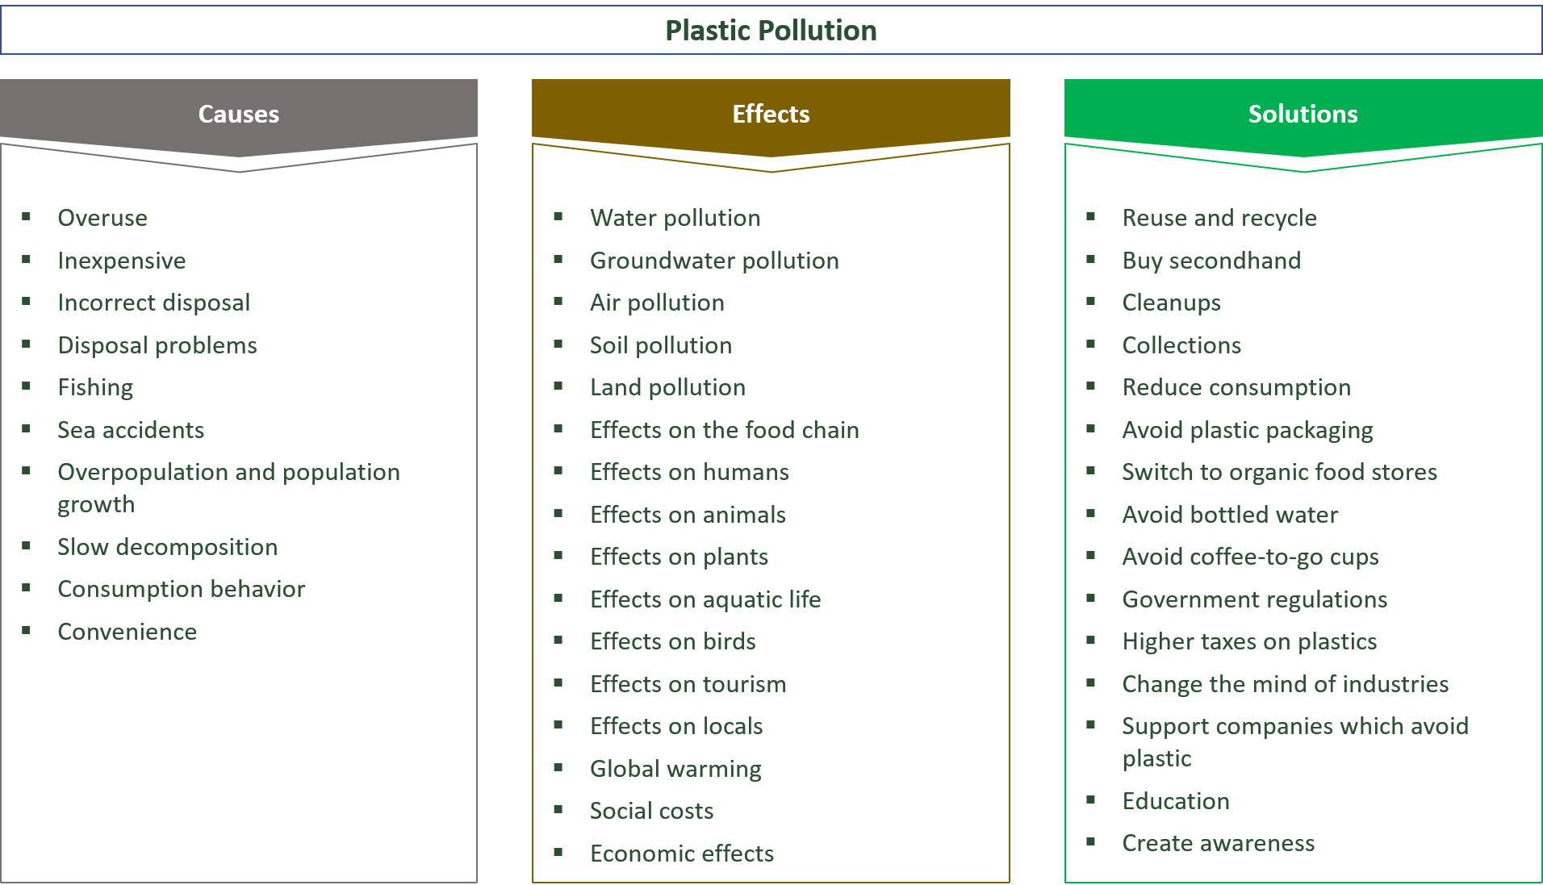

Activity – Paragraph Writing
Plastics have become part of our everyday activities. The overuse of plastics has become a problem to our environment in Fiji. Discuss by:
- Describing two ways plastics have become a problem.
- State two effects of plastics to the environment.
- Two solutions to the problem.

Lesson 36: Types of Water
Learning Outcome: Understand sources of water and types of water
There are two types of water:
- Soft water
- hard water
- Soft water - have low mineral content for e.g. tap water, rain water.
- Hard water - have high amount mineral content for e.g. sea water, bore water. Temporary hardness is caused by calcium bicarbonate and be removed by boiling.
Differences between hard water and soft water
Hard water
- does not lather with soap.
- ions dissolved in water react with chemicals present in soap and produces in insoluble residue (scum) making the clothes look dirty.
- Source of minerals such as magnesium and calcium
Soft Water
- lathers well with soap
- reacts well with soap making the skin smooth and glowing.
- saves money and does waste soap.
Activity
1.Describe two difference between soft water and hard water.

