YEAR 10 BASIC SCIENCE
WORKSHEETS - WEEK 2
LESSON 32
LO - understand reaction and types of reaction
REACTIONS

Chemical Reactions
Consider the following situations of daily life and think what happens when –
• milk is left at room temperature during a hot day.
• an iron nail is left exposed to humid atmosphere.
• pineapple becomes rotten.
• food is cooked.
• food gets digested in our body.
• we respire.

In all the above situations, the nature and the identity of the initial substance have somewhat
changed. Whenever a chemical change occurs, we can say that a chemical reaction has taken place.

Activity 1
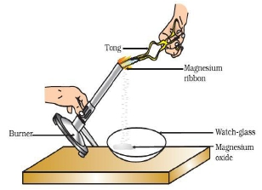
A strip of magnesium ribbon was held with a pair of tongs over
a Bunsen burner flame. The ash produced was collected in a
watch glass. Observations were made.
Caution: Donot look directly at the flame.

Observations
- Magnesium burns with a brilliant white flame.
- White ash is produced.

The name of the substance produced is magnesium oxide. As magnesium burns in air, it combines
with oxygen to form magnesium oxide.

Activity 2
A few zinc granules were taken and placed in a conical
flask. Dilute sulphuric acid (or hydrochloric acid) was added
to the fask containing the zinc granules. Observations were made.
Caution: Handle the acid with care.

Observations
- Bubbles were seen (a gas was produced).
The gas produced is hydrogen gas (H₂).
- Zinc granules disappear.
- The conical flask felt warm. Heat was produced.

From the above two activities, we can say that any of the following observations (clues) helps us to
determine whether a chemical reaction has taken place:

• change in state (forming of precipitate)
• change in colour
• release of a gas
• change in temperature (heat energy is given out or taken in)

As we observe the changes around us, we can see that there is a large variety of chemical reactions
taking place around us.

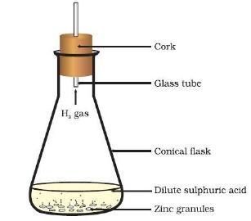

Chemical reaction - is when a new substance is formed with new characteristics and composition
(also known as chemical change).

Examples of chemical reactions: fireworks exploding to produce spectacular colour, coke producing gas bubbles,
making cake, nail turning rusty, digestion of food.

During chemical reaction products are formed from reactants

LESSOM 33
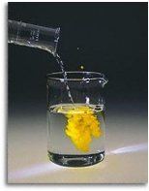
LO – understand products and reactants and write a balanced equation

Reactants Products

Reactants - substances present at the beginning of a chemical reaction.
(Starting substances of a chemical reaction.)

Products – substances formed in a chemical reaction.

Properties of Chemical Reaction
• One or more new chemical substances are formed.
• Heat is often released.
• Change is usually difficult to reverse (to change back to its original substance)
Writing and Balancing Chemical Equations

Chemical Equations
• Represents a chemical reaction by briefly summarizing what has happened.
• It shows the substances that are reacting- reactants and the substances that are formed- product.
• Symbols and formulae are used.
• An arrow in the equation represents the change that takes place in the reaction, from the
reactants to the products.
• Chemical equations can be written into 2 ways: word equation and chemical equation.

For example, the word equation for Activity 1would be:

Magnesium + oxygen Magnesium oxide (1.1)
[Reactants] [Product]

• Chemical equations can be made more meaningful and useful if we use chemical formulae
instead of words. A chemical equation represents a chemical reaction. If you recall formulae of
magnesium, oxygen and magnesium oxide, the above word-equation can be written as:

Mg + O2 MgO (1.2)

• Count and compare the number of atoms of each element on the LHS and RHS of the
arrow. Is the number of atoms of each element the same on both the sides? If not, then the equation
is unbalanced because the mass is not the same on both sides of the equation. Such a chemical
equation is a skeletal chemical equation for a reaction. Equation (1.2) is a skeletal chemical equation
for the burning of magnesium in air.

Balancing Chemical Equations
One of the most important rules of Chemistry is that matter is not created or destroyed in a chemical
reaction. It only changed into a new form. This is the Law of Conservation of Mass which states
that in a chemical reaction, the mass of the product is equal to the mass of the reactants.

• Balanced chemical equation has the same number of atoms of each element on each side.

• To balance the equation, we place coefficients in front of each chemical.
coefficient (is added to the formulae in balancing equation)

2NH4 subscript (is not changed during the balancing of equation)

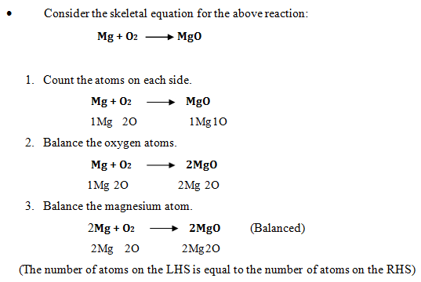

Exercise
Balance the following skeletal chemical equations:
(i) Zn + O₂ ZnO

(ii) Na + O₂ Na₂O

(iii) Mg + HCl MgCl₂ + H₂

(iv) MgO + HCl MgCl₂ + H₂O

LESSON 34
LO - understand types of chemical reaction
- Understand displacement reaction

Types of Chemical Reactions
During a chemical reaction atoms of one element do not change into those of another element. Nor
do atoms disappear from the mixture or appear from elsewhere. Actually, chemical reactions involve
the breaking and making of bonds between atoms to produce new substances.

1. Displacement Reaction (also known as Single Replacement)
A displacement reaction is where a more reactive metal displaces a less reactive metal from a
compound. In other words a metal higher up in the reactivity series will 'push out' or take the place of a metal lower in the series

Activity
- Three iron nails were taken and cleaned by rubbing with sand paper.
- Two test tubes were taken and marked as A and B. Each test tube was filled with 10
- ml of copper sulphate (bluestone) solution. [Note: Copper sulphate solution is blue in colour.]
- Two iron nails were tied with a thread and immersed in the copper sulphate solution in test tube B for about 20 minutes. One iron nail was kept aside for comparison (control).
- After 20 minutes the iron nails were taken out from the copper sulphate solution.
- The intensity of the blue colour of copper sulphate solutions in test tubes A and B were compared. The colour of iron nails dipped in the copper sulphate solution was compared with the iron nail that was kept aside.

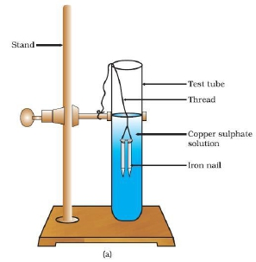
Experimental Set-up

Observations
- The iron nails placed in copper sulphate solution became brownish in colour.
[Brown deposits were seen on the iron nails which were placed in the copper sulphate solution.

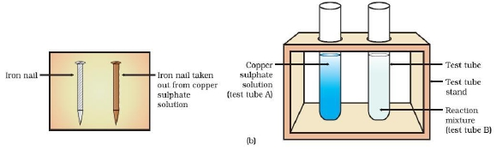
- The blue colour of copper sulphate solution fades. Copper sulphate solution becomes pale (light) blue in colour.
Why does the iron nail become brownish in colour and the blue colour of copper sulphate solution
fade? The reason why this happened is because iron is higher in the reactivity series so it 'takes' the
sulphate from the copper to form iron sulphate and copper. Iron is more reactive than copper so it displaces copper from its solution.
In this reaction, iron has displaced or removed another element (copper) from copper sulphate
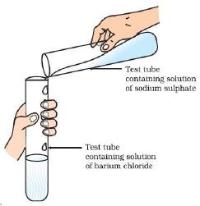
solution. This reaction is known as displacement reaction.

A + BC AC + B

Iron + Copper sulphate Iron sulphate + Copper

Fe + CuSO4 FeSO4 + Cu

Basically, the rule is: If the pure metal is higher in the reactivity series than the metal in the
compound, then displacement will happen.

LESSON 35
LO- understand precipitation reaction and symthesis reaction

2. Precipitation (also known as Double Replacement)
Precipitation is a reaction in which the elements in two compounds are exchanged and form different

compounds. When some solutions are mixed, an insoluble solid forms as one of the products.
The insoluble solid is called precipitate. Any reaction that produces a precipitate can be called a precipitation reaction.

Activity
- About 3ml of sodium sulphate solution was taken in a test tube. In another test tube, 3ml of barium chloride solution was taken. The two solutions were mixed and observations were made.

When the two solutions were mixed, a precipitate (insoluble solid) is
formed. This is an example of a precipitation reaction.

Na₂SO₄ (aq) + BaCl₂ (aq) BaSO₄ (s) + 2NaCl (aq)

Sodium sulphate + Barium chloride Barium sulphate + Sodium chloride

3. Synthesis (also known as Combination reaction)
A synthesis reaction is one where two substances combine to make a new substance.
It can be shown in an equation such that: A + B AB
The properties of the reactants are different from the properties of the compound formed.

Activity
- 2g of iron fillings (grey solid) was placed in a test tube.
- 2g of sulphur (yellow powder) was placed in the same test tube.
- Iron and sulphur were mixed.
- The test tube was heated over a Bunsen burner and heating
was stopped once the reaction began.
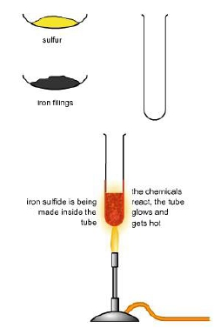

When iron is heated with sulphur, iron sulphide is formed.
Iron combines with sulphur forming iron sulphide.

Fe + S FeS
Iron + Sulphur Iron sulphide

Reactants : iron and sulphur
Product : iron sulphide

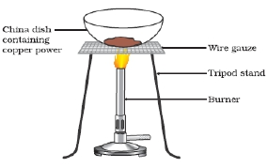

RATU NAVULA COLLEGE
YEAR 10 BASIC SCIENCE
WEEK 3
LESSON 36
LO- understand oxidation reaction and reduction reaction

4. Oxidation and Reduction

Oxidation is a reaction where an element gains oxygen. It is the loss of electrons from an
atom or ion. Reduction is a reaction where an element loses oxygen. It is the gain of electrons from
an atom or ion. Examples of oxidation are combustion (burning), respiration and rusting.

Rusting: Iron gains oxygen to form iron oxide.

4Fe + 3O₂ 2Fe₂O₃
Activity
- A china dish containing 1g of copper powder was heated. Observations were made.

When copper powder is heated in a china dish, the
surface of copper powder becomes coated with a black
coloured substance. Copper combines with oxygen in
air to form copper oxide. Copper oxide is black in colour,
because of which the surface of copper powder turns black.
This reaction is a redox reaction. The chemical equation for
the above reaction is as follows:
heat
Copper + oxygen Copper oxide

An example of reduction is the decomposition of mercury oxide (HgO). When it is heated, mercury

oxide decomposes (breaks down) to form mercury and oxygen. Because mercury loses oxygen in this
reaction, we say that it is reduced.
(i) 2Hg + O₂ 2HgO Oxidation

(ii) 2HgO 2Hg + O₂ Reduction

LESSON 37
LO - understand electroplating of metals
5. Electrolysis – Electroplating
Electrolysis is the decomposition of a compound using electricity.
Electrolyte – is the compound which conducts electric current in molten or when dissolved in water
(aqueous solution).
Electrode – is a rod or plate where electric current enters or leaves the electrolyte during electrolysis.
Reaction occurs at electrodes.
Anode – is the positive electrode; anion – is negative ion (attracted to anode).
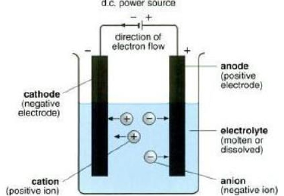
The liquid electrolyte always contains a compound of the metal to be plated e.g. silver nitrate
(AgNO3). The plating metal (anode) gradually dissolves and eventually gets deposited on the object
to be plated (cathode).

Another example of electroplating:

The diagram given below shows a set-up that could be used to electroplate a steel key.

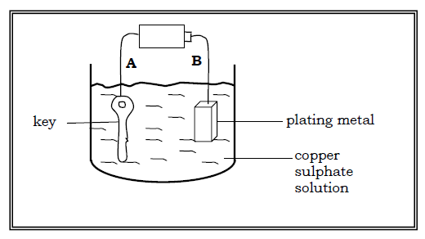
- The positive electrode is B (plating metal).
The plating metal is always the positive electrode.
- The negative electrode is A (key – object to be plated).
The object to be plated is always the negative electrode.
- The electrolyte is copper sulphate solution.
The electrolyte contains a compound of the plating metal.
The plating metal is copper and copper sulphate is a
compound of copper.
- Observations:
- The key gets plated with copper. / Copper deposits seen on the key.
- The plating metal gradually becomes smaller in size.

Electroplating is very useful because of the following reasons:

Cathode – is the negative electrode; cation – is positive ion (attracted to cathode).
Surface protection (prevent the metal from rusting) e.g. nickel plating of iron to prevent
corrosion, bumper parts and door handles are often made from steel or brass plated with
chromium.
➢ Makes the article (object) attractive e.g. electroplating of silver or gold on brass.
➢ Repair of finer machine parts.

LESSON 38
LO- understand facors affecting reaction rate

Factors Affecting Reaction Rate

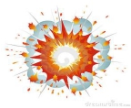
Explosions are chemical reactions that take place very quickly. Explosions
also produce a lot of heat, light and sound. In less than 10 milliseconds, a
dynamite blast in a large mine can produce 5 billion litres of gas and release
20 billion joules of energy - enough energy to tear any rock apart.

In contrast, the chemical reactions that cause concrete to set are very slow. It can take several days for
the concrete to set hard. Rusting is another example of a slow chemical reaction.

The rate of a chemical reaction is a measure of how fast the reactants are being used up and how fast
the products are being made. Particles must collide for a chemical reaction to happen. The rate of a
reaction depends on the frequency and energy of collisions between particles.

Chemical reactions proceed at different rates. The factors that affect reaction rates are:

1. Temperature

If the temperature is increased, the rate of reaction will increase; low temperature - reaction rate will
be slow.

Activity
- 2 – 3 pieces of calcium carbonate (or coral) was placed inside a test tube.
- Dilute hydrochloric acid (HCl) was added to half fill the test tube.
Observations were made.
When hydrochloric acid was added to calcium carbonate, bubbles were seen indicating that a gas is produced.
- The test tube was then heated gently and the reaction was observed.

When the test tube was heated, the bubbles were formed at a faster rate. This means that the gas was produced at a faster rate when the test tube was heated. Increase in temperature increased the reaction rate.

In this reaction the calcium carbonate reacted with HCl to form calcium chloride, water and
carbon dioxide gas. The word equation for this chemical reaction is as follows:

calcium carbonate + hydrochloric acid calcium chloride + water + carbon dioxide

If the temperature is increased, the particles have more energy and so move quicker. Increasing the
temperature increases the rate of reaction because the particles collide more often and with more
energy.

Look at the graph of the reaction between hydrochloric acid and calcium carbonate. Notice how an
increase in temperature leads to an increase in the speed of release of carbon dioxide, but not the
total volume.
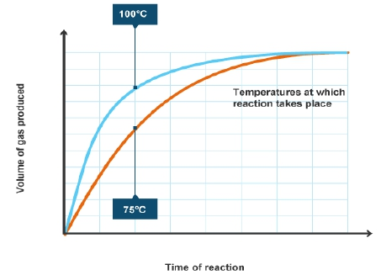

LESSON 39
LO- understand factors affecting reaction rate

2. Concentration

Increasing concentration increases the rate of reaction. Dilute solutions react slowly and
concentrated solutions react quickly.

Activity
- Two pieces of magnesium ribbon of the same length were placed in separate test tubes.
- 2 mL of dilute HCl was added to one test tube. In the other test tube, 2 mL of concentrated HCl was added.
Observations were made on the reaction rate of the two test tubes.
Observations

- Bubbles are formed in both test tubes indicating that a gas is produced. The gas produced is hydrogen gas (H₂). Reaction occurs in both test tubes but at a faster rate in the test tube which contains concentrated HCl. Gas was produced at a faster rate in the test tube containing concentrated HCl.

The chemical equation for the above reaction is:

magnesium + hydrochloric acid magnesium chloride + hydrogen gas

When the concentration is higher, there are more particles taking part in the reaction. Therefore, the reaction rate is faster.

If the concentration of reactants is increased, there are more reactant particles moving together.
There will be more collisions and so the reaction rate is increased. The higher the concentration of
reactants, the faster the rate of a reaction will be.

3. Surface Area

Increasing the surface area increases the rate of reaction.

Activity
- 2g solid and 2g powdered calcium carbonate (or coral)
- Hydrochloric acid
- beaker and 2 test tubes
- A solution of dilute hydrochloric acid was prepared in a beaker by adding 2 mL of the
- concentrated solution to 20 mL of water. The solid and powdered calcium carbonate was placed in separate test tubes. 10 mL of dilute hydrochloric acid was added to each test tube and observations were made on the rate at which carbon dioxide gas is produced.

Observations
- Carbon dioxide gas is produced at a faster rate in the test tube containing powdered calcium carbonate. This happens because in powdered calcium carbonate the particle size has decreased
and this increases the surface area, therefore increases the reaction rate.

The chemical equation for the above reaction is:

calcium carbonate + hydrochloric acid calcium chloride + water + carbon dioxide

CaCO₃ + 2HCl CaCl₂ + H₂O + CO₂

By decreasing the particle size of a reactant, we are increasing the surface area. The greater the
surface area, the higher the chance of collisions occurring, thus the faster the rate of reaction. The
smaller the particle sizes the faster the reaction. Smaller particles have a larger surface area.

surface area 6 sides surface area 6x8 = 48cm2

4. Catalysts

A catalyst speeds up the rate of a reaction but it is not used up in the reaction. If a catalyst is present,
the reacting particles can collide more successfully with less energy and so the reaction can take
place at a lower temperature.

Activity

10 mL of hydrogen peroxide was added to a graduated cylinder. 1 drop of detergent solution was added and the measuring cylinder was swirled. Using a spatula, a small amount of yeast was added to the
hydrogen peroxide in the graduated cylinder and swirled. The graduated cylinder was placed on the table and watched for any bubbling. The graduated cylinder was held to see if there is any change in temperature.

The chemical formula for hydrogen peroxide is H₂O₂. Hydrogen peroxide is not a very stable compound, so it is always decomposing to water and oxygen, but under normal conditions, the decomposition goes very slowly. In this reaction, yeast catalyzes the decomposition, making the reaction go much more quickly. If you add a little dishwashing detergent, you get foam!
2H₂O₂2H₂O + O₂

The production of oxygen gas is made more noticeable by adding some dish soap, which makes the
foam. The reaction is catalyzed by the active yeast added to the container. The yeast changes the
mechanism, or pathway, by which the reaction occurs. The rapid production of bubbles of oxygen gas,
along with the dish soap, quickly creates a large quantity of foam.

When yeast is mixed in with the hydrogen peroxide, the yeast causes this decomposition chemical
reaction to occur much more quickly. The hydrogen peroxide changes into water and oxygen gas much
more quickly. The observed bubbles and foam is the oxygen gas being formed very rapidly.

