RATU NAVULA COLLEGE
YEAR 10 NOTES AND ACTIVITY 2021 – WEEK 10
AGRICULTURAL SCIENCE
C.L.O: 10.4.1.6 EXPLAIN THE CHALLEMGES FACING THE POULTRY INDUSTRY AND ITS POSSIBLE SOLUTIONS
LESSON 55: Challenge facing the poultry industry and suggested solutions
LESSON OUTCOME: Identify the challenges facing the poultry industry and discuss its possible solutions
Subsidy: government assistance to aid and encourage private enterprise that serves the public
Vaccinate: injecting of vaccines into the bloodstream for protection against disease
Susceptible: easily affected or harmed
Poultry farming is a business that faces many problems that hinder efficiency. To overcome these problems, farmers need to find solutions.
Below are some of the challenges with its suggested solutions.
 | Problems | Solutions
1 | Cost of feed  Most of the raw materials for preparing feed are imported causing the feed to be expensive. Eg wheat | Government to provide subsidy  Framers to produce raw materials like maize
2 | Adverse weather condition  Fiji is prone to flooding and hurricane and drought | Farmers to build shed on high grounds  Poultry sheds to be well ventilated
3 | Disease  Poultry are susceptible to various diseases, viral, bacterial and fungal | Purchase day old chicks from reputable hatcheries e.g Pacific Feeds  Vaccinate day old chicks  Proper management
4 | Competition  There is competition between farmers | Raise breeds that convert feed efficiently and produce good grade eggs  Proper feeding and better management
5 | Availability of inputs  Feed and day old chicks | Farmers to cultivate local raw materials for feed  Government to provide assistance to farmers in the cultivation of maize
Activity
- Give one reason why Fiji is importing maize and wheat.
- State a reason why farmers need to buy day old chicks from reputable hatcheries.
- State two ways in which we can maintain quality egg grades and meat birds.

C.L.O: 10.4.1.7 RECOGNISE THE IMPORTANCE OF MANAGEMENT PRACTICES IN THE REARING OF POULTRY BIRDS
LESSON 56: THE BROODING PHASE
LESSON OUTCOME: Identify the two types of brooder/ List the components of brooder/ Discuss the seven fundamentals of brooding
Brooder: an equipment for raising day old chicks that provides warmth, water, feed and security
Pullets: young female birds that have not lay eggs (0-18 weeks old)
Debeaking: removing part of the upper part of beak
The brooding period for poultry is 6 weeks for layer pullets and two weeks for broiler.
There are two types of brooders, cold brooder and warm brooder. A cold brooder does not have a source of heat whereas a warm brooder has a source of heat.
Components of brooder
- Light 2. Heater 3. Security 4. Water
- Feed 6. Ventilation 7. Space
Seven fundamentals of brooding
- Pre-placement preparation: the key to successful rearing lies on an effective management program starting well before the day old chicks arrive. Rearing shed should be clean. Floor should be covered with litter to prevent heat loss. Water lines should be ready. Feed trays to be filled. Shed should be secured and no openings which may allow predators to enter.
- Feed management: feed trays must be filled with starter feed in crumble form.
- Light management: once day old chicks are placed in the brooder, continuous lighting must be provided for at least 48-72 hours.
- Water management: birds drink twice as much water by weight of feed consumed. Water consumption increase when temperature increases. Medications can also be added to the drinking water.
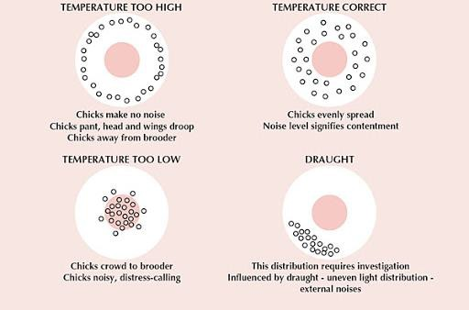
- Temperature management: observe chicks’ behavior and adjust for their comfort. Make sure not to overheat.
The effect of temperature on the bird distribution under brooders.

Stages of growth Temperature (degrees)
Week 1 35
Week 2 32
- Air quality and ventilation: proper ventilation must be available to distribute heat evenly throughout the shed and maintain optimum air quality in the shed.
- Debeaking: prevent feed wastage. Prevent cannibalism. Prevent egg damage
- Declawing: cutting off claws. Prevent injuries. Prevent feather picking.

Activity
- Explain the main function of the brooder.
- Differentiate between a cold brooder and a warm brooder.
- List two reasons for debeaking poultry.
- What is the brooding period for layer birds and broiler birds?

LESSON 57: The Rearing Phase
LESSON OUTCOME: Describe the management of poultry during the rearing phase

Rearing: the growing period
Ad libitum: feeding at free will to make sure feed is always available
Point of lay: age at which pullets start to lay eggs (18-20 weeks)

The rearing phase for layer birds is 6 weeks to 18/20 weeks (point of lay) and 3 weeks to 5 weeks for broilers.
Rearing Practice | Layers | Broilers
Feed management | Fed with grower pellets  Fed ad libitum | Fed grower pellets  Fed ad libitum
Water management | Clean water provided ad libitum  Avoid spillage | Clean water provided ad libitum  Avoid spillage
Ventilation management | Control relative humidity  Maintain litter condition  Low level of ammonia and CO2 | Enough oxygen  Maintain relative humidity  Maintain litter condition
Stocking management | 1 ½ ft2 per bird | 1ft2 per bird
Weighing management | Regular weighing to monitor growth | Regular weighing so that target weight is achieved
Litter management | Change litter when it is wet | Change litter when it is wet
Light management | 14/16 hours of light to stimulate laying. 9 hours of dark | 18-20 hours of light for feeding
Disease management | Separate diseased bird immediately and apply control | Check for signs of disease  Separate affected birds immediately and apply control
Activity
- Name the type of feed given during the rearing phase.
- What is the importance of lighting to layer birds?
- How can a farmer monitor the growth of his stock?
- What is the point of lay for layer birds?

