RATU NAVULA COLLEGE
YEAR 10 NOTES AND ACTIVITY 2021 – WEEK 4
AGRICULTURAL SCIENCE
Lesson 38: Propagation by Grafting
Learning Outcome: List the steps in grafting
Grafting: an asexual method of plant propagation where a scion is attached to the rootstock of a different plant of the same species.
- Grafting involves the growing of a scion of one type of plant onto the rootstock of another plant of the same botanical family.
Example: an orange scion (sweet taste) is grafted onto the rootstock of a lemon plant (strong roots).

Advantage of grafting
- Grafted plants mature faster than seeds.
- Grafting improves the yield of crops.

Tips for successful grafting
- The cambium layer of scion and rootstock to be in contact for growth to take place.
- Seal the wound with wax to prevent infection.
- The union or joint to be secured with a grafting tape to avoid movement of scion and rootstock.
- The best time for grafting is at the beginning of rainy season.
- Wrap the scion with a clear plastic to avoid dehydration or drying.

Types of grafting
- V shaped or wedge
- Slant (bevel) or angle
- Bark grafting
- Whip and tongue
Common plants on which grafting is practiced
- Guava
- Citrus
- Mango
- Ornamental plants

Principle or steps in grafting

STEP | 1 | 2 | 3 | 4
DESCRIPTION | Select and Prepare the scion | Select and Prepare the root stock | Unite scion and stock | Wrap the union with grafting tape
DIAGRAM

Activity
- Explain the term grafting.
- State the importance of the following in grafting:
- Cambium layers to be in contact
- Scion to be covered with clear plastic
- Wound to be sealed
- When is the best time to carry out grafting?

Lesson 39: Plant propagation by ground layering

Learning Outcome: State the principles of layering

Layering: it is a practice of inducing root growth on a stem of plant which is still attached to the tree.
Rooting hormone: a chemical that is applied to increase root growth

- Ground layering is simply the bending of a stem or branch and buried in the soil. The branch is still attached to the tree. It is good to be practiced on plants with soft stems. Once the roots are produced, the branch is removed and planted.
- Ground layering is good because water loss is minimized.
- It can be practiced on crops as well as ornamental plants

Principle or steps in ground layering

STEPS IN GROUND LAYERING
STEP | 1 | 2 | 3 | 4
DESCRIPTION | A soft stem is taken from a parent tree and gently pulled down to the ground then pegged down and covered with moist soil to a depth of about 5cm.  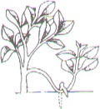 | The soil has to be kept moist and look for root development after a period of 3 – 4 weeks. When root growth has taken place  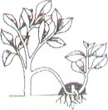 | The stem is cut from the parent plant  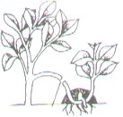 | A week later, dig out the new plant with its roots attached to the soil, it can be either potted or directly planted in the plot with frequent watering.  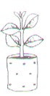
DIAGRAM

Activity
- Explain the term ground layering.

- State one good thing about ground layering.

- Practice ground layering at home.

Lesson 40: Propagation by aerial layering

Learning Outcome: State the principles of aerial layering

Aerial layering/ marcotting: practice of inducing roots on a stem or branch of plant

- Aerial layering or marcotting is practiced on plants that have hard or woody stems.
- It is practiced on plants like citrus, mango, guava, breadfruit and ornamental plants as well.
- Remember that no new plant is produced. You only need to produce roots in a branch.

Principle of marcotting
DIAGRAM DESCRIPTION STEP | 1 | 2 | 3 | 4 | 5
 | A ring of bark | The soil mixture | The roots emerge | It is removed | The marcot is
 | about 5cm long is | is put around the | and can be seen | from the mother | then planted in a
 | removed from a | wound to completely | at the upper end | plant with a | polythene bag
 | branch and it is | surround it and then | of the wound in 2 | sharp knife or a | and kept in the
 | cleaned off by | Covered with a thin | –3 months. The | pruning saw. | nursery till it is
 | scrapping with a | Sheet of transparent | marcot is now |  | ready for field
 | knife. | polythene. It is then | ready for |  | planting.
 |  | tied firmly at 4 – 5 | removal.
 |  | Places with a piece of
 |  | string.
 | 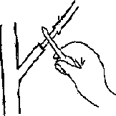 | 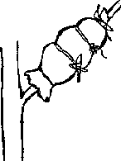 | 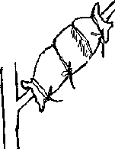 | 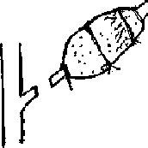
Activity
 |  | STEPS
1.
2.
3.
4. | 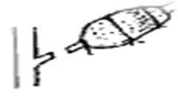
5.

