RATU NAVULA COLLEGE
YEAR 10 NOTES AND ACTIVITY 2021 – WEEK 3
AGRICULTURAL SCIENCE
SUBSTRAND 10.3.2 HORTICULTURE
C.L.O: Discuss and demonstrate methods of plant propagation
Lesson 35: Sexual Propagation
Learning Outcome: Explain what sexual propagation is/ State three advantages and three disadvantages/ Differentiate between cotyledon and dicotyledon seeds
What is sexual propagation?
It is a process of producing plants through seeds.
Types of seeds:
Monocotyledon seeds: these are seeds with only one cotyledon or seed coat
Examples: pawpaw, rice, maize, coconut, grass
Dicotyledon: these are seeds with two cotyledon or seed coat
Example: mango, citrus, bean, peas
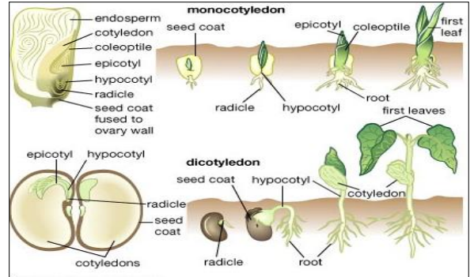

Advantage of sexual propagation | Disadvantages of sexual propagation
- Can produce hybrids | - Genetic variability due to hybrids
- Can handle large number | - Some seeds are slow or hard to germinate
- Large number of plants can be produced in a short time | - Some plants cannot produce viable seeds
Activity
- Explain what sexual propagation is.
- Differentiate between monocotyledon and dicotyledon seeds
- List two advantages of sexual propagation.
Lesson 36: Asexual Propagation
Learning Outcome: Explain what asexual propagation is/State two advantages and two disadvantages/Identify some methods of asexual propagation
What is asexual propagation
It is a method of producing new plants through the vegetative parts of the plant.
Vegetative parts – any part of the plant but not the seed.[stem, roots, rhizome, bulb, suckers]
Two advantages - all new plants(offsprings) are similar to the parents
Takes short time to mature
Two disadvantages – a lot of work needed/ can only propagate a few from each parent
Some methods of asexual propagation
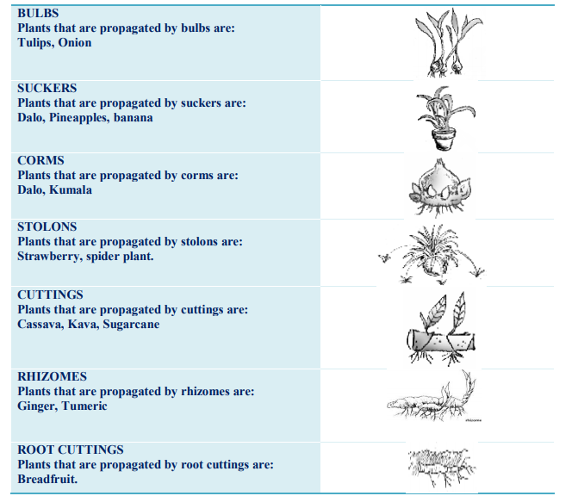
Lesson 37 : Budding
Learning Outcome: Discuss how budding is done
Scion: upper part of the plant that contains the branch and leaves
Rootstock: lower part of the plant that contains the roots
Cambium: part of the stem that contains xylem and phloem vessels
What is budding?
It is a method of propagation where a bud(scion) of one plant is grown onto the stem(rootstock) of another plant.
- In Fiji this method of propagation is practiced on citrus, guava and mango
- It can also be done on flowers
- Both plants must belong to the same family
How budding is done (principles)
What is needed : budding knife/clear plastic/budding tape/scion/rootstock
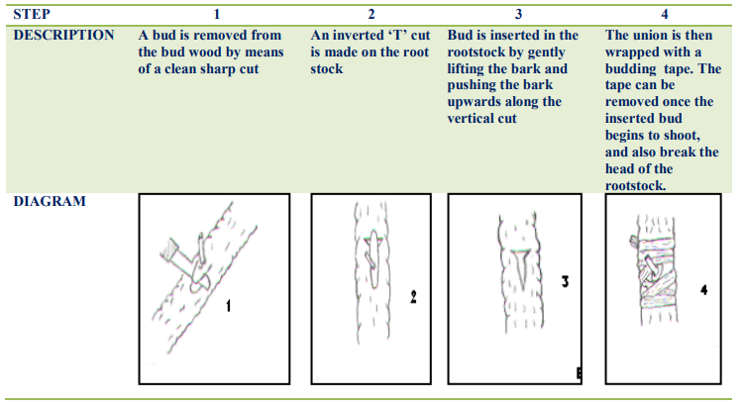
Activity
- Explain what budding is.
- Explain the four steps in budding.
- Practice budding at home.

