RATU NAVULA COLLEGE
YEAR 10 NOTES AND ACTIVITY 2021 – WEEK 2
AGRICULTURAL SCIENCE
Lesson 29: Contour Farming
Learning Outcome : Explain how contour farming control erosion
Contour – across the slope
- contour farming is cultivating, planting across the slope
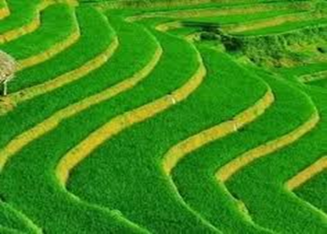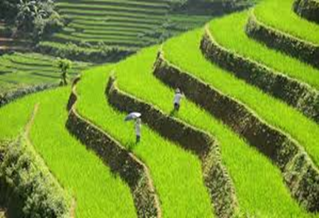

How contour farming control erosion
- keeps valuable topsoil in place
- slow water flow down the slope
- improve irrigation and conserve water

Where is contour farming used?
• On sloping fields where crops are grown
- On sloping fields with vegetable beds

What crops can be grown?
• Sugarcane
- Pineapple
- Vegetables

STUDENT ACTIVITY

- How are pineapples planted on slopes, why?

- How are vertiver grass planted on the slopes, why?

Lesson 30: Terrace Farming
Learning Outcome: Explain how terracing controls erosion
Terrace: cutting slopes into steps
- terracing is the cutting of steep slopes into step like structure
How terracing controls erosion
- slows down the speed of water on steep slopes( water stops on level plains instead of flowing down directly)
- planting can be done on the level areas which will hold the soil particles
Why use terrace farming?
- Lowers or prevent the rapid surface runoff.
- Water stops on the level plain where the force of run-off slows down .

Where is terrace farming practiced?
  On very steep slopes to plant crops.
  When flood irrigation is to be used on slopes

What crops can be grown on terraces?
  Dalo (Fiji)
  Rice (Asian countries)
  Vegetables
  Sugarcane

STUDENT ACTIVITY

- How is it possible to plant rice on a slope land? Can it be irrigated?

- What are the advantages of practicing terrace farming?

Lesson 31: Minimum Tillage

Learning Outcome: Explain the importance of minimum tillage in soil conservation
What is minimum tillage?
- it is a way of growing crops with minimum disturbance to the soil. Also known as zero tillage.
- Slashing or chemicals are used to control weeds
- Zero (minimum) tillage or direct drilling is a way of growing crops with minimum disturbance to the soil.

How minimum tillage minimizes erosion
- Protect soil from degradation(through stubble retention)
- High level of organic matter/biological activity
- Increase water infiltration
- Increase recycling of minerals in soil
What crops can be grown under minimum tillage?
- All vegetables
- Most crops (maize, rice, pulses)

Where is minimum tillage practiced?
- Pulses -cowpea or Urdi can be planted in the stubble of rice.
- Maize seeds can be spot planted after a legume.

Student activity
- How can you grow pasture grass without cultivating the land.

Soil Conservation : Activity
Briefly explain how the following soil conservation methods control soil erosion:
- Terracing

- Mulching

- Cover cropping

- Name some crops that can be used in contour farming.

- Practice mulching in your home garden.

